Report to the Washington Utilities and Transportation Commission

Electric Service Reliability - Major Event Report

Date: September 17, 2012
Date Submitted: October 12, 2012
Primary Operating Area(s) Affected: Yakima
Exclude from Reporting Status: Yes
Report Prepared by: Diane DeNuccio
Report Approved by: Heide Caswell

Event Description:
On September 17, 2012, a sidestack insulator failed, which allowed a phase of 115kV transmission to fall into the 12kV distribution underbuild. The fault caused the transmission line protection to open the section of line between River Road and Union Gap substations, resulting in loss of supply to three substations and nearly 25,000 Yakima customers for about a half hour.

Customers Out Sustained: 24,521
Total Customer Minutes Lost: 763,390
Sustained Interruptions: 25

PacifiCorp is requesting this event and the consequences thereof to be classified a SAIFI-based Major Event, pursuant the Company’s Modified Electric Reliability Reporting Plan, Docket UE 110634, with the 2012 threshold being 13,471 customer interruptions in a 24-hour period in Washington.

Major Resources Utilized:

Troubleman/Assessors 4
Internal Local crewmembers 5
Substation crewmembers 2

Restoration:
The line was patrolled, the problem isolated, and two sections of the line were energized to restore the three substations while leaving the damaged section isolated. A crew was sent to replace the damaged insulator and return the transmission line to normal.
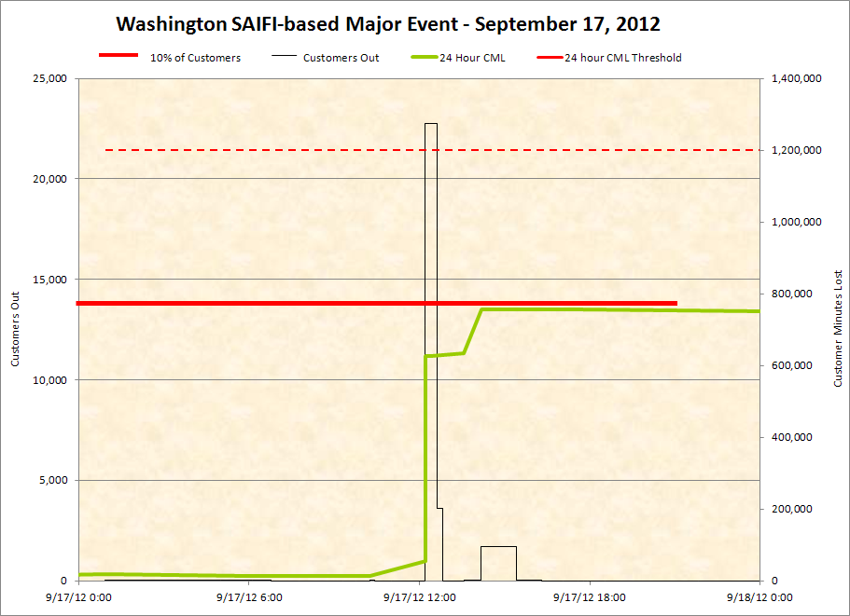

Estimated Major Event Cost:

This event did not generate significant incremental costs to the company.

SAIDI, SAIFI, CAIDI Report: Attached

