Cascade Natural Gas Corporation
Annual Conservation Achievement Report
Calendar Year 2018

Background
ANNUAL REPORT ACRONYMS
AEG | Applied Energy Group
CY | Calendar Year
CO2e | Carbon Dioxide Equivalent
CNGC | Cascade Natural Gas Corporation
C/I | Commercial/ Industrial
CAG | Conservation Advisory Group
CPA | Conservation Potential Assessment
DSM | Demand Side Management
DBtC | Direct Benefit to Customer
EE | Energy Efficiency
EWIP | Enhanced Weatherization Incentive Program
EM&V | Evaluation Measurement & Verification
FWB | Feasibility Work Book
IRP | Integrated Resource Plan
LM | Lockheed Martin
NEEA | Northwest Energy Efficiency Alliance
PY | Program Year
TRC | Total Resource Cost Test
UCT | Utility Cost Test
WUTC | WA Utilities and Transportation Commission
WAP | Weatherization Assistance Program
WIP | Weatherization Incentive Program

On October 1, 2007 the Washington Utilities and Transportation Commission (WUTC or Commission) approved an addendum to the Cascade Natural Gas (Cascade or Company) Conservation Alliance Plan and Decoupling Pilot, which was developed in compliance with the Commission’s Order 06 in Docket UG-060256. As part of this addendum, the Company agreed to submit “an annual report to the Commission on the achievement of the Calendar Year (CY) therm savings target, along with its Commission Basis results of operations report”. Following this order, the Company submitted an annual report by March 31 of each year, to report prior years’ Energy Efficiency (EE) achievements and Conservation Alliance Plan deferrals. As of October 1, 2010, the Pilot Decoupling Mechanism and Conservation Plan, approved by the WUTC on October 1, 2007, were no longer in effect. Per its commitment in the 2010 Annual Conservation Report, the Company voluntarily continued this reporting with the WUTC, submitting its energy efficiency achievements by July 1st of the following program year. As of CY 2016, per Docket UG-152286, the Company has committed to submitting the Annual Conservation Report to the WUTC by June 1 each year, with advanced copies provided to the Company’s Conservation Advisory Group (CAG) 30 days prior to Commission filing.

The Annual Conservation Achievement Report is intended as a synopsis of Cascade’s Energy Efficiency achievements and activities in the previous calendar year. The report contains the following:

- The year’s conservation achievement by program and customer type
- Total expenditures for the year by program and customer class
- Cost effectiveness calculations
- Program evaluations completed during the calendar year
- Program outreach from CY 2018

Forecasting of savings potential is available for review within the Demand Side Management (DSM) section of the Company’s Integrated Resource Plan (IRP). Additionally, as of CY 2015 the Company submits an Annual Conservation Plan by December 1st, which includes the EE targets for the following year by program and customer class. The Conservation Plan also addresses program development, measure portfolios, projected budgets, an estimate of program cost effectiveness, and a list of measures and updates for the following year.

Cost-Effectiveness Inputs
Variations to avoided costs have a significant impact on program cost effectiveness. Thus Residential, Commercial/Industrial (C/I) and Low-Income program cost effectiveness are calculated based on the avoided costs as published in the 2016 IRP, which coincides with the EE tariffs in place throughout the 2018 CY. DSM calculations have been updated for this report to include a 4.43% long-term discount rate and an inflation rate of 2.00% for the avoided costs and DSM efforts.

Discrete non-energy benefits are calculated per measure for the Residential and C/I programs. The Low-Income program continues to utilize a flat 10% of costs to represent non-energy benefits. These non-energy benefits traditionally have the greatest impact on the Total Resource Cost test (TRC) which is included in this report. However, for the purposes of program valuation and the continuation of robust, multi-faceted energy efficiency programs, Cascade continues to utilize the Utility Cost Test (UCT) or Program Administrator Cost test as is allowed under UG-121207 in accordance with guidance from the CAG. The UCT is the Company’s primary metric of program success and cost-effectiveness. Cascade will continue to evaluate and revise non-energy benefits for the TRC through analysis performed in 2019, and aims to incorporate updates in 2020.

Additionally, the Company contracted with Applied Energy Group (AEG) to perform a Conservation Potential Assessment (CPA) released in Q2 2018. This CPA and its accompanying LoadMAP forecasting tool will feed into future program planning, goal setting and cost effectiveness calculations. The CPA allows the Company to explore updates to the program portfolio including additions of new measures, changes to incentive offerings and updates to deemed therm savings. As the LoadMAP tool was not available during the 2018 planning cycle, goals for this report were set using the Company’s previous forecasting tool. Future forecasting and achievements will be weighed against LoadMAP’s results.

Summary of 2018 Program Achievements

The 2017 CY Annual Conservation Achievement Report used split avoided cost calculations to most accurately represent a mid-year tariff change from June 2017. As the program offerings for the Residential and C/I program remained consistent throughout 2018 a single avoided cost is referenced in this report, which is relatively high compared to recent avoided costs.

Table A represents the Company’s CY 2018 Energy Efficiency Incentive Program achievements. The Residential program exceeded the Commercial program’s therm savings for the second year in a row. Prior to 2017 the Company attributed a higher percentage of its therm savings to the C/I program than to the Residential as C/I projects typically have larger savings per application than the Residential program. This is also the second year the residential program significantly increased residential rebate payments to customers, with more than $2.5 million in rebates distributed.

Table A: 2018 Program Achievements

 | Residential | Commercial | Total |  | Low Income
2018 Targets | 238,627 | 377,640 | 616,267 |  | 5,000
Therms Achieved | 420,639 | 345,999 | 766,638 |  | 5,181
Measures Installed | 5,563 | 336 | 5,899 |  | 91
Carbon Offset  (metric tons CO_{2e} avoided)* | 2,187 | 1,799 | 3,986 |  | 27
*Based on 2018 IRP Avoided Cost carbon offset calculations of 11.46 pounds per therm

In CY 2018, Cascade Natural Gas Corporation achieved a deemed therm savings of 420,639 for its Residential program. This represents 176% of the projected goal of 238,627 therms set in the 2018 Conservation Plan. CY 2018 saw a 123,511 increase in therm savings over those reported for the 2017 program year.

Cascade achieved a deemed therm savings of 345,999 in its C/I program. This is 92% of the Company’s projected savings goal of 377,640 for CY 2018, and 85,823 more therms than was achieved in the prior year. The program increased its overall measure install number and assisted with 139 discreet project installs.

At a portfolio level the projected savings for Residential, C/I and Low Income equated to 771,819 therms for CY 2018, significantly exceeding the goal of 616,267 by 25%. Both the Residential and Low-Income program met their goals, while the C/I program fell short by 8%.

The residential program represents a significant increase in participation from previous years, due in great part to increased incentives implemented in mid-2017. These increases were just starting to demonstrate uptake in the last quarter of 2017. CY 2018 continued the Residential program’s upward therm savings trend, commensurate with the increased incentive levels and requisite increased staffing.

Program cost effectiveness is shown in Table B. On an individual basis, the Residential program proved cost effective at a UCT benefit cost ratio of 2.367. The C/I program was also cost effective at a 2.351 UCT benefit cost ratio. At a portfolio level, the combined program is cost effective at a UCT of 2.360. See UG-152286, CNGC 2018 Conservation Annual Rpt WP-1, 5.31.19.xlsx for the full portfolio cost-effectiveness calculations.

Table B: 2018 Program Cost Effectiveness

Cost Effectiveness* | UCT | TRC
Residential | 2.367 | 1.880
Commercial | 2.351 | 1.574
Portfolio | 2.360 | 1.742
*Cost effectiveness excludes Northwest Energy Efficiency Alliance membership and software implementation

Although the Company gauges cost-effectiveness primarily based on the UCT, the TRC test is also provided for reference. Note the CPA from 2018 provides recommendations and some guidance for the Company to incorporate TRC calculation’s cost-effectiveness to better balance the metric. Due in part to the residential program accomplishments and the program measure balance the Residential program calculates at a 1.880 TRC, the C/I at a 1.574, and a combined 1.742 at a portfolio level.

Programmatic achievements in the C/I sector have historically hinged upon intermittent deep therm-savings projects. The Company’s energy efficiency team is now taking a strategic approach to address this variability by increasing the percentage of projects through the prescriptive program. This revised approach allows for a steadier trajectory for forecasting, while providing a more consistent and dependable basis for program planning.

It is also common for C/I projects to stretch beyond the year they were initiated. In such cases, the Company builds a queue, or pipeline of projects with significant energy savings potential in future years. Thus, it is beneficial to gauge C/I program accomplishments both as a single year accomplishment and through a two-year lens.

Table C represents the total program expenditures for incentives and programmatic delivery and administrative costs associated for implementation of the Company’s Washington EE programs compared to estimated budgets.

Table C: 2018 Residential/Commercial Programmatic Expenses and Paid Rebates

 | Estimated Incentive Budget | Incentives Paid | Estimated Programmatic Budget | Programmatic Expenditures | Totals
Residential | $1,523,459 | $ 2,509,800 | $566,500 | $ 727,238 | $ 3,237,037
Commercial | $1,021,089 | $ 908,818 | $1,250,000 | $ 1,040,578 | $ 1,949,397
Low Income | $190,000 | $ 234,667 | $6,000 | $ 23,880 | $ 258,547
 |  |  |  |  | $ 5,444,981
 | Direct Benefit to Customers (DBtC)** |  | Program Delivery |  | Total Program Costs
Program Expense Comparison | $ 3,696,889 |  | $ 1,748,092 |  | $ 5,444,981
Program Expenditure Ratio | 68% |  | 32%
NEEA Gas Market Transformation |  |  |  |  | $452,211
Residential Software eM&V Implementation |  |  |  |  | $20,893
**Note DBtC includes all rebates paid through the Residential, Commercial/Industrial and Low-Income program in addition to some expenses recorded under the “programmatic expenditures category” like bonus coupon payments to customers, quality control inspections and partnership agreements with community organizations working directly with customers to assist with rebate eligibility and installation.

Costs associated with the Northwest Energy Efficiency Alliance (NEEA) Gas Market Transformation efforts, and one-time software implementation costs are separated from general programmatic expenditures for the purposes of assessing program cost-effectiveness. A second calculation in UG-152286, CNGC 2018 Conservation Annual Rpt WP-1, 5.31.19.xlsx is available to assess cost-effectiveness of the program portfolio including the software implementation fees and the NEEA Gas Market Transformation Collaborative expenses for the fourth year of the Company’s NEEA partnership. Note - expenses associated with the NEEA Collaborative effort increase each year through 2019.

The Company has included a Direct Benefit to Customer (DBtC) ratio per Docket UG-161253 with a target of 60% expenses attributed as a direct customer benefit. Initial estimates of DBtC in the 2018 Conservation Plan were 61% of total program costs. The year exceeded this goal at a 68% DBtC ratio. The Company’s increased incentives, paired with a focus on nurturing Trade Ally involvement through bonus coupons, played a key role in the improved benefit allocation. Additionally, the Company encouraged multi-measure installs through a holistic approach to whole home weatherization and bundle offerings.

Current Year Highlights

CY 2018 highlights are provided in the following section for both the Residential and C/I programs.

Residential
The CY 2018 results represent a total participant decline in attic insulation from the previous year, however there is substantial growth in square footage and therms per install. The average square footage per application increased from 400 to 1279 square feet of insulation, which is far closer to the Company’s average home size per the 2018 Conservation Potential Assessment performed by AEG. The bundle measures helped drive weatherization installs throughout the year and represent positive adoption by many of the Company’s insulation Trade Allies.

Furnaces maintain their equilibrium as the most prevalent residential measure, and hearths experienced an unexpected level of growth in a tough category despite inconsistencies throughout the industry in marketing and messaging about their efficiency. Hearth therm levels are becoming significant contributors to the savings for Residential program equipment installs.

Additionally, Cascade’s Residential EE Program once more experienced growth due to targeted builder outreach, equating to a nearly 30% increase in the Built Green® category in 2018. However, a few anchor builders’ applications were submitted in mid-December, so a large part of the group was not processed and paid in 2018. The Company anticipates 2019 will remain a strong year for Built Green home submittals in the Tri-Cities area, while recognizing challenges remain for Built Green support to CNGC’s builders in Skagit and Yakima counties. This is driving builders to seek alternative efficient new home programs. Cascade will continue to support the Built Green program while researching and reviewing additional certification programs to promote new high-efficiency natural gas homes. One option includes use of the Performance Path offered through NEEA Next Step Homes programs in the future.

Builder participants drove tankless water heater and door uptake in 2018, as recent tankless analysis shows retrofit tankless upgrades nearly flat between 2017 and 2018. Uptake of conventional water heater installs was negligible, resulting in removal from the portfolio in Q1 2019’s tariff updates. The decision to eliminate the conventional water heater measure from the portfolio is due, in part, to an increase in administrative costs that were not offset by additional therm savings because market barriers resulted in few eligible installs. This is addressed in the 2019 Conservation Plan as the Company is working with NEEA to introduce alternative high-efficiency water heater measures to the portfolio as they mature and become viable.

Combination space and water heating systems experienced a good year driven by high rebates, three active Trade Ally installers and upstream efforts with suppliers to partner with Cascade and promote available rebates.
Table D: Residential Program Highlights

 | Participants |  |  | Square Feet |  |  | Program Therms
Existing Home Measures | 2017 | 2018 | Growth | 2017 | 2018 | Growth
Ceiling or Attic Insulation | 1,026 | 678 | -34% | 409,898 | 867,373 | 53% | 16.0%
Floor Insulation | 202 | 330 | 63% | 235,984 | 387,777 | 39% | 5.2%
Wall Insulation | 85 | 94 | 11% | 69,379 | 75,267 | 8% | 1.3%
Whole Home Air Sealing | 85 | 94 | 11% |  |  |  | 3.0%
Weatherization Bundle A | 127 | 266 | 109%
Weatherization Bundle B | 5 | 12 | 140%
Existing Home Subtotals | 1530 | 1474 | -4%
New Home Measures
Built Green Certified | 92 | 82 | -11% |  |  |  | 4.1%
Energy Star Certified | 5 | 14 | 180% |  |  |  | 0.7%
New Home Subtotals | 97 | 96 | -1%
Residential Equipment Measures
High Efficiency (HE) Tankless Water Heater | 293 | 499 | 70% |  |  |  | 6.4%
Conventional HE Water Heater | 21 | 13 | -38% |  |  |  | 0.1%
Energy Savings Kits | 175 | 167 | -5% |  |  |  | 1.1%
Combination HE Hot Water & Hydronic Space Heating | 26 | 52 | 100% |  |  |  | 5.9%
HE Boiler | 2 | 13 | 550% |  |  |  | 0.3%
HE Exterior Door | 25 | 44 | 76% |  |  |  | 0.2%
HE Natural Gas Furnace | 1556 | 1817 | 17% |  |  |  | 48.2%
HE Natural Gas Hearth | 73 | 177 | 142% |  |  |  | 2.4%
Programmable Thermostat | 292 | 1086 | 272% |  |  |  | 5.0%
Equipment Subtotals | 2461 | 3868 | 57%
Residential Program Totals | 4088 | 5438 | 33%

Commercial
The Commercial program experienced growth from 260,176 therms in CY 2017 to 345,999 therms in CY 2018, representing approximately a 33% increase. This year’s proportion of Prescriptive measures equaled 81% of the mix versus 2017’s at 59% of savings. See Figure A for a side-by-side comparison of custom to prescriptive savings for the past five years.

Figure A: Prescriptive vs Custom C/I Therms Savings 2014-2018

19%
81%
81%
41%
59%
19%
63%
77%
23%
37%

The C/I program did not meet 100% of the 2018 goal, but did increase prescriptive installs by 97% and prescriptive insulation installs by 113%. See Table E for C/I highlights.

Table E: Commercial Program Highlights

 | Measures |  |  |  | Square Feet |  | % of Prescriptive Therms
Insulation Measures | 2017 | 2018 | Growth |  | 2017 | 2018
Attic Insulation (Tier 1) | 4 | 8 | 100% |  | 11,009 | 87,988 | 9.7%
Attic Insulation (Tier 2) | 2 | 6 | 200% |  | 9,298 | 19,013 | 2.2%
Wall Insulation (Tier 1) | 2 | 3 | 50% |  | 9,797 | 2,223 | 0.1%
Wall Insulation (Tier 2) | 3 | 11 | 267% |  | 39,282 | 63,971 | 4.3%
Roof Insulation (Tier 1) | 0 | 2 | N/A |  | 0 | 92,563 | 11.6%
Roof Insulation (Tier 2) | 4 | 2 | -50% |  | 92,182 | 22,000 | 2.8%
Insulation subtotals | 15 | 32 | 113%
Food Service Measures |  |  |  |  | Therms |  | % of Prescriptive Therms
Gas Conveyor Oven | 0 | 7 | N/A |  | 1,232 |  | 0.4%
Gas Convection Oven | 9 | 12 | 33% |  | 8,212 |  | 2.9%
Gas Fryer | 22 | 31 | 41% |  | 32,575 |  | 11.6%
Door Type Dishwasher Low Temp Gas - New Tariff | 1 | 3 | 200% |  | 1,344 |  | 0.5%
Food Service subtotals | 32 | 53 | 66%
Space & Water Heat Measures
Demand Control Ventilation | 0 | 1 | N/A |  | 910 |  | 0.3%
Boiler | 18 | 48 | 167% |  | 112,193 |  | 40.1%
Motion Control Faucet | 3 | 5 | 67% |  | 8,432 |  | 3.0%
DHW Tankless Water Heater | 15 | 18 | 20% |  | 3,635 |  | 1.3%
Domestic Hot Water Tanks | 31 | 57 | 84% |  | 11,551 |  | 4.1%
Warm Air Furnace | 26 | 57 | 119% |  | 7,068 |  | 2.5%
Radiant Heating | 0 | 5 | N/A |  | 3,031 |  | 1.1%
Space/ Water Heat subtotals | 93 | 191 | 105%
Prescriptive Program Totals | 140 | 276 | 97%

Cumulative Savings – Overview of the larger impact

Since 2010, Cascade’s Energy Efficiency Incentive Programs have saved a total of roughly 5.4 million therms, which equates to 28,847 metric tons of Carbon Dioxide Equivalent (CO2e). This can be likened to either:
- Green House Gas emissions from 70,529,965 miles driven in an average vehicle
- CO2e emissions from:
  - 3,245,950 gallons of gasoline consumed
  - 31,536,022 pounds of coal burned
  - 3,454 homes’ energy use for one year
  - 66,786 barrels of oil consumed

Reporting Details
Prior to 2016, the Company tracked savings based solely on install date, which frequently required review of accomplishments after the annual report was filed to fully capture savings for the previous year. The Cascade Energy Efficiency Incentive Program now records its annual performance based on the year the incentive was paid by the Company, as opposed to reporting based on the measure’s install date. The Company still records the install dates on rebate eligible upgrades for data integrity and granularity. This alteration in reporting has removed the Company’s need to revisit the previous year’s report, as it is less likely to require the Company to revise based on late submissions. It has also allowed Cascade to better gauge program accomplishments in real time, and pivot efforts.

Note, projects received in mid to late December of 2018 will be attributed to 2019 program accomplishments based on paid dates. Since the Company has absorbed residential rebate processing in house, it has taken a critical look at rebate queue levels to better understand the ebbs and flows of rebate submissions and address the wait time experienced by customers. See Figure C for monthly total queue levels since 2016. To remain within the 8-12-week processing target the Company tries to maintain a queue around 400 applications, allowing for standard processing within 10 weeks of submission.

Figure B: Residential Applications Received by Month 2016-2018

The Company experiences a significant uptick in Residential submittals from late November, through March of the following year. Figure C displays the increased performance over time with the red trend line smoothing the variability to depict a smooth increase by almost 2 and a half times over the past three years.

Figure C: Residential Program Application Receipts 2016-2018

Low Income

Cascade’s partnership with the Low-Income Weatherization Assistance Program (WAP) started in 2008. The Company offers rebates to qualified agencies delivering whole-home energy improvements to income eligible customers in the State of Washington. Weatherization reduces the customer’s energy burden by improving efficiency through upgrades to the building envelope and home-heating equipment. Whereas bill assistance addresses the immediate crisis, weatherization addresses the household’s long-term energy demand by reducing the amount of energy needed to heat the home. Cascade commits to ensuring as many low-income natural gas homes receive weatherization services as possible within the Company’s service area.

In 2018, Cascade worked closely with its local weatherization partners to serve more low-income customers. On August 1, an expanded weatherization tariff designed to remove additional barriers to implementation took effect. This program expansion was developed in coordination with WUTC Staff, The Energy Project, and other key stakeholders as part of the Company’s recent rate case.

The revised Enhanced Weatherization Incentive Program (EWIP) removes the $10k per-project cap, and provides a 15% project coordination fee and 10% indirect rate. The Company also updated the per-therm payment allowable in the tariff to reflect the most recently acknowledged IRP avoided cost rate of $18.77 for 30-year measures.

In addition to these changes, the Company removed the $500 cap for health and safety funding. Agencies may now submit a request for the total costs associated with health and safety work directly tied to a qualified weatherization measure.

After approval of the revised tariff, Cascade held a gathering of its partner weatherization agencies where Company staff walked through the program changes and discussed additional ways Cascade can assist in reaching more natural gas homes. During this time, the Company and agencies discussed ways to streamline paperwork requirements, resulting in the Company’s decision to no longer require the Final Inspection Report from agencies submitting for Weatherization Incentive Program (WIP)/EWIP rebates. The Company further simplified the process for validating costs when the cost-variance between the TREAT audit (the modeling software used by the low-income agencies to determine which measures can be cost-effectively applied to a client’s home) and the invoice is significant. The Company agreed it only requires a letter or change order explaining measure cost variances when one exists in excess of 20% between TREAT and the invoice, and will also accept a copy of the agency’s change order.

After the meeting, the Company revised its Memorandum of Understanding with the agencies to synchronize with the tariff changes, and administrative adjustments agreed upon with the group.

It is important to keep in mind the changes only took effect for the last four months of the year and impacted five projects. The Company anticipates many barriers to agency participation have been removed, and greater participation will be seen in 2019. Tables F and G show results for Program Years (PY) 2008 through PY 2018 and indicate program costs. Note, PY 2018’s goal of 5,000 therms was met.

Table F: Weatherization Incentive Program Participation Levels and Savings by Year

Year | Homes Served | Measures Installed | Therms Saved | Carbon Offset (metric tons of CO2e avoided)*
2008 | 46 | 125 | 13,985 | 72.7
2009 | 54 | 168 | 14,733 | 76.6
2010 | 112 | 354 | 30,809 | 160.2
2011 | 84 | 259 | 24,130 | 125.4
2012 | 64 | 227 | 21,824 | 113.4
2013 | 38 | 144 | 14,960 | 77.8
2014 | 21 | 66 | 7,338 | 38.1
2015 | 19 | 64 | 11,724 | 60.9
2016 | 24 | 87 | 11,743 | 61.0
2017 | 27 | 108 | 5,564 | 28.9
2018 | 28 | 91 | 5,181 | 26.9
*Based on 2018 IRP Avoided Cost carbon offset calculation of 11.46 pounds per therm.

Table G: 2018 Low Income Programmatic Costs

Total Costs** | Low Income
Incentives Paid at $10k per project cap | $193,872
Health & Safety Repairs | $2,320
Audit Fees | $24,005
Inspection Fees | $14,470
Programmatic Costs | $23,880
**Totals rounded to the nearest dollar. The Low-Income program does not fall under the same cost-effectiveness criteria as the rest of the portfolio, and while both the Utility Cost and Total Resource Cost are provided in UG-152286, CNGC 2018 Conservation Annual Rpt WP-4, 5.31.19.xlsx, they are not included in the full portfolio cost effectiveness calculation.

As demonstrated in Table F, the Company experienced a small increase in the number of homes served, reaching 28 in PY 2018. However, overall therm savings again saw a slight decrease. Total therm savings for the PY was 5,181—a decline of 383 therms from the prior year. This is likely attributable to a decrease in the number of measures installed per home.

Lowered savings may also reflect the challenges agencies face as they navigate increased program costs associated with state directives on the use of prevailing wage for all WAP-funded weatherization work. The directives raise the minimum costs associated with certain weatherization work, such as insulation and carpentry. These increased costs reduced the amount of measures that passed TREAT audit. Cascade therefore encourages agencies to use the Commerce-approved priority list where possible. However, the Company recognizes not all agencies utilize the Commerce priority list.

After conferring with its CAG and individual weatherization agencies in Cascade’s service territory, the Company issued a memo on January 8, 2019 recognizing applicability of Department of Commerce Policy 5.2.7-SF when determining the cost-effectiveness of pertinent measures associated with qualified Weatherization Projects in Cascade’s service area.

Policy 5.2.7-SF provides weatherization agencies with a Deemed Measures list for assessing the cost effectiveness of projects completed November 1, 2018 through June 30, 2019, or until the waiver is discontinued by Commerce. This waiver allows more measures as cost-effective, even if the cost of performing this work is higher under prevailing wage. Projects submitted to Cascade under Policy 5.2.7-SF must be accompanied by a notation in the rebate application indicating each measure submitted to Cascade under this policy. The Company hopes to see an increase in the number of homes served in PY 2019 as a result of this policy. However, Cascade has communicated to the agencies that the Deemed Measures list should not be used as a substitute for the Priority List or TREAT when a measure would otherwise qualify under these mechanisms. Rather, it is a way to help keep projects moving forward under the new Prevailing Wage guidelines in a manner consistent with Commerce Policy 5.2.7-SF while the waiver is in effect.

On April 17, 2019, HB 1743, Prevailing Rate of Wages: Certain Residential Construction, took effect. The law creates a sector-specific prevailing wage, applied to wages for the construction of affordable housing, homeless and domestic violence shelters, and low-income weatherization and home rehabilitation programs. The Company anticipates costs associated with low income insulation and associated carpentry work will significantly decline, eliminating one of the core variables driving program expenses.

Cascade continues to work closely with the agencies to help ensure their success in PY 2019. Through their Memorandums of Understanding with the Company, the agencies in total have committed to an anticipated 50 homes served through the WIP/EWIP program in 2019. Cascade is actively coordinating with its weatherization partners and has engaged in proactive outreach to generate more customer awareness of available services. To this end, the Company has launched a radio campaign in the Walla Walla/Tri-Cities areas to encourage greater program uptake in both English and Spanish. Cascade also launched a co-branded bill insert to all customers with weatherization information and eligibility guidelines. At the request of its community partners, the Company purchased sandwich boards for several of its agencies that can be placed in a customer’s yard while work is being completed to encourage participation from others in the surrounding neighborhood.
As demonstrated, 2018 was a year of robust engagement and partnership between Cascade Natural Gas and its weatherization agencies. The Company is hopeful these efforts will ultimately result in lowered energy burdens for vulnerable low-income households throughout the Company’s service area.

Goal Setting

As mentioned, the Company’s Conservation Plan is the platform for goal setting. This Annual Report is, however, a good opportunity to delve into factors that can affect whether Cascade is able to accomplish the goals set through its modeling software. Portfolios for the programs offered in the 2018 CY were developed based on the modeling software available to Cascade prior to Q2 2018. Portfolios are periodically reevaluated and updated to balance cost-effectiveness (in keeping with current avoided costs), participation outcomes and updated building codes. The Company also confers with its CAG when alterations to the program portfolios are necessary.

As of Q2 2018, the Company now has an updated Conservation Potential Assessment and new tool, LoadMAP, to replace the previous model as the end use planning software for the 2018 DSM section of the IRP. One of the primary benefits of the new tool is its ability to run the forecast based on a methodology consistent with the Northwest Power and Conservation Council’s Seventh Conservation and Electric Power Plan. “This includes estimated technical, achievable technical, then achievable economic potential using the Council’s ramp rates as the starting point for all achievability assumptions.”.

Goal setting is an estimate only, as the achievable level of potential savings identified by a model is unable to fully account for all possible reasons a customer would not apply, or qualify for, a rebate. For instance, some customers install higher-efficiency upgrades and choose not to notify the Company of the install. Alternatively, some who do apply do not qualify for a rebate due to lack of documentation, late submission or a misunderstanding of program requirements (including use of a licensed contractor). As part of the Company’s efforts to increase customer participation and satisfaction, Cascade continues to remove barriers to successful rebate submittal and increase customer satisfaction through process improvements, tariff upgrades and program clarifications. The Company recently updated its Residential and C/I tariffs in February 2019 to align with recommendations from the 2018 CPA for deemed therm savings updates and to increase rebate amounts where viable. Additionally, new measures were added to the portfolio for CY 2019 including residential windows, duct insulation and duct sealing. The C/I program experienced some revisions as well including addition of floor insulation and windows upgrades.

Program Review, Quality Control and Evaluation

The Company’s Energy Efficiency (EE) Program growth requires intensive focus on resource planning and deployment. Both the Residential and C/I Programs have experienced turnover and the Residential Program’s robust trajectory has justified additional staffing as the Company maxed out its in-house processing capacity. Continual improvements within the Quality Management framework are driving efficiencies across programs, promoting customer satisfaction and maintaining data quality.

Process Improvements
- To increase transparency and clearly define cost allocations between the programs within the portfolio the EE Department revised its administration and commercial rebate invoice tracking and coding methodology.
- A Point of Sale pilot was instigated in line after exploring requirements and criteria for select Trade Allies to participate. The Company will continue to review, analyze and evaluate the success of the pilot with the goal to institute a more encompassing offering late in CY 2019.
- The Builder Coordinator focused on simplifying the residential builder submission process and driving further uptake while participating in regional discussions around certification programs supported through the Company’s EE efforts.
- The EE Department continued to work through the Company’s Feasibility Work Book (FWB) process to obtain information on customer installs early in the process to inform consumers and encourage high-efficiency measure installs. The FWB is an internal document completed by each district office for all customers installing and/or updating service lines. This has been a collaborative and iterative process between the district operations staff and the EE Department working directly with the customers. The Company identified more than a dozen projects for the C/I program through this process in 2018.
- Cascade streamlined rebate processing to maintain the queue levels and desired turnaround timeframes, evaluating progress to goal on a biweekly basis and pivoting rebate processing totals per week to increase throughput as needed.

Software Customization
- The Low-income rebate processing software was updated to accommodate the August 2018 tariff changes through in-house resources after evaluating the software’s capability’s and performing a cost analysis.
- In 2017 the Company contracted Nexant to develop in-house Evaluation, Measurement and Verification (EM&V) capabilities. This capability was intended to serve as a cost-effective interim tool between third-party EM&V assessments. Throughout the efforts Nexant repeatedly altered their business model, and experienced significant internal turn-over slowing development of the eM&V solution. The Significance F and P value, and the randomized selector, were particularly difficult for Nexant to implement and required months of coding and testing. At one-point Cascade spoke to a Senior Vice President leading Nexant’s evaluation and planning for the DSM utility programs, who verified Cascade’s proposed framework and methodology and confirmed the process was reasonable. At this point Nexant recommend Cascade use the lowercase “e” to differentiate the in-house evaluation program from a third-party assessment. Nexant has subsequently developed an offering based on Cascade’s technical specifications for eM&V to Avista, PSE and Tacoma Power. The government shutdown at the end of 2018 further delayed completion of the solution due to unavailability of National Oceanic and Atmospheric Administration data.
- Project selection and migration specifications were developed and implemented. As of April 2019, sample customer files are migrated from the Company’s Customer Care and Billing system to the eM&V platform for user acceptance testing. Release to Production is expected by early summer.
- The Company engaged in training with the software provider for the Trade Ally program module, Low-Income program module, tariff update reconfigurations and the reporting tool available through the provider.

Resource management
- In early 2018, the EE department increased staffing by initially contracting for temporary support and then eventually adding an EE Support Specialist position to field incoming phone calls, track missing information applications, FWB process coordination, website support, bill insert design and email response administration.
- The Department’s processing was stress-tested in June by the departure of one of the Analysts who helped bring the Residential Rebate program in-house. An Analyst II was hired by late July with no loss of production, impact to data quality or negative customer experience. Regulatory staff providing Trade Ally assistance east of the mountains accepted another position, and in October one of the two Commercial Business Development staff working through the Company’s third-party implementer Lockheed Martin, accepted another position. These two changes to program delivery had some impact on staff availability for in person meetings with commercial customers and were offset by increased efforts from existing Lockheed Martin staff.
- Internal growth has also put pressure on office space, requiring creative staff placement within the Company’s district office.
- Analysis was provided in 2018 to upper management to support hiring temporary data entry assistance in early 2019 to maintain queue levels and allow for development of additional resources. The Company is planning for similar coverage in late 2018 based on the cyclical nature of residential rebate submissions through the heating season.

Miscellaneous
- Cascade managed the analysis and on-time implementation for the Conservation Potential Assessment and forecast modeling tool in 2018, presented to the CAG at the beginning of Q2 2018.
- The Company analyzed and redesigned the website, www.cngc.com/energy-efficiency and incorporated a revised energy efficiency series of pages as part of the corporate alignment to streamline and improve compatibility with tablets and mobile phones.
- Cascade began discussions with the Regional Technical Forum to explore inclusion of natural gas measures into their efforts and will continue to evaluate participation and costs in 2019 for potential inclusion starting in 2020.
- Cascade is developing a more robust Business Development Department and EE is working with the Director to partner and explore opportunities to further promote installation of highly efficient equipment whenever viable.
- Provided internal support and analysis to NEEA on tankless water heater program participation in Cascade territories.
- Evaluated the Company’s participation with NEEA and desire to engage at the Board of Director’s level to assist with steering the Natural Gas efforts of the organization. Petitioned to have the gas only utilities added to the Board (NW Natural and Cascade) and gained a seat as of September 2018.

Quality Control Inspections
The Company performs quality control Inspections on both C/I and Residential projects. All C/I projects in 2018 over $5,000 had quality control inspections performed, and historically up to 5% of applications submitted for the Residential rebate program were assigned quality control inspections. In 2018’s Residential program, 22 inspections were performed in Climate Zone 1 (Northwest portion of the Company’s service territory), 6 in Zone 2 (Western/Coastal region) and 96 in Zone 3 (East of the Cascade Mountains). See Figure D for key towns located within Cascade’s three Climate Zones. These projects consisted of a combination of randomly selected and flagged Residential submissions.

Figure D: Cascade Energy Efficiency Washington Climate Zones

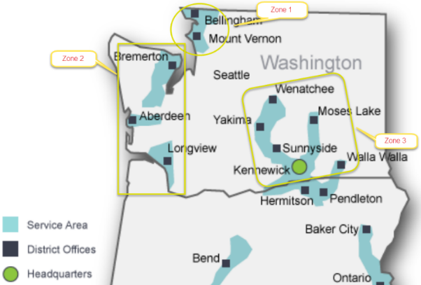

The Residential program inspections are performed through a combination of internal staff review and third party contracting through the Sustainable Living Center located out of Walla Walla, Washington. The Company covered more than 950 miles in 2018 to perform inspections in Zones 1 and 2 and committed more than $12,500 worth of funding to accommodate third party inspections in Zone 3. Table H provides a breakdown of the number of Residential inspections performed in 2018 per climate zone.

Table H: Residential Program 2018 Inspection Summary

Climate Zone | QC performed
Zone 1 | 22
Zone 2 | 6
Zone 3 | 96
Total | 124

All Commercial inspections are performed by the Company’s C/I vendor as part of their program delivery. The C/I inspection includes one of four elements - either a pre-installation, post-installation, study review, and/or general project review. The Reviewer verifies all measures listed on the application were installed, are operational, meet the program requirements, include start up reports and invoices, and often include photos of the installed equipment for verification and proof of install at qualifying locations. The reviewer then confirms his or her approval and signs and dates the form.

The Residential inspections are geared toward confirming submitted applications match installed measures and meet minimum efficiency requirements, that all pertinent health and safety requirements have been addressed, and that generally accepted industry best practices have been demonstrated. The inspector verifies efficiency of the equipment as well as the R-values and U-factors on weatherization projects to confirm deemed savings are viable for those projects. If an issue is noted as part of an inspection the customer and contractor are notified of the issue and in most cases given an opportunity to address and correct. Cascade also uses quality control inspections to confirm the quality of installations performed by Trade Ally contractors to the program as well as vet contractors seeking admittance.

Issues addressed as part of the inspection process in 2018:
- As indicated in Table H, Zone 3 (Cascade’s Washington service territory east of the Cascades) experienced more quality control inspections than the other two zones, exceeding the standard 5% inspection rate. This was a result of an assertive contractor working to weatherize a large number of homes. The Company implemented a quality control inspection process for projects submitted by this contractor to confirm all program requirements were met, which contributed to an increase in attic insulation and air sealing accomplishments during 2018. This accommodation required significant administrative time and assistance from the Company to support and maintain customer satisfaction.
- Builder outreach efforts continued during 2018, the number of projects and measures steadily increasing compared to previous annual accomplishments. The Company worked with a Heating, Ventilation, Air Conditioning (HVAC) sub-contractor to inspect natural gas appliances, in operation, prior to final sale at a large subdivision. Six (6) inspections were completed, all tankless water heaters and furnaces passed.
- The Company revised the Residential weatherization manual. The manual is distributed to all CNGC Trade Allies, with the intention of providing consistency across all service areas. The manual will also confirm uniformity between internal staff inspections, and any performed by a third-party.

Participation Summary

A full breakdown of therm savings, Utility Costs and Total Resource Costs by all measures and programs for the 2018 program year can be found within the following files filed in addition to this report with the commission:
- UG-152286, CNGC 2018 Conservation Annual Rpt WP-1, 5.31.19.xlsx - This first work paper provides the cost effectiveness calculations for the entire portfolio.
- UG-152286, CNGC 2018 Conservation Annual Rpt WP-2, 5.31.19.xlsx - This second work paper provides the cost effectiveness calculation for the Commercial program.
- UG-152286, CNGC 2018 Conservation Annual Rpt WP-3, 5.31.19.xlsx - This third work paper provides the cost effectiveness calculation for the Residential program.
- UG-152286, CNGC 2018 Conservation Annual Rpt WP-4, 5.31.19.xlsx - This fourth work paper provides the cost effectiveness calculation for the Low-Income Weatherization program.
- UG-152286, CNGC 2018 Conservation Annual Rpt WP-5, 5.31.19.xlsx - This attachment provides details about the Company’s 2018 NEEA efforts.

Updates to CY17 Program Achievements

No 2017 True-up is provided as no additional expenditures or rebates were submitted after the report was filed. This is due in large part to the Company reporting savings by paid versus install date.

Marketing and Outreach Report

Cascade performs outreach and marketing internally for the Residential and Low-Income programs and contracts with Lockheed Martin to perform outreach related to its C/I program.

One of the primary updates to program outreach involves the revisions to the website https://www.cngc.com/energy-efficiency/. Updates were intended to modernize, simplify, ease searchability and improve capability for a wider array of users.

Residential

The Residential program hosted a Radio Campaign in Zone 1 to promote its Trade Allies during the heating season (Fall 2018- Winter 2019) when customers experience cold weather and higher energy bills. The pilot used a donut ad format, housing consistent CNGC program information at the beginning and end of the ad throughout the all advertisements and featuring various Trade Allies and their offerings in the middle of the ad. The Company also continued to provide bonus coupons to its Trade Allies to drive high efficiency upgrades and tie customer benefits to actual installs.

Trade Ally Bonus Coupons | Sample Trade Ally Radio Ads
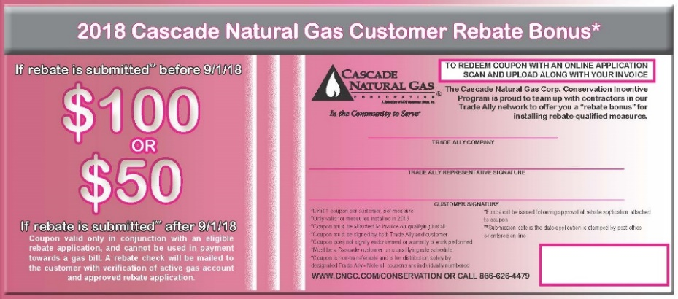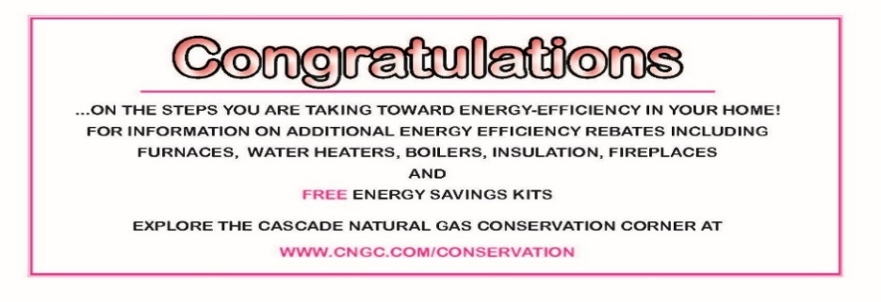 | marketing audio files\8794-Coast Insulation.mp3  marketing audio files\8504-CNGC Handys (2).mp3

Organizations frequently request EE presence at community events and exhibitions. These events provide an opportunity to tailor the message to the audience:

Bremerton Ice Cream Social Tabling
 |  | 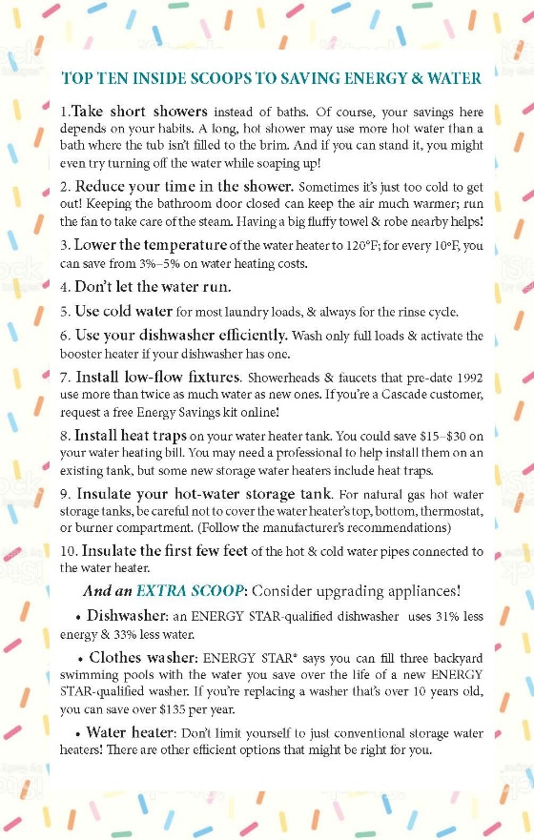
Energy Exchange Student Handout
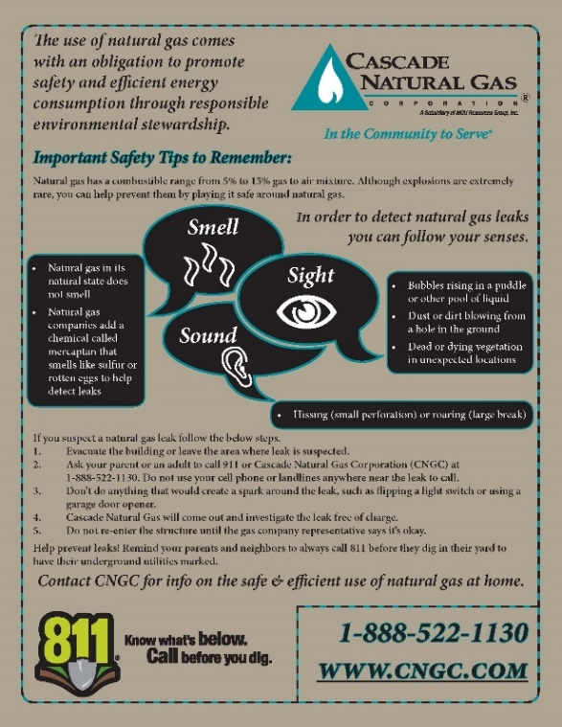 |  |  | 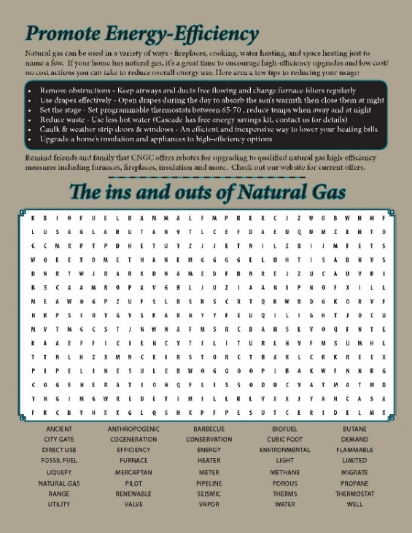
Baseball Outreach Campaign
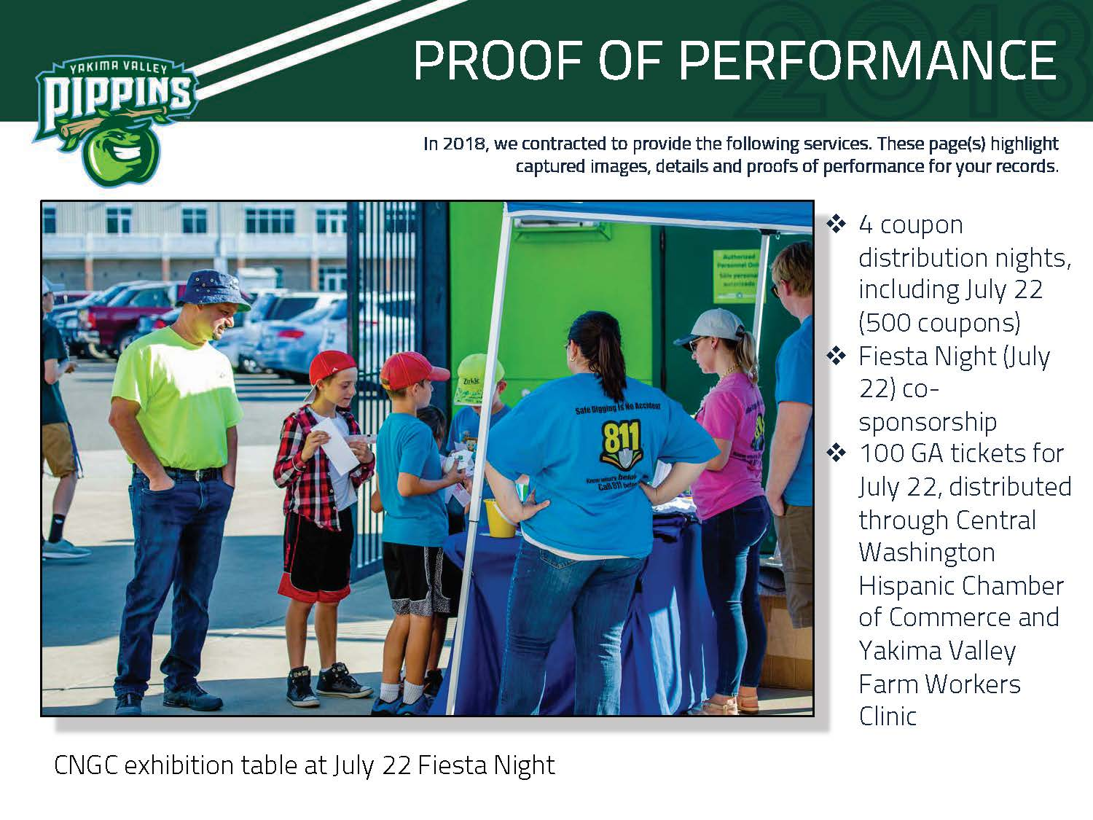  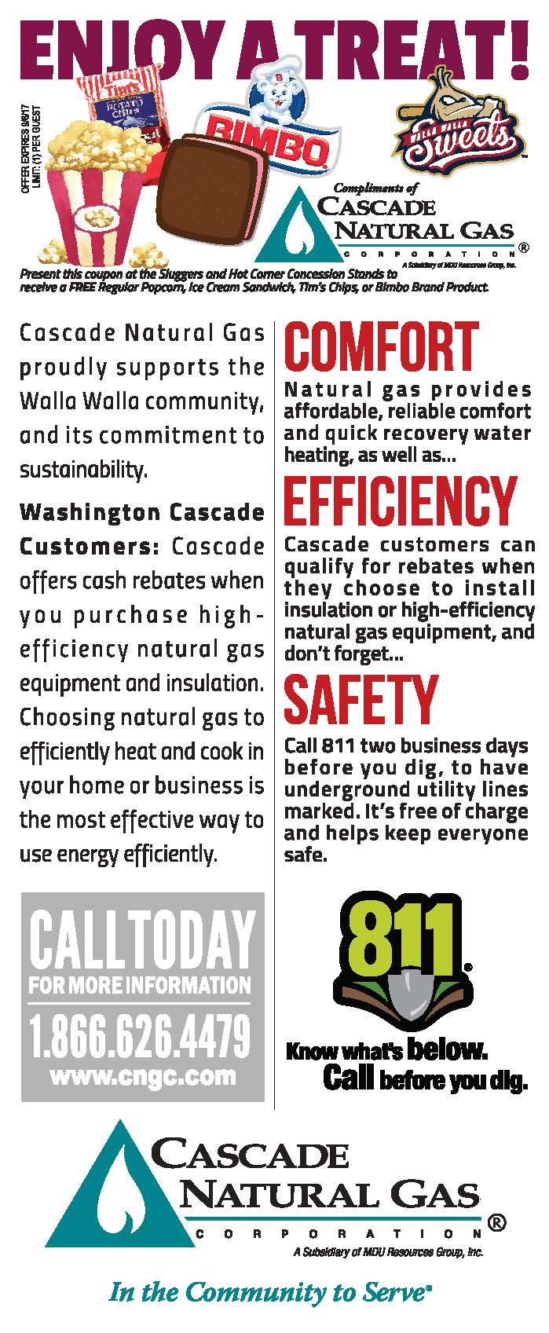 | 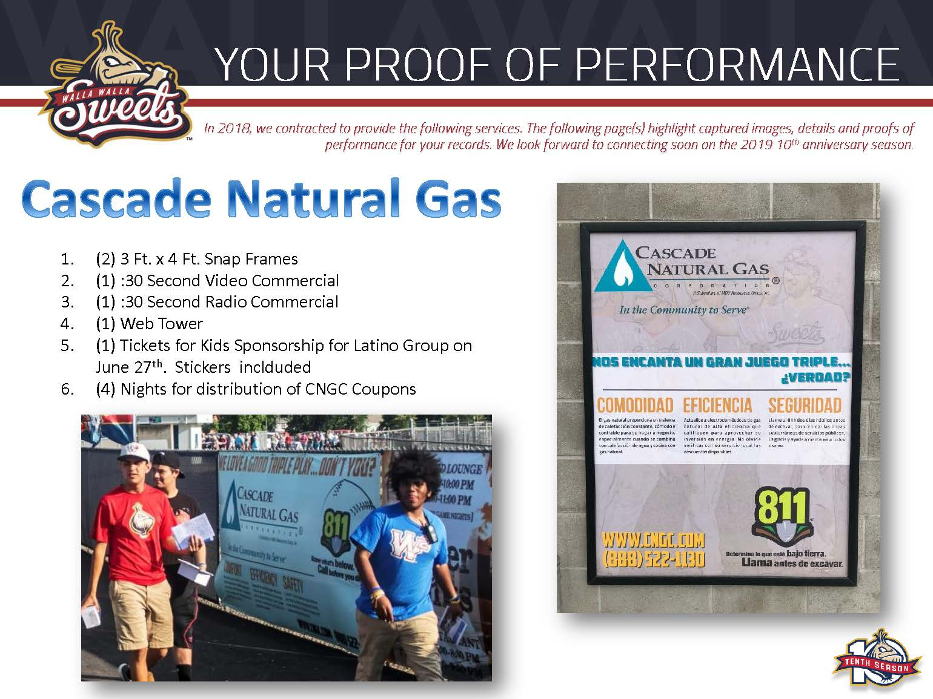  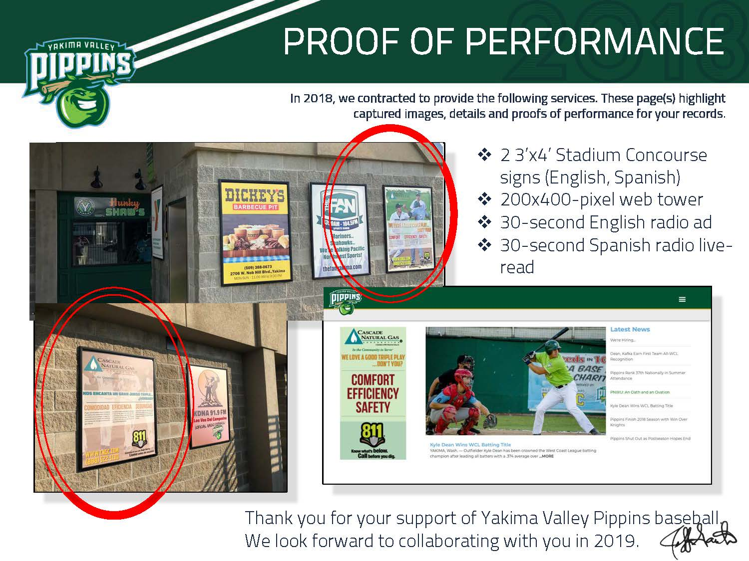  marketing audio files\Cascade Natural Gas 29158.mp3

The Company continues to leverage bill inserts as a messaging opportunity to its Residential, Low Income and C/I customer base.

2018 Bill insert samples
 | 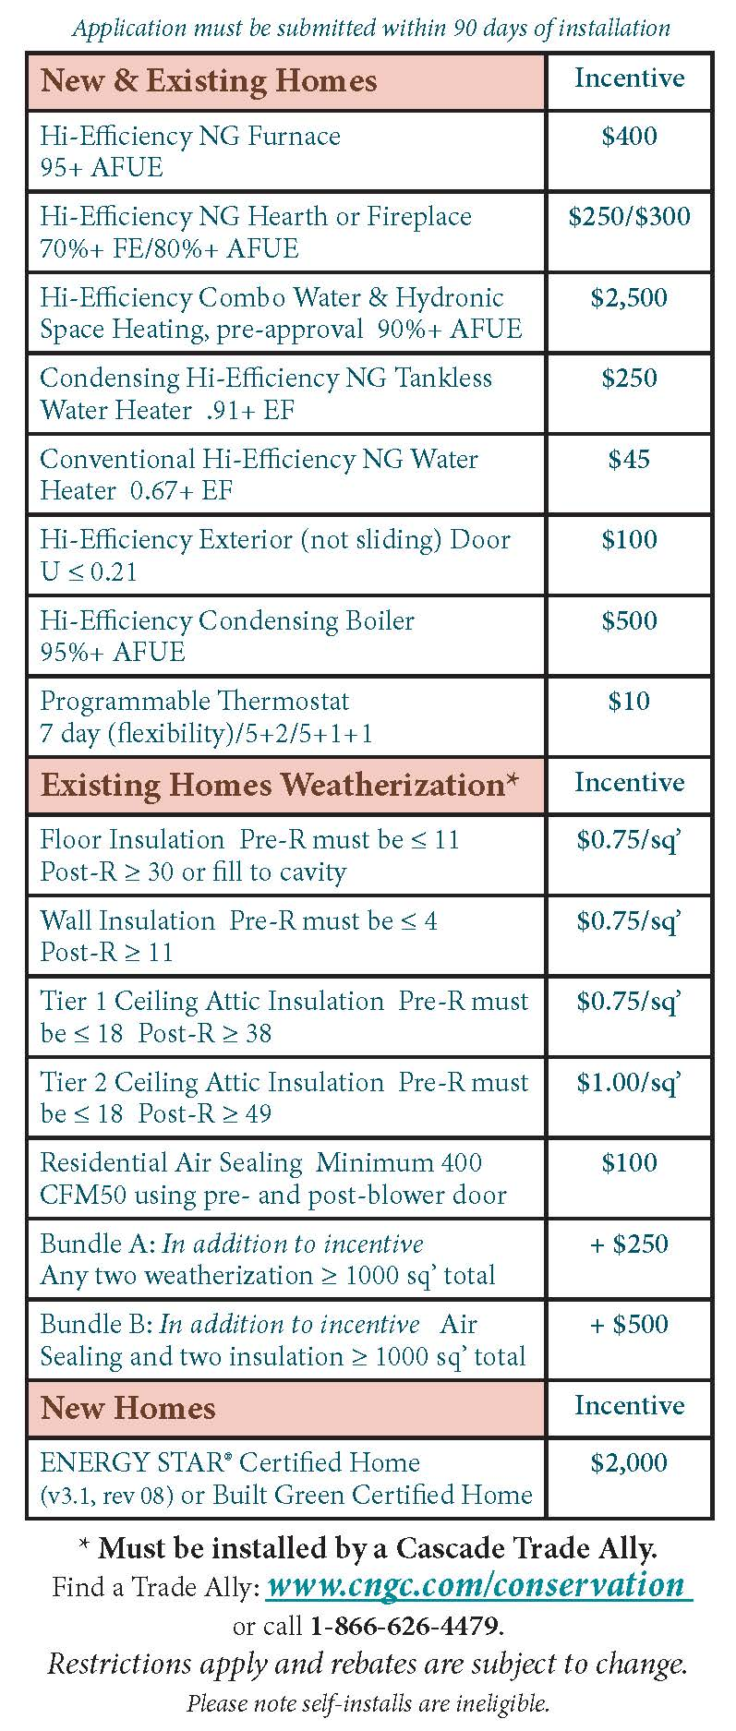
March 2018
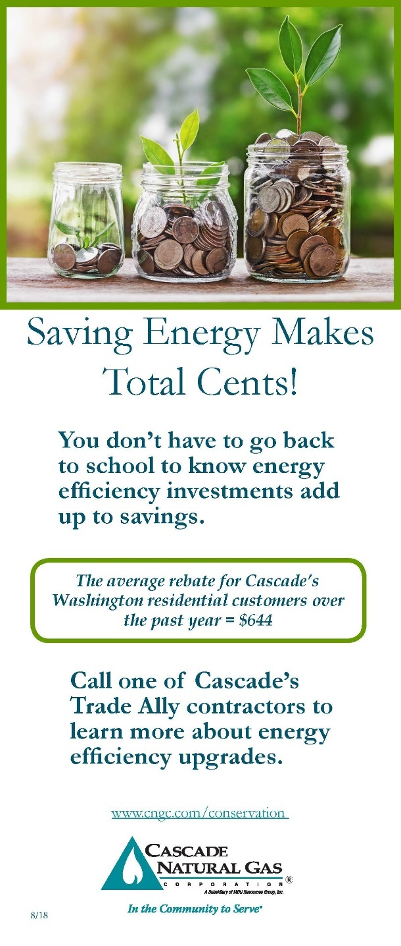 | 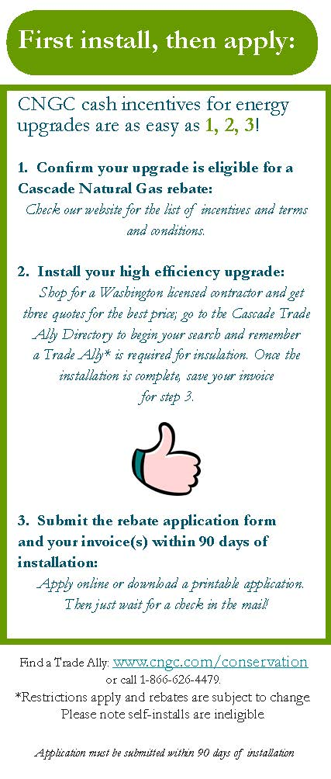
August 2018
 | 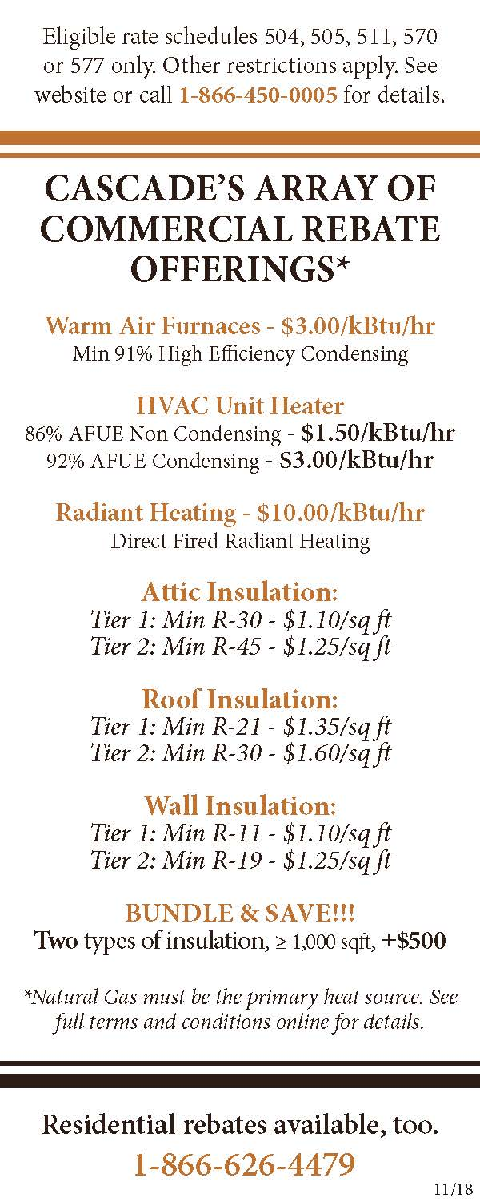
November & December 2018

Home Builders Associations throughout the service territory remain a key opportunity to provide messaging to builders and homeowners looking to purchase new or renovate old properties. Cascade provides messaging during Home and Garden Shows, Resource Directories and Home Tours.

Home and Garden Show & Directories

Home Tour
Yard Sign
Home Tour ad | In home signage

Commercial/Industrial

The Lockheed Martin (LM) Marketing team deployed numerous tactics in 2018 to drive program awareness and participation for C/I rebates. The integrated promotional campaigns used a variety of outreach channels including paid and earned media, email, direct mail, trade shows and events, photography, and collateral. Overall, the efforts aided in a substantial increase of web traffic which illustrates an increased awareness of program offerings. The website page for C/I Business corner represented a 53% increase of unique visits compared to 2017 and application had 75% increased views.

Advertising

LM developed a paid media plan and schedule that casts a broader reach to increase general awareness for the CNGC brand and C/I rebate program. To increase brand awareness in targeted locations, three billboards were placed in Longview, Bellingham and Yakima in January-February yielding 395,747 impressions. Other advertisements promoting customer success stories were placed and/or distributed in the following publications:
- Bellingham/Whatcom Chamber of Commerce
- Bellingham Business Journal
- Kitsap Peninsula Business Journal
- Tri-Cities Area of Business Journal
- Greater Yakima Chamber of Commerce
- Selah Chamber of Commerce

Google Ad Words
AdWords allowed CNGC to intercept customers during the research and discovery phase of their purchasing process. From June 1 to September 30 – the campaign achieved 7,318 impressions and 174 clicks. The cost of the campaign was $607.43 and the click-through rate (CTR) was 2.38%. The campaign was successful given the low-cost and increased web traffic.
Case Studies
Case studies are perceived as relatable, relevant and of high interest for learning how other customers have benefited from energy-efficiency improvements and the savings they have achieved. In 2018, the LM team produced the following case studies that were distributed via print and digital channels.
- Cap Santé Court Assisted Living – video, check presentation
- Megalodon Property Management – check presentation, photography, case study
- Shari’s Restaurants – print case study
The stories gained attention from several media outlets including:
- Energy Central Newsletter
- Bellingham/Whatcom Chamber website
- Goskagit.com
- Yakima Herald
Direct Mail
To support an uptick in targeted sectors, the team distributed several mail campaigns with specific case studies. The Cap Santé Case Study was mailed to assisted living/hospitality sectors and the Megalodon Property Management case study to large warehouses around the state. Both mailers supported the effort of promoting the program. The customer testimonials were used to highlight energy-efficiency and persuade end-users to make energy efficient choices at their business. Views to the website and case studies increased around the same time the mailers were distributed.
Email Blasts
Seven emails were sent in 2018 to Cascade customers and Trade Allies with Company service information, updated cash incentices, and customer stories. The emails had an average open rate of 28.7% and an average click rate of 2%.

Events
LM increased visibility for Cascade at industry-related events, regional events and trade shows. Program collateral was distributed at events, when applicable, and business development staff networked with attendees.

- ACEEE Hot Water Forum on March 20
- Tri-Cities Regional Chamber of Commerce event
- NW Industrial Energy Efficiency Summit on April 12
- NW Facilities Expo on April 18-19
- Spotlight on Skagit on April 19
- WA Hospitality Association on May 8
- Efficiency Exchange on May 15-16
- WHCA Annual Conference on May 22-23
- Energy Management Congress on June 20-21
- Kelso/Longview Chamber lunch on June 28
- Washington Energy Leadership Summit on October 30
- Washington Hospitality Association Conference
- The Trade Ally Workshop in Kennewick on October 25th.
Billboards
January 15- February 11, Yakima, Longview and Bellingham
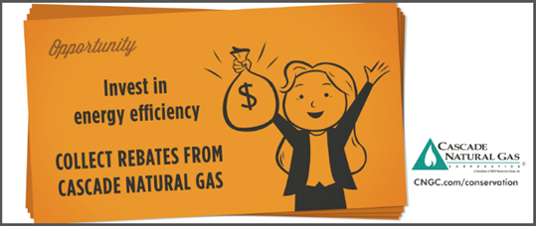
Commercial/Industrial Print Collateral

Created in April, mailed in May to 5,258 healthcare customers. (front)
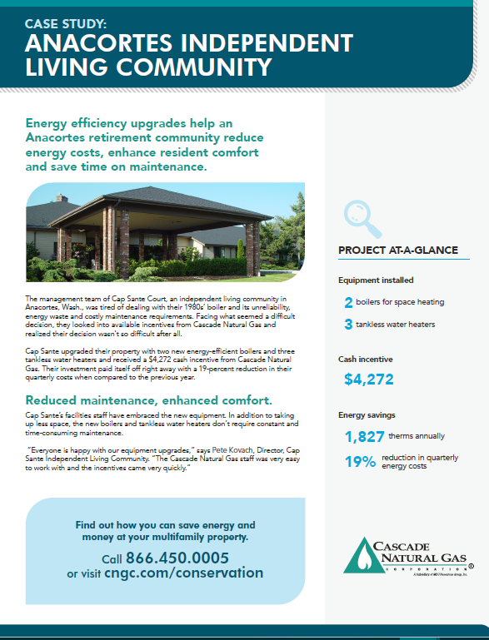

Created in April, mailed in May to 5,258 healthcare customers. (back)
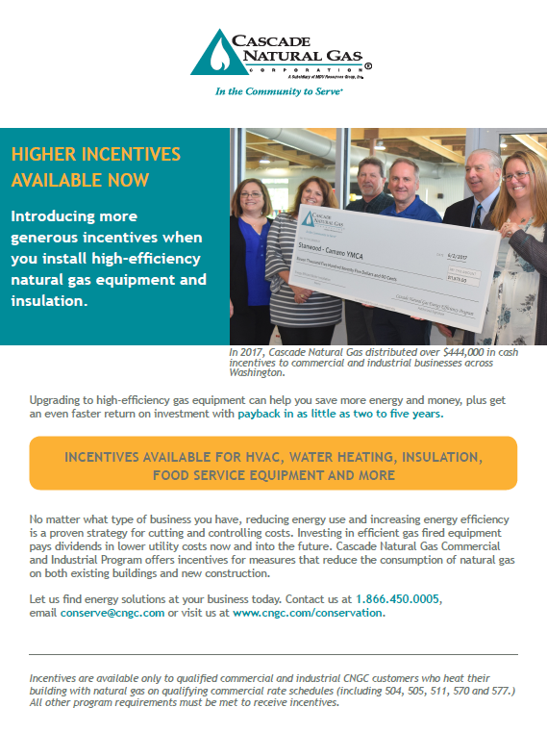

Foodservice flyer. June, mailed to small group of restaurants.
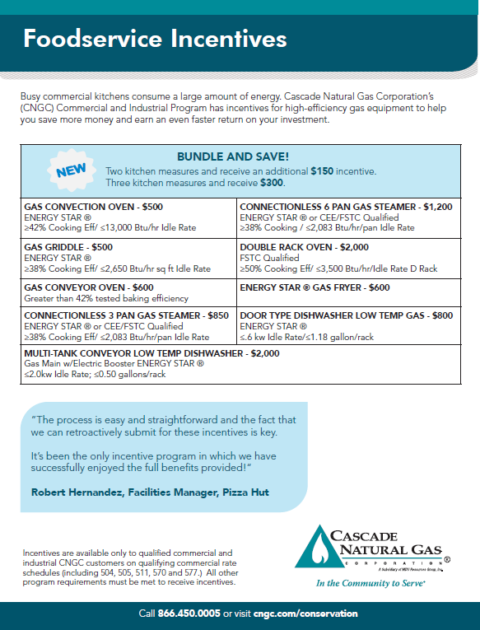

Megalodon Case Study. October, mailed to 4,000 large commercial customers.
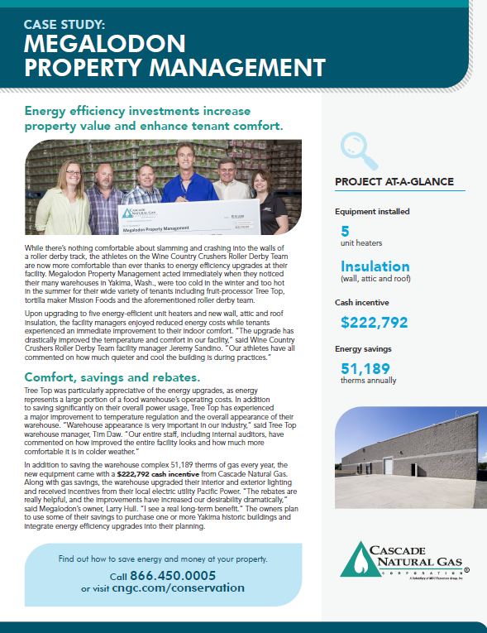

Shari’s Case Study. November, distributed by Businss Development team.
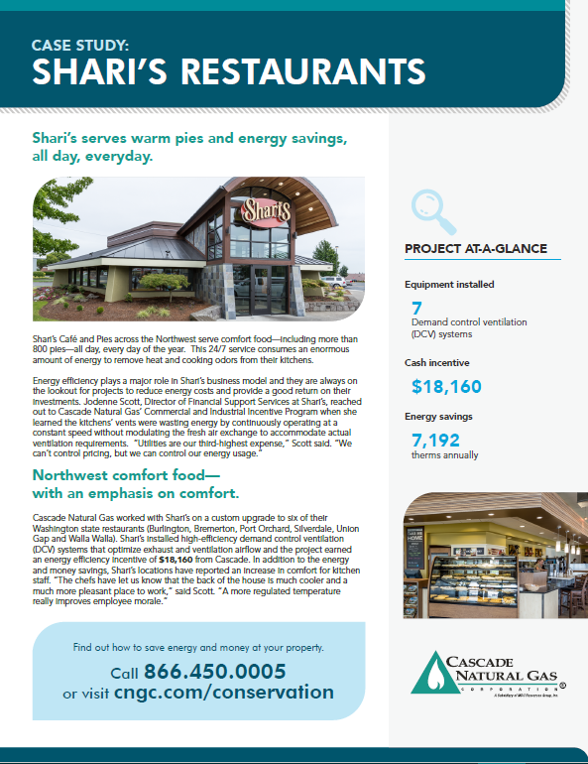

Email Blasts
Cap Santé email blast, April. | Insulation promotion, May.
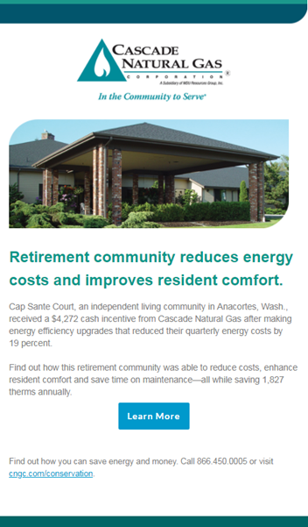 | 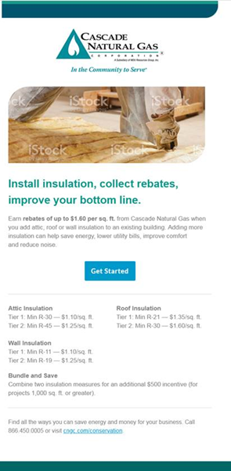

Cap Santé Video, June. | Megalodon case study, October.
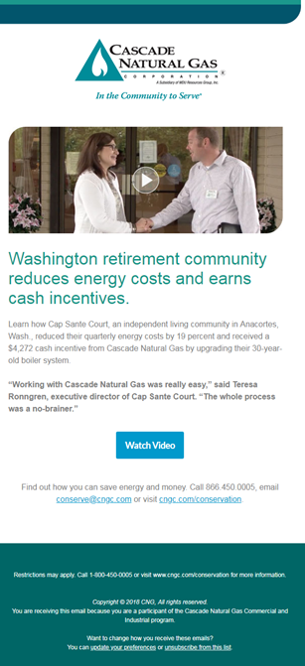 | 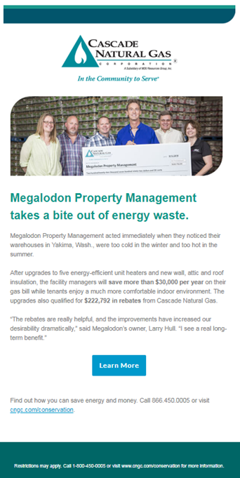

Shari’s Case Study, November.
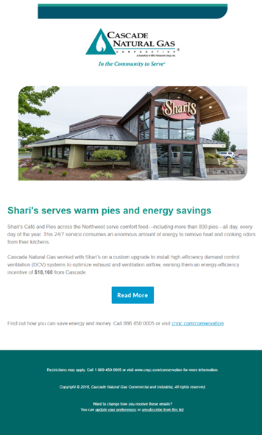

Advertisements
Bellingham Business Journal, July. (print) | Bellingham Business Journal, July. (online)
 | 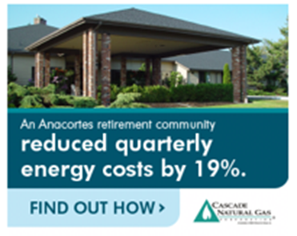
Tri Cities Business Journal, August. (print) | Washington State Fair Magazine, July. (print)

Tri Cities Business Journal, November. (Print) | Tri Cities Business Journal, December. (Print)
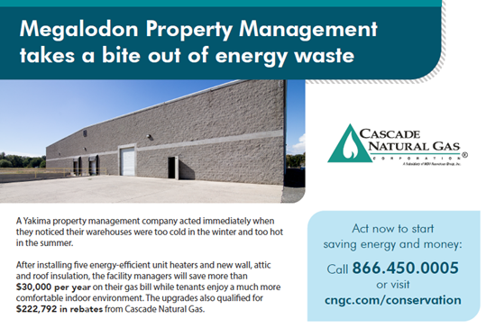 | 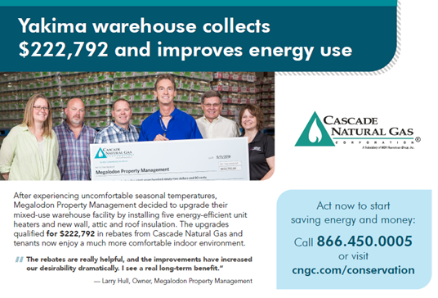
CleanTec Alliance Energy Leadership Summit.
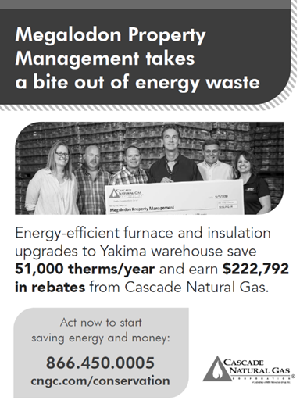

Applied Energy Group: 2017 Cascade Natural Gas Conservation Potential Assessment Volume 1, Final Report 04/16/18.
Calculations based on United States Environmental Protection Agency Greenhouse Gas Equivalencies Calculator - https://www.epa.gov/energy/greenhouse-gas-equivalencies-calculator
“Seventh Northwest Conservation and Electric Power Plan.” Northwest Power & Conservation Council, February 10, 2016. http://www.nwcouncil.org/energy/powerplan/7/plan/
“2017 Cascade Natural Gas Conservation Potential Assessment” AEG, Applied Energy Group, March 16, 2018.

