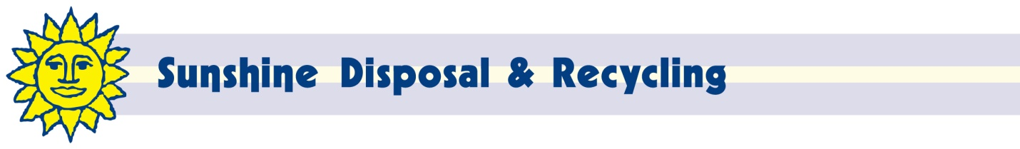

October 19, 2016
Steven V. King, Executive Director and Secretary
Washington Utilities and Transportation Commission
PO Box 47250
Olympia, WA 98504-4720

Dear Mr. King:

Enclosed is a proposed revision to Tariff 7 of Torre Refuse & Recycling d/b/a Sunshine Disposal & Recycling (G-260).

The purpose of this filing is to increase rates to cover higher disposal fees in Stevens County effective January 1, 2017 (notice enclosed). It also reflects the change in item 18 as we are now billing residential customers on a 3 month cycle.

If approved, this increase will increase rates approximately $47,000 or 1.3% annually.

Customers will be notified of the rate change on their next regular billing.

We request waiver from the requirements of WAC 480-07-520 due to the fact that this rate change only covers increases in disposal fees.

If I can be of any further assistance, please contact me at 509-924-5678 x217 or 509-252-3500 (fax) or at johnl@sunshinedisposal.com.

Respectfully,

John Lloyd
Chief Financial Officer

