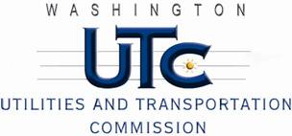

Memorandum
April 25, 2013

To: TR-130154 - File

From: Betty Young, Compliance Investigator, Transportation Safety

Subject: TR-130154 – Washington & Idaho Railway
Grade Crossing Protective Fund (GCPF) project to modify a railroad-highway grade crossing at Stadium Way in Pullman, USDOT # 066162L

On February 20, 2013, the Washington Utilities and Transportation Commission (Commission) awarded the Washington & Idaho Railway (WIR) a GCPF grant in the amount of $19,991.99 to modify and improve active warning devices at the Stadium Way crossing in Pullman. The USDOT is #066162L. The estimated project cost was $19,991.99 with WIR paying for all costs exceeding that amount.

On April 11, 2013, the WIR submitted a request for reimbursement for work pursuant to Commission order. Because the commission does not currently have its own signal inspector, Stan Versnick, a certified FRA signal inspector, conducted a site visit on April 16, 2013, and verified that the project was completed according to the specifications outlined in the order approving the grant.

Please close this docket.

