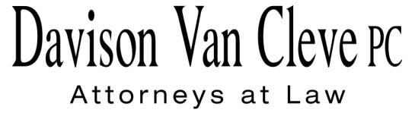
TEL (503) 241-7242 ● FAX (503) 241-8160 ● jog@dvclaw.com
Suite 400
333 S.W. Taylor
Portland, OR 97204

June 30, 2015

Via Electronic Mail

Mr. Steven V. King
Executive Director & Secretary
Washington Utilities & Transportation Commission
1300 S. Evergreen Pk. Dr. S.W.
P. O. Box 47250
Olympia, WA 98504-7250

Re: In the Matter of Pacific Power & Light Company
2015 Renewable Resources Report
Docket UE-151162

Dear Mr. King:

Enclosed for filing in the above-referenced docket, please find the Comments of Boise White Paper, L.L.C.

Thank you for your assistance. If you have any questions, please do not hesitate to call.

Sincerely,

/s/ Jesse O. Gorsuch
Jesse O. Gorsuch
Enclosure

