SECTION 9

DISTRIBUTION SYSTEM PLANNING

Overview

Cascade’s IRP includes the evaluation of safe, economical and reliable full-path delivery of natural gas from basin to the customer meter. Securing adequate natural gas supply and ensuring sufficient pipeline transportation capacity to Cascade’s city gates become secondary issues if distribution system growth behind the city gates becomes severely constrained. Important parts of the planning process include forecasting local demand growth, determining potential distribution system constraints, analyzing possible solutions and estimating costs for eliminating constraints.

Analyzing resource needs in the IRP is primarily focused on ensuring adequate upstream capacity to the city gates, especially during a peak event. Distribution planning focuses on determining if there will be adequate pressure during a peak hour. Despite this different perspective, distribution planning shares many of the same goals, objectives, risks and solutions as resource planning.

Cascade’s natural gas distribution system consists of approximately 4,744 miles of distribution main pipelines in Washington, and1,604 miles in Oregon; as well as numerous regulator stations, service distribution lines, monitoring and metering devices, and other equipment. Currently, there is a compressor station within Cascade’s distribution system near Fredonia, WA. The vast majority of the distribution network pipelines and regulating stations operate and maintain system pressure solely from the pressure provided by the interstate transportation pipelines.

Network Design Fundamentals

Gas distribution networks rely on pressure differentials to move gas from one place to another. If the pressure is exactly the same on both ends of a pipe, the gas will not flow. Therefore, it is important that gas engineers design the distribution network such that the pressure in the pipe will always be high enough that a differential can be created when gas leaves the system. As gas flow increases, pressure is lost due to friction. Using the laws of fluid mechanics, engineers determine the maximum flow of gas through a pipe of a certain diameter and length that will not cause pressure drops that are too great.

Not all natural gas flows equally throughout a network. Certain points within the network constrain flow and restrict overall network capacity. Network constraints can occur as demand requirements evolve. Anticipating these demand requirements, identifying potential constraints and forming cost-effective solutions with sufficient lead times without overbuilding infrastructure are the key challenges in network design. Figure 9-1 provides an example of a network diagram.

Figure 9-1: Network Design Fundamentals

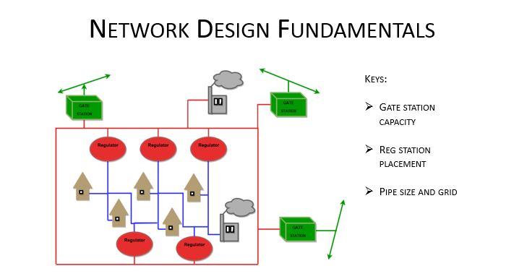

.Computer Modeling

Developing and maintaining effective network design is aided by computer modeling for network demand studies. Demand studies have evolved with technology in the past decade to become a highly technical and powerful means of analyzing distribution system performance. Utilizing computer software, individual models were created for each of Cascade's different systems. These models include both high-pressure lines and distribution system networks. As gas loads are simulated to increase according to the load forecasts, the pressures within each system are checked. When the simulation shows the pressure dropping to an unacceptable level, that system and the surrounding area is determined to be a constraint area. When constraint areas are found, the analyst determines the most effective way of solving the problem.

Cascade’s geographical information system (GIS) keeps an up to date record of pipe and facilities, complete with all system attributes such date of install and operation pressure. Using the internal GIS environment and other input data Cascade is able to create system models through the use of Synergi software. The software provides the means to theoretically model piping and facilities to represent current pressure and flow conditions while predicting future events and growth. Synergi is the successor to the GasWorks models that were built years ago and have been upgraded along the way as needed. Cascade’s philosophy is that every couple of years the models should be rebuilt and recalibrated to represent the system more accurately. Synergi is more advanced than GasWorks and much more user friendly. Synergi is also the modeling software of choice for many other LDCs.

Distribution System Planning

Many LDCs conduct two primary types of evaluations in their distribution system planning efforts to determine the need for resource additions, including distribution system reinforcements and expansions. Reinforcements are upgrades to existing infrastructure, or new system additions, which increase system capacity, reliability and safety. Expansions are new system additions to accommodate new demand. Collectively, these are distribution enhancements.

The engineering department works closely with engineering associates and district management to make sure the system stays safe and reliable. As towns develop, the need for pipeline extensions and reinforcements increases. The expansions are usually driven by new city developments or new housing plats. Before expansions and installation can be done to serve these new customers, engineering analysis should be done. Using system modeling software to represent cold weather scenarios, predictions can be made about the capacity of the system. As new groups of customers seek natural gas service, the models provide feedback on how best to serve them reliably.

Another aspect of system planning involves gate capacity analysis and forecasting. Over time each gate station will take on more and more demand and it is our goal to get out in front with predictions. The IRP growth data received, along with design day modeling allow for forecasting of necessary gate upgrades. SCADA technology utilized by Cascade allows us to verify our numbers with real time and historic gate flow and pressure data. The data proves very useful in verifying our models and forecasting our projects.

Distribution System Enhancements

Demand studies facilitate modeling multiple demand forecasting scenarios, constraint identification and corresponding optimum combinations of pipe modification, and pressure modification solutions to maintain adequate pressures throughout the network. Distribution system enhancements do not reduce demand nor do they create additional supply. Enhancements can increase the overall capacity of a distribution pipeline system while utilizing existing gate station supply points. The two broad categories of distribution enhancement solutions are pipelines and regulators.

Pipelines

Pipeline solutions consist of looping, upsizing and uprating. Pipeline looping is the most common method of increasing capacity in an existing distribution system. It involves constructing new pipe parallel to an existing pipeline that has, or may become, a constraint point. Constraint points inhibit flow capacities downstream of the constraint creating inadequate pressures during periods of high demand. When the parallel line connects to the system, this alternative path allows natural gas flow to bypass the original constraint and bolsters downstream pressures. Looping can also involve connecting previously unconnected mains. The feasibility of looping a pipeline depends upon the location where the pipeline will be constructed. Installing gas pipelines through private easements, residential areas, existing asphalt, and steep or rocky terrain can increase the cost to a point where alternative solutions are more cost effective.

Pipeline upsizing involves replacing existing pipe with a larger size pipe. The increased pipe capacity relative to surface area results in less friction, and therefore a lower pressure drop. This option is usually pursued when there is damaged pipe or where pipe integrity issues exist. If the existing pipe is otherwise in satisfactory condition, looping augments existing pipe, which remains in use.

Pipeline uprating increases the maximum allowable operating pressure of an existing pipeline. This enhancement can be a quick and relatively inexpensive method of increasing capacity in the existing distribution system before constructing more costly additional facilities. However, safety considerations and pipe regulations may prohibit the feasibility or lengthen the time before completion of this option. Also, increasing line pressure may produce leaks and other pipeline damage creating costly repairs. A thorough review is conducted to ensure pipeline integrity before pressure is increased. Figure 9-2 provides a snapshot of some the major components of the system.

Figure 9-2: Cascade System Pipeline Overview

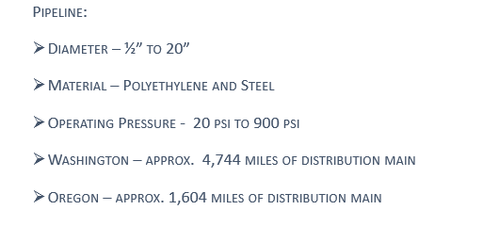

Regulators

Regulators, or regulator stations, reduce pipeline pressure at various stages in the distribution system. Regulation provides a specified and constant outlet pressure before natural gas continues its downstream travel to a city’s distribution system, customer’s property or natural gas appliance. Regulators also ensure that flow requirements are met at a desired pressure regardless of pressure fluctuations upstream of the regulator. Regulators are at city gate stations, district regulators stations, farm taps and customer services. Utilization and strategic positioning of new stations can be very helpful in increasing system reliability and capacity. Cascade has over 700 regulator stations along its’ system.

Compression

Compressor stations present a capacity enhancing option for pipelines with significant natural gas flow and the ability to operate at higher pressures. For pipelines experiencing a relatively high and constant flow of natural gas, a large volume compressor installation along the pipeline boosts downstream pressure.
A second option is the installation of smaller compressors located close together or strategically placed along a pipeline. Multiple compressors accommodate a large flow range and use smaller and very reliable compressors. These smaller compressor stations are well suited for areas where gas demand is growing at a relatively slow and steady pace, so that purchasing and installing these less expensive compressors over time allows a pipeline to serve growing customer demand into the future.

Compressors can be a cost effective option to resolving system constraints; however, regulatory and environmental approvals to install a station, along with engineering and construction time can be a significant deterrent. Adding compressor stations typically involves considerable capital expenditure. Based on Cascade’s detailed knowledge of the distribution system, there are no foreseeable plans to add compressors to the distribution network.

Conservation Resources

Equally important is to review the impacts of proposed conservation resources on anticipated distribution constraints. Although the Company historically provides utility sponsored conservation programs throughout a particular jurisdiction (i.e. all of Washington or all of Oregon), there may be instances where a more targeted approach could reduce or delay the estimated reinforcement for a specific area. However, as will be discussed in Section 5, the acquisition of conservation resources is entirely dependent upon the individual consumers’ day-to-day purchasing and behavior decisions. Although the utility attempts to influence these decisions through its conservation programs, the consumer is still the ultimate decision maker regarding the purchase of a conservation measure. Therefore, the Company does not anticipate that the peak day load reductions resulting from incremental conservation will be adequate enough to eliminate distribution system constraint areas at this time. However, over the longer term, (the 2015 through 2025 timeframe) the opportunity for targeted conservation programs to provide a cumulative benefit that offsets potential constraint areas may be an effective strategy.

Distribution Scenario Decision-Making Process

After achieving a working load study, analyses are performed on every system at design day conditions to identify areas where potential outages may occur. These areas of concern are then risk ranked against each other to ensure the highest risk areas are corrected first. Within a given area, projects/reinforcements are selected using the following criteria:

- The shortest segment(s) of pipe that improves the deficient part of the distribution system.
- The segment of pipe with the most favorable construction conditions, such as ease of access or rights or traffic issues.
- Minimal to no water, railroad, major highway crossings, etc.
- The segment of pipe that minimizes environmental concerns including minimal to no wetland involvement, and the minimization of impacts to local communities and neighborhoods.
- The segment of pipe that provides opportunity to add additional customers.
- Total construction costs including restoration.

Once a project/reinforcement is identified, the design engineer or construction project coordinator (CPC) begins a more thorough investigation by surveying the route and filing for permits. This process may uncover additional impacts such as moratoriums on road excavation, underground hazards, discontent among landowners, etc., resulting in another iteration of the above project/reinforcement selection criteria. Figure 9-3 provides a schematic representation of the distribution scenario process.

Figure 9-3: Distribution Scenario Process

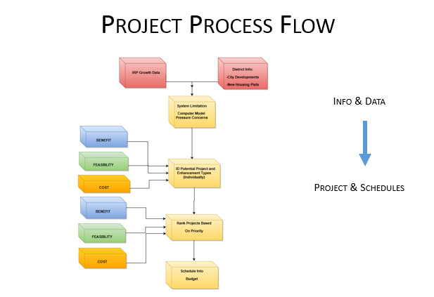

Planning Results

Table 9-1 summarizes the cost and timing of major distribution system enhancements addressing growth-related system constraints, system integrity issues and the timing of expenditures. These projects are preliminary estimates of timing and costs of major reinforcement solutions. The scope and needs of distribution system enhancement projects generally evolve with new information requiring ongoing reassessment. Actual solutions may differ due to differences in actual growth patterns and/or construction conditions that differ from the initial assessment.

The following discussion provides information about key near-term projects.

- Stanwood 4” PE Reinforcement: This intermediate pressure reinforcement will create another connection to the eastside of the system at the north end. The growth has been seen in this area to the north and the west and this will provide the necessary capacity for continued growth. The project consists of about 1550’ of 4” PE. The project cost is $116,130 and it will be completed in 2017.

- Manchester 4” PE Reinforcement: This intermediate pressure reinforcement will help provide capacity to the end of the system, while also improving the system and allowing for growth to the north and south. The project will consist of 5,100’ feet of 4” PE. The project will take place in 2018 and will cost $245,870.

- South Walla Walla Gate and HP Line: The new gate station and high pressure pipeline in these projects will provide gas service to customers south of Walla Walla, Washington. The current distribution system has very limited capacity south of Walla Walla and flow modeling shoes that it will not be able to serve the areas experiencing growth. Gate station is estimated to cost $3,106,259 and pipeline is estimated to cost $2,174,381. Construction is anticipated for 2018 and 2019.

Figure 9-1: Distribution Planning Capital Projects

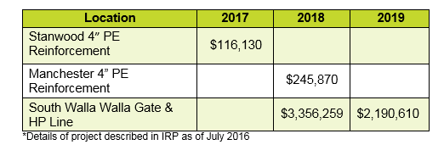

Conclusion

Cascade’s goal is to maintain its natural gas distribution systems reliably and cost effectively to deliver natural gas to every customer. This goal relies on modeling to increase the capacity and reliability of the distribution system by identifying specific areas that may require changes. The ability to meet the goal of reliable and cost effective natural gas delivery is enhanced through localized distribution planning, which enables coordinated targeting of distribution projects responsive to customer growth pattern.

