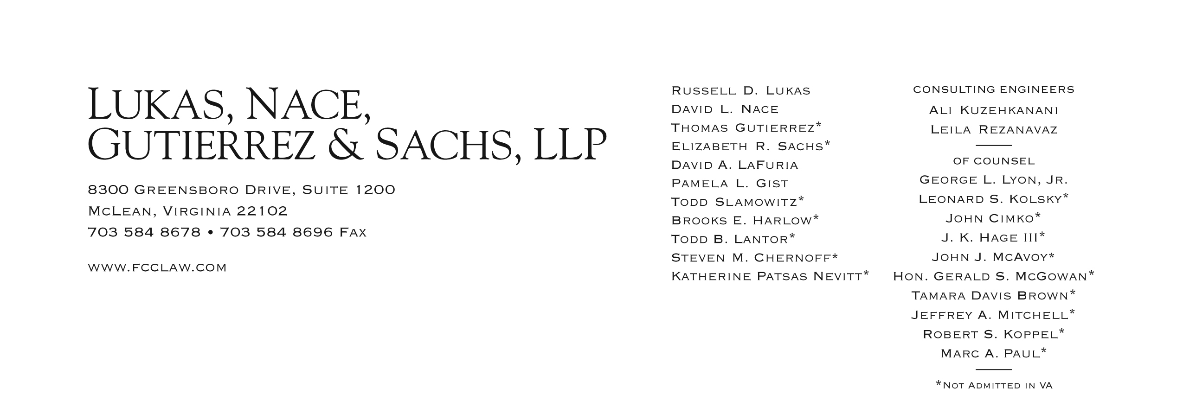

Brooks E. Harlow
703-584-8680
bharlow@fcclaw.com
January 26, 2012
BY WEB PORTAL & Federal Express
David W. Danner
Executive Director and Secretary
Washington Utilities and Transportation Commission
1300 S. Evergreen Park Drive S.W.
Post Office Box 47250
Olympia, Washington 98504-7250
In re: Application of Shuttle Express, Inc;
Excalibur Limousine, LLC d/b/a Seattle Green Limo; and
Pacific Northwest Transportation Services, Inc. d/b/a Capital Aeroporter,
For Permanent Auto Transportation Authority.
Docket No. TC-111446, 111643, 111619, Consolidated

Dear Mr. Danner:
Enclosed, for filing, are the original and four copies of the Witness and Exhibits List for Shuttle Express, Inc. for the January 30, 2012, hearing in the above-mentioned dockets.
If you have any questions, please do not hesitate to contact the undersigned.
Very truly yours,
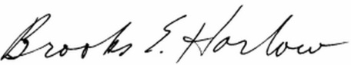
Brooks E. Harlow, P.C.
Enclosures

cc: ALJ Martin Lovinger
Excalibur Limousine, LLC
Capital Aeroporter
Commission Staff

