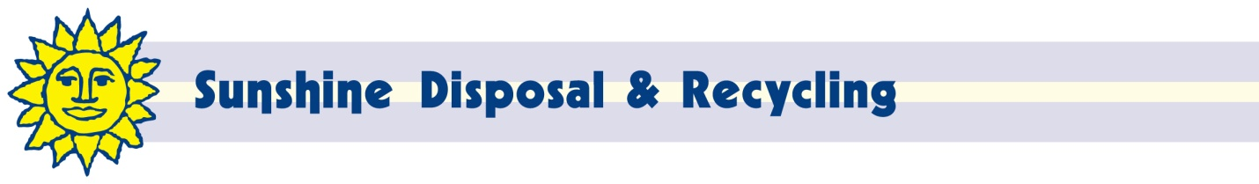

April 12, 2017
Steven V. King, Executive Director and Secretary
Washington Utilities and Transportation Commission
PO Box 47250
Olympia, WA 98504-4720

Re: Docket TG-170248

Dear Mr. King:

Enclosed is a proposed revision to the above named Docket for Tariff 10.1 of Ada-Lin Waste Systems, Inc, d/b/a Sunshine Disposal & Recycling (G-104).

This change adds the correct symbol to Item 230.

If I can be of any further assistance, please contact me at 509-924-5678 x217 or 509-252-3500 (fax) or at johnl@sunshinedisposal.com.

Respectfully,

John Lloyd
Chief Financial Officer

