SECTION 1

EXECUTIVE SUMMARY

Purpose

The primary purpose of Cascade’s long-term resource planning process has been and continues to be to inform and guide the Company’s resource acquisition process consistent with state regulatory requirements.
Key Points
- Cascade’s first resource deficiency is in 2017 with the need for incremental transportation in 2020. This is based on SENDOUT® modeling.
- The Company’s two-year action plan provides the road map for implementation.
- Load growth is forecasted to be 1.25% per year, or 26% over the 20-year planning horizon.
- Avoided costs range from approximately $.5041/therm to approximately $.6659/therm, beginning with a $10/ton carbon cost adder and rising to $30/ton.
- Part of future resources are projected to include 1.7 million therms of energy efficiency over the next two years.
- Future pipeline infrastructure needs will focus on three major enhancement projects over the next three years.
- This Plan was informed by six Technical Advisory Group meetings with active engagement from stakeholders.
- Cascade has fully committed to the IRP process with significant new administrative approaches.
- Each section provides an “at-a-glance” view by inclusion of “Key Points.”
Cascade’s resource planning focuses on ensuring that the Company meets the needs of firm gas sales customers in a way that minimizes costs over the long term. Although some pipeline citygates indicate potential shortfalls, in aggregate, through 2019, Cascade has sufficient upstream pipeline capacity. However, looking past the 2019-2020 winter heating season, Cascade’s capacity will fall short of its design peak day demand forecast primarily as a result of growth in its residential and commercial customer base. As a result, the Company is entering a period where Cascade will need to acquire additional resources to meet the growing needs of the Company’s core customers. This Executive Summary provides a broad overview of the planning process and summarizes key findings from this Plan.

IRP Process and Stakeholder Involvement

Cascade’s long-term resource planning process is consistent with the Integrated Resource Plan (IRP) rule requirements found in Washington Administrative Code (WAC) 480-90-238. Input and feedback from the Company’s Technical Advisory Group (TAG) is an important resource to help ensure that Cascade’s IRP is developed from a broader perspective than Cascade could have done on its own. Historically, participants at these public meetings have included interested customers, regional pipelines, local distribution companies (LDCs), Commission Staff, and stakeholder representatives such as the Northwest Gas Association (NWGA), Citizens Utility Board of Oregon (CUB), Washington Public Counsel, and the Northwest Industrial Gas Users (NWIGU). Cascade held six public TAG meetings with engaged stakeholders. Additionally, throughout the plan development stage, Cascade provided supplemental workshops at the request of WUTC Staff to cover Cascade’s forecasting methodology in greater detail as well as to provide a more detailed overview of the Company’s Gas Supply function.

See Section 10, Stakeholder Engagement, for a more detailed description of the list of stakeholders and specific information about the TAG meetings.

Responding to the 2014 IRP Issues
In response to the issues identified with the 2014 IRP, Cascade has strengthened its commitment to securing and supporting the appropriate internal and external resources necessary to work with all stakeholders to produce a 2016 IRP that meets all regulatory requirements. Part of the Company’s commitment to the IRP includes hiring two additional resource planning analysts and an independent IRP consultant. Based on this commitment, Cascade has hired one resource planning analyst, is actively pursuing the second hiring, and contracted with a consultant during the 2016 IRP process. Additionally, an IRP Steering Committee consisting of various members of Cascade’s senior management was formed to improve management oversight of the entire IRP process.
In WUTC’s April 14, 2016, letter to the Company, the WUTC identified a number of issues concerning Cascade’s 2014 Integrated Resource Plan. These issues are described below, along with Cascade’s response to resolving the concerns.

- The lack of clear explanation of the timing of resource needs and how capacity deficits at specific citygates would be met [WAC 480-90-238(3)(g)]

  - Cascade worked with stakeholders to clearly identify by TAG 6 the specific timing, potential exceptions, and method of dealing with upstream pipeline capacity deficits at demand areas. Table 8-4 in Section 8, Resource Integration, states planned major actions by year to address shortfalls. Additionally, Appendix F, Capacity Requirements & Peak Day Planning, provides graphs showing the expected resource stack for each of the 65 citygates.

- The lack of detailed load forecast information by class and state [WAC 480-90-238 (3)(a)]

  - The Company provides a detailed description regarding the development of the load forecast by class and state in Section 3, Demand Forecast. Additionally, each individual citygate/load center’s forecast demand is displayed by rate class in Appendix B, Demand Forecast.

- Insufficient analysis and explanation of conservation potential [WAC 480-90-238 (3)(b)]

  - Cascade worked with stakeholders during TAG 3 to identify Staff’s specific concerns regarding the insufficient analysis and explanation of conservation potential. The Company believes the discussion in Section 7, Demand Side Management, provides the required analysis and explanation of conservation potential.

- The lack of a description of the Company’s stakeholder engagement process [WAC-480-90-238(5)]

  - The 2016 IRP provides an improved description of the stakeholder participation process with the inclusion of TAG meeting presentations, minutes and responses to stakeholder comments. Section 10, Stakeholder Engagement, describes the public participation approach, list of stakeholders, number and dates of the various TAG meetings. Additionally, copies of all TAG presentation materials and minutes are provided in Appendix A, IRP Process. Lastly, to improve the public’s access to IRP related information, Cascade recently established a dedicated Internet webpage where all parties can view the IRP timeline, TAG presentations and minutes, as well as current and past IRPs.

- Unclear explanation of the Company’s risk management rationale and hedging strategy [WAC 480-90-238(3) (f)].

  - Cascade is currently participating in the WUTC’s hedging Docket UG-132019. Throughout this process, the Company has provided comments and explanations of its risk management efforts. Cascade will continue to participate in Docket UG-132019. A more robust explanation of the Company’s risk management and hedging strategy is provided in Section 4, Supply Side Resources.

- In addition to the above-listed rule requirements, the Commission also identified a general lack of organization and presentation that made the Plan difficult to read and understand.

  - Cascade provided a draft version of the expanded IRP Table of Contents for WUTC Staff’s review in September 2016. This expanded table of contents reflected more discussion items and provided more detail regarding the organizational structure of the components of the 2016 IRP. This table of contents was discussed with stakeholders at TAG 4. Additionally, Cascade obtained the services of an independent IRP consulting firm, Bruce W Folsom Consulting LLC, to provide recommendations that have been incorporated to improve Cascade’s IRP.

Highlights from Each Section

Demand Forecast
The Cascade demand forecast developed for the IRP is a forecast of customers, core natural gas demand, and core peak demand for the next 20 years. Cascade’s core load consists of approximately 53% residential and 47% commercial and industrial for the first year 2017 projection. Cascade utilizes seven weather locations, effectively covering the entire service territory. Figure 1-1 breaks out the percentage of 2017 forecast load by class. Figure 1-2 provides this breakout for Washington.

Figure 1-1: 2017 System Forecast Load Breakout by Class

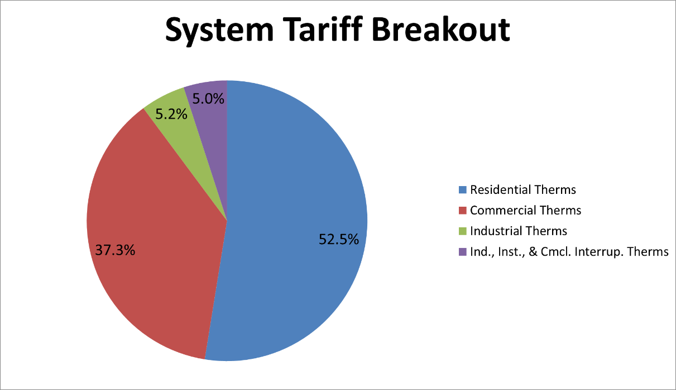

Figure 1-2: 2017 Washington Forecast Load Breakout by Class

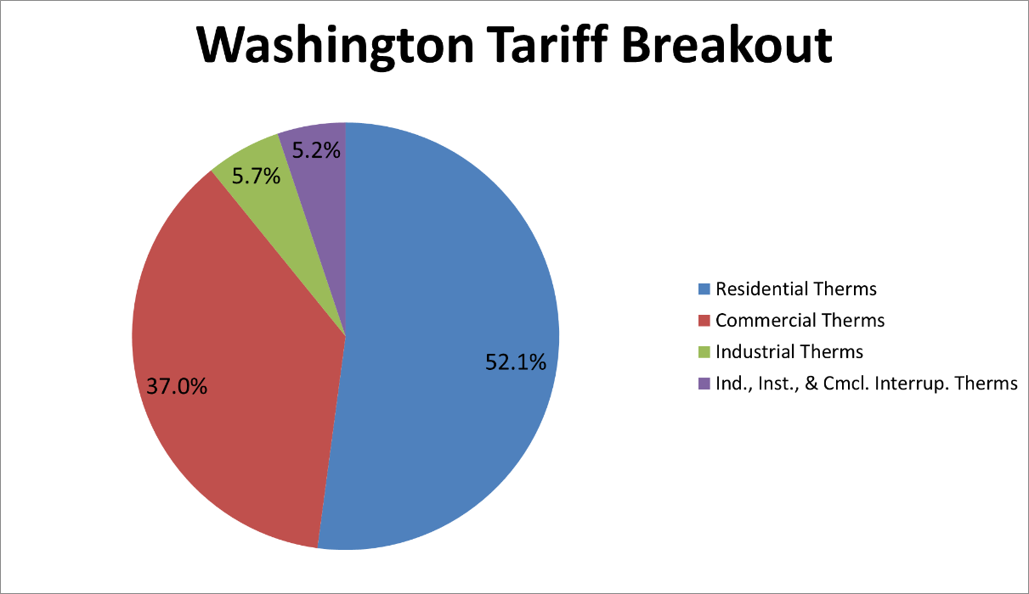

Cascade’s demand is weather and customer driven; the colder the weather or greater the customer count, the greater the demand. This current forecast uses 30 years of recent weather history as the “normal” or expected weather. It is forecasted under various weather and growth scenarios – expected annual weather, cold annual weather, warm annual weather, extreme cold day, high growth, low growth, etc. Cascade performed analysis on weather and demand for each of 65 citygates that serve core customers. Growth factors are applied to each of the 20 years in the forecast for each citygate. Since Cascade has observed that heating demand does not appreciatively start until average temperatures dip below 60 °F, a 60 °F threshold is used to calculate Heating Degree Days (HDDs).

Cascade has a portion of its load that is non-weather dependent. This is typically caused by a non-residential customer who ramps up production based on the time of season. This demand is removed prior to running the demand versus weather analysis. After the HDD and customer forecast are input into the regression to produce a usage forecast, the non-weather dependent demand is added back to reflect actual usage.

Cascade anticipates core customer base will continue growing over the planning horizon and annual throughput is anticipated to increase between 1.1% and 1.3% per year. Figure 1-3 displays the annual forecasted therms over the planning horizon.

Figure 1-3: Annual Load Forecast for 20-Year Planning Horizon
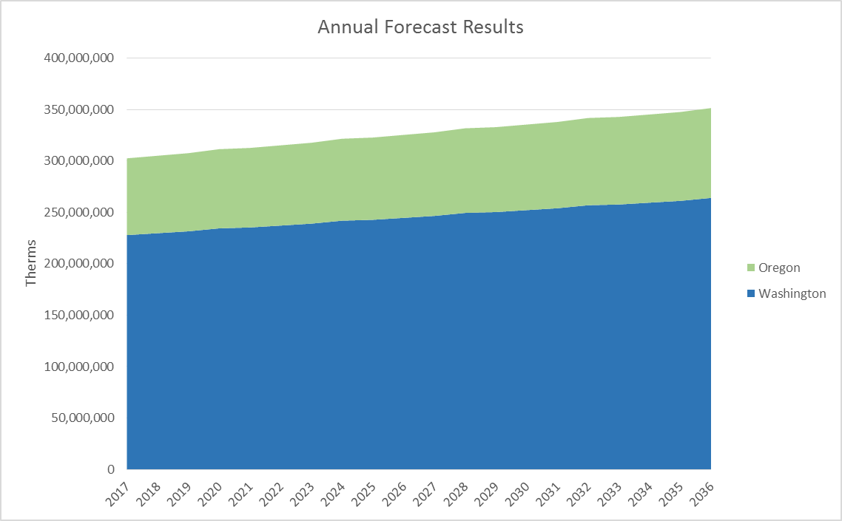

Figure 1-4: Western U.S. and Canadian Pipeline Map
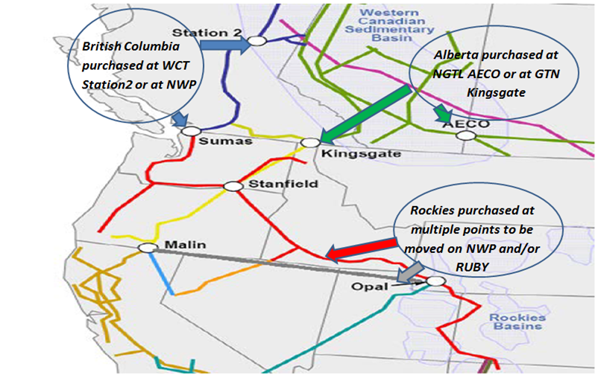
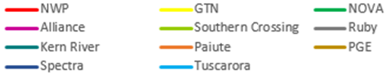
Figure 1-4 displays general flow paths for the regional supply basins. A larger map of Figure 1-4 is also provided in Section 13, Glossary and Maps, with Figure 13-12. Physical gas supply is expected to be more than sufficient to meet growing demand in the Pacific Northwest and North America. New supply development technologies continue to provide additional resources in British Columbia and the Rocky Mountain regions. Shale gas from the Horn River Basin, Montney and Marcellus is likely to keep sufficient supplies available in North America. Looking ahead, Cascade anticipates that Rockies production will slightly decline. However, some industry experts, such as Wood Mackenzie, believe that Liquefied Natural Gas (LNG) will flow from BC in the early 2020s. The market could see AECO prices begin to rise relative to Rockies if LNG exports from the Canadian west coast pulls supplies away from AECO. Figure 1-5 shows the Canadian demand growth that demonstrates the increase in LNG export growth.

Figure 1-5: Canadian Demand Showing LNG Export Growth
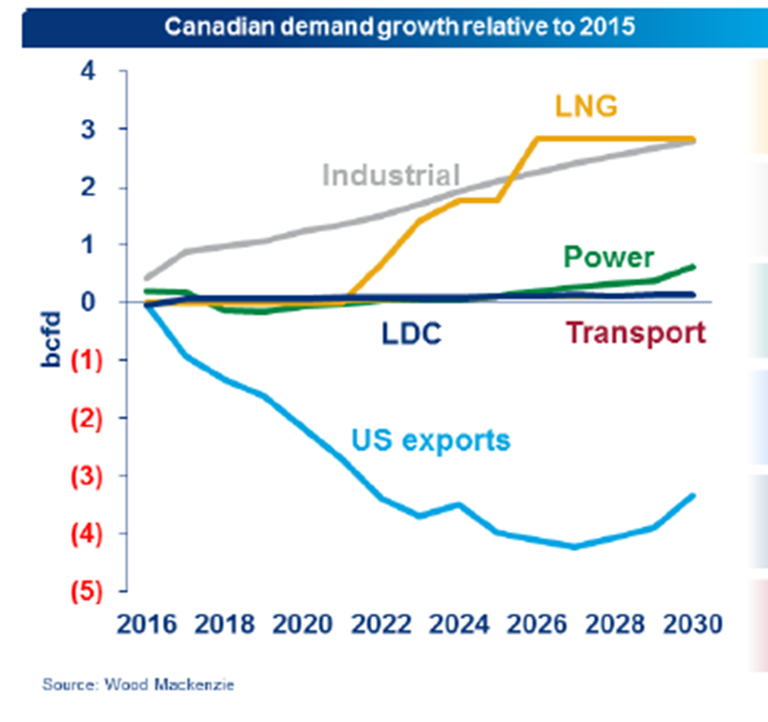

Experts predict U.S. production is expected to be over 90 Bcf/d in 2020 and over 110 Bcf/d in 2030 with larger amounts of low-cost gas in the Marcellus basin. Production growth in Western Canada is flat and low prices will ultimately reduce any long-term production expectations. U.S. demand is expected to exceed 90 Bcf/d in 2020 and 115 Bcf/d by 2030, about 7-10% higher than expected in the Company’s 2012 IRP. Low long-term prices will likely encourage new gas-intensive industrial projects. Power-sector consumption strengthens as coal displacement continues. U.S. and Canadian LNG exports are likely to ramp up by 2022. Several projects utilizing Canadian resources continue to emerge in the U.S. Pacific NW and British Columbia; although it is likely few, if any, will make it to service due to a combination of financial, regulatory, and regional environmental concerns. Mexico's power sector is expected to continue to grow as new gas-fired power plants are built and existing fuel-oil plants are converted to burn gas.

Cascade has considered bio-natural gas (BNG) as an alternative, but as of this writing there are no viable projects available to serve Cascade’s core customers. Regardless, prior to any BNG supplies being added to the portfolio, gas quality issues will need to be satisfactorily addressed. In addition to Cascade, upstream pipelines, such as Northwest Pipeline are beginning to address gas quality issues regarding BNG. Cascade will continue to monitor market intelligence sources to see if viable BNG opportunities develop.

The projected costs for natural gas have declined significantly in recent years. Long-term prices are estimated to range from $2.50 to $5 over the planning horizon compared to the $8 to $13 forecasted in the 2008 IRP.

Environmental Considerations
Cascade’s 2016 Integrated Resource Plan includes an expanded discussion regarding environmental considerations compared to prior plans. The purpose of these considerations is to support policies that cost-effectively achieve state and federal carbon emission reduction targets. Included in the discussion are Cascade’s carbon methodology and assumptions for calculating inputs towards a 20-year avoided cost of natural gas with an associated two-year action items.

Federal, Washington, and Oregon agencies are proposing a series of regulations and policies to address greenhouse gas (GHG) emissions with carbon dioxide CO₂ being their primary component. While focused on the Pacific Northwest electric industry, the Northwest Power and Conservation Council (NPCC or Council) exhaustively examines CO₂ in its Seventh Power Plan (Plan) released in May 2016. This Plan builds on the Council’s previous work and has become the recognized standard for carbon analyses. Cascade’s work on its IRP is best informed by the Council’s survey of approaches, sensitivity analyses, and scenarios, with attention to Cascade’s customers regarding cost-effectiveness and the results of other local distribution companies (LDC). Cascade is addressing CO₂ by promoting energy efficiency, encouraging of the direct use of natural gas, recapturing methane, and preventing gas leaks. Regarding expectations, there is less of an impact on customers as compared to the electric utility industry.

Thus the question is not whether carbon adders should be included in Washington and Oregon but, rather, how and in what amount. Of the eight approaches NPCC examined, virtually all LDCs and electric utilities—as well as the Council—have centered on the Carbon Cost Risk approach. This results in a $10/ton carbon cost adder to Cascade’s avoided costs (via the 20-year price forecast) in 2018, and $30/ton in 2035.

A more detailed discussion regarding carbon assumptions for this IRP can be found in Section 5, Environmental Considerations.

Long-Term Price Forecast/Avoided Costs
Cascade’s long-term planning price forecast is based on a blend of current market pricing along with long-term fundamental price forecasts. The fundamental forecasts used are from Wood Mackenzie, the Energy Information Administration (EIA), the NPCC, and Bentek. Market price forecasts, particularly in near term, are heavily influenced by NYMEX Henry Hub prices. While not a guarantee of where the market will ultimately finish, NYMEX Henry Hub and regional basis are the most current information that provides some direction for future market prices.

Several complicating factors call into question the accuracy and application of price elasticities. These include: regulatory mechanisms (e.g., purchased gas adjustments (PGAs) and general rate cases) which dampen price signals, or information to customers about future pricing. Historical data (embedded with effects of conservation, technology, and economic conditions) is imperfect for a precise price elasticity determination. The retail price of the most “substitutable” fuel—electricity—moves with the cost of natural gas, thereby reducing the economic value for customers to use electricity for heat when natural gas is selling at a high-price. Evolution of modeling suggests that future IRP modeling should incorporate iterative quantitative equations to allow built-in price elasticity effects.

With this 2016 IRP, Cascade has incorporated price elasticity into the plan. For Cascade’s current IRP cycle, a short-run coefficient factor of -0.10 and a long-run factor of -0.12 with ranges of plus or minus 0.07 are incorporated, given regional studies and other utilities’ modeling efforts.

As part of the IRP process, Cascade calculates a 20-year gas price forecast and 45 years of avoided costs. The avoided cost is an estimated cost to serve the next unit of demand with a supply side resource option at a point in time. This incremental cost to serve represents the cost that could be avoided through energy conservation. The avoided cost forecast can be used as a guideline for evaluating energy conservation next to the cost of acquiring and transporting natural gas to meet demand. Cascade evaluates the impact that a range of environmental externalities, including CO₂ emission prices, would have on the avoided costs in terms of cost adders and supply costs. The avoided costs are produced based on system-wide peak day. Peak day is discussed more in Section 3, Demand Forecast.

The components of the avoided costs include:
- The long-term gas price forecast compiled from multiple consultants’ gas price forecast (which is the majority of the cost);
- A price for carbon included in the gas price forecast, which has been provided by a consultant;
- Gas storage variable and fixed costs;
- Upstream variable and fixed transmission costs;
- Peak related on‐system transmission costs; and
- A 10% adder for environmental benefits, as recommended by the Northwest Power and Conservation Council (NPCC).

For the 2016 IRP the system avoided costs ranges between $0.5041/therm and $0.6659/therm over the 20-year planning horizon. Further discussion and details regarding the avoided cost projections for the 45 years through 2060 can be found in Section 6, Avoided Costs, and further discussion regarding price elasticity can be found in Section 8, Resource Integration.

Demand Side Management (DSM)

Section 7, Demand Side Management, is an Executive Summary in accordance with the commitment made to transition toward a separate Conservation Plan provided each December where the majority of the energy-efficiency planning process will take place. The majority of the low income program elements have been pulled out of the IRP to be addressed in the annual Conservation Plan per the July 2016 Conservation Advisory Group (CAG) meeting.

Smoother assimilation into the other IRP sections is reflected by moving from statewide conservation forecasts to a climate zone granularity. Focus is also placed on how the Company incorporates its goals into the resource allocations and how the Company has the tools to ensure its achievement potential is achieved, including insights into items needing to be accomplished in the future ten-year range to meet its goals.

The DSM section discusses the Company’s motivation for investing in conservation (through policy, Commission directive, etc.), what has been accomplished, and how the Company is going to move forward including what the Company will do differently to accomplish conservation goals in the near future.

Cascade Natural Gas uses Nexant Inc.’s in-house developed Microsoft Excel-based modeling tool, TEA-POT (Technical/Economic/Achievable Potential), to run multiple scenarios to establish market potential savings based on variable inputs within the Company’s Washington Service territory.

TEA-POT was rerun with updated load forecast inputs for Section 7, Demand Side Management. For the first time, it was run at the climate zone level of granularity with separate unique inputs for each of the three geographic service territories.

Figure 1-6 shows location of the various climate zones.

Figure 1-6: Climate Zones
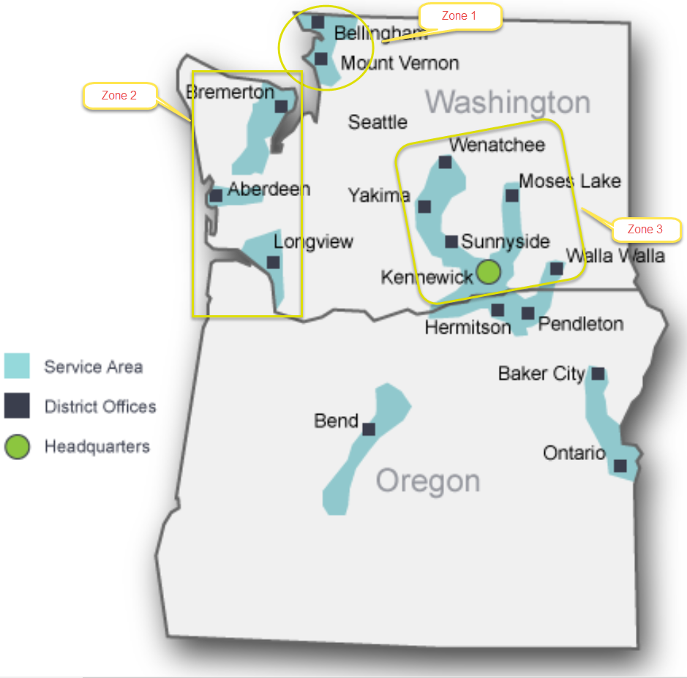

.
Figure 1-7 shows how the conservation portfolio grows over the planning horizon. Figure 1-8 shows this growth by customer class.

Figure 1-7: Full Conservation Portfolio by Climate Zone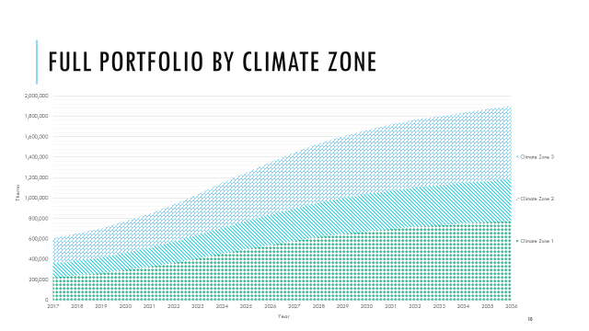

Figure 1-8: Full Conservation Portfolio by Customer Class
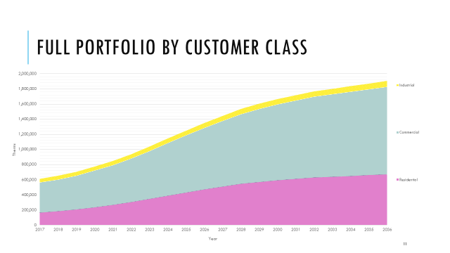

Resource Integration
Cascade utilizes SENDOUT® for resource optimization. This model permits the Company to develop and analyze a variety of resource portfolios to help determine the type, size, and timing of resources best matched to forecast requirements. SENDOUT® is very powerful and complex. It operates by combining a series of existing and potential demand side and supply side resources and optimizes their utilization at the lowest net present cost over the entire planning period for a given demand forecast. SENDOUT® utilizes a linear programming approach. The model knows the exact load and price for every day of the planning period based on input and can therefore minimize costs in a way that would not be possible in the real world. Therefore, it is important to acknowledge that linear programming analysis provides helpful but not perfect information to guide decisions.

One of the purposes of integrated resource planning is to identify an illustrative resource portfolio to help guide specific resource acquisitions. In this planning cycle, the Company considered a host of resource alternatives that can be added to its resource portfolio, including additional conservation programs, incremental off-system storage alternatives at AECO Hub, Mist, Ryckman Creek, Wild Goose, and Gill Ranch. Additionally, incremental transportation capacity on NWP, Ruby, NGTL, Foothills and GTN pipeline systems was considered, along with on-system satellite LNG facilities, biogas, and imported LNG. Typically, utility infrastructure projects are “lumpy,” since demand grows annually at a small percentage rate, while capacity is typically added on a project-by-project basis. Utilities often have surplus capacity and must “grow into” their new pipeline capacity, because it is more cost effective for pipelines to build for several years’ worth of load growth at one time than to make small additions each year. However, the Company can minimize the impacts through the acquisition of citygate peaking resources which include both the supplies and the associated pipeline delivery for a certain number of days or through the purchase of other’s excess capacity through short or medium term capacity releases.

Even with energy efficiency programs, Cascade will need to acquire additional capacity resources or enter into other supply arrangements to meet anticipated peak day requirements, primarily due to continued growth in the Company’s residential and commercial customer base. Utilizing the SENDOUT® resource optimization model, several scenarios were run to test the viability of acquiring incremental storage and transportation resources either based on existing recourse rates, discounted rates and via capacity release through a third party. Basin prices in the model over the 20-year planning horizon have AECO’s trading at a discount to Rockies, Malin and Sumas. The acquisition of additional traditional pipeline capacity represents the most reasonable resource to address most capacity shortfalls on a peak day.

Satellite LNG facilities that are located within Cascade’s distribution system are also attractive alternatives. Satellite LNG may alleviate the need for incremental pipeline capacity and to the extent the facility could be strategically located on a portion of the distribution system, it could provide the further benefit of eliminating or reducing distribution system constraints. Cascade’s modeling indicates that should it be determined by late 2017 that a combination of realigned delivery rights and/or an NWP expansion along the Yakima-Wenatchee line is not possible by 2022, Cascade should consider securing satellite LNG directly connected to the distribution system to address potential shortfalls in the area.

Many of the proposed pipeline projects will not be viable resources until 2018 at the earliest. In the interim, incremental capacity needs can be met through the use of peaking resources and citygate gas supply deliveries which will utilize third-party (non-Cascade) upstream pipeline transportation.

Using input from these alternative resources discussed, SENDOUT® derives a portfolio of existing and incremental resources that Cascade defines as the Expected Scenario. This scenario provides guidance as to what resources should be considered to reduce unserved demand with the least cost mix of all of the alternatives that the Company has considered, under expected pricing, weather, and growth environments.

20-year portfolio costs are expected to range between $3,179,914,000 to $5,086,396,000 for the planning period, with an average cost per therm ranging between $0.449 and $0.718.

A more detailed discussion regarding the Company’s resource integration and the results can be found in Section 8, Resource Integration, beginning on page 8-17.

Distribution System Planning
Distribution planning focuses on determining if the Company will have adequate pressure during a peak hour.

Cascade’s natural gas distribution system consists of approximately 4,744 miles of distribution main pipelines in Washington, and 1,604 miles in Oregon; as well as numerous regulator stations, service distribution lines, monitoring and metering devices, and other equipment. Currently, one compressor station is placed within Cascade’s distribution system near Fredonia, WA. The vast majority of the distribution network pipelines and regulating stations operate and maintain system pressure solely from the pressure provided by the interstate transportation pipelines.

Cascade’s Geographic Information System (GIS) helps engineering look at what is currently in place to meet load demand and assists them to create system models. Cascade’s engineers use GIS and other input data such as customer billings to create models using a software application called Synergi. After achieving a working load study, analyses are performed on every system at design day conditions to identify areas where potential outages may occur. These areas of concern are then risk-ranked against each other to ensure the highest risk areas are addressed first.

The results of Cascade’s current modeling has identified near term growth around Stanwood and Manchester which may require reinforcement work in 2017 and 2018. Gate station work may begin in 2019 to address growth in Walla Walla. The distribution planning process and more description regarding possible near term projects is provided in Section 9, Distribution System Planning.

Table 1-1 shows Cascade’s Two-Year Action Plan. Further descriptions plus other anticipated action items can be found in Section 12, Two-Year Action Plan.

Table 1-1: Two-Year Action Items Highlights
Functional Area | Anticipated Action | Timing
Demand Forecast | Expanding forecasting to test non-linear regression methodology using SAS | Beginning in 2016 for 2018 IRP
Demand Forecast | Consider the new weather normalization model in the forecast | Beginning in 2016 for 2018 IRP
Demand Forecast | Cascade will work on gathering growth information from other locations to compare with Woods & Poole. Also include analysis from State Economist Report | Beginning in 2017 for inclusion in 2018 IRP
DSM | Investigate incorporating distribution system costs into the avoided cost calculation | Beginning in 2017 for inclusion in 2018 IRP
DSM | As specific carbon legislation is passed, the Company will update its avoided cost calculations, conservation potential and make modifications to its DSM incentive programs as necessary. | Consider in 2017 for possible modification in the 2018 IRP
Environmental, DSM, Demand Forecast | The Washington State Dept. of Ecology issued a new carbon rule. Cascade will need to consider IRP implications | Beginning in 2017 for inclusion in 2018 IRP
Resource Integration | Expand Monte Carlo methodology to include analyses of a variety of potential portfolio scenarios (e.g., high growth, low pricing, etc.) | Beginning in 2017 for inclusion in 2018 IRP

Functional Area | Anticipated Action | Timing
Supply Resources | Negotiate with TransCanada for the needed incremental GTN capacity for November 2017 | Complete by June 2017, with a November 2018 in-service date
Supply Resources | Work with NWP to define what delivery rights can be modified to meet potential shortfalls | Complete assessment by July 2017
Supply Resources | Work with NWP and potentially other regional LDCs to determine if a combination of I-5, Wenatchee, etc. expansion or segmentation can address shortfalls and regional infrastructure concerns. | Complete assessment by July 2017
Distribution System Planning, Resource Planning, Gas Supply | Incorporate the citygate study into the IRP. | Beginning in 2016, complete in early 2017 for inclusion in IRP
Distribution System Planning, Gas Supply, Operations, Others | Use the results of the citygate study to confirm aligning of alternative resources, specifically satellite LNG | Confirm if satellite LNG is proper solution by July 2017;
Distribution System Planning, Gas Supply, Operations, Others | Subject to confirmation of a need for satellite LNG, proceed with implementation of facility | Begins no later than July 2017, for potential in service date of November 2018

Use and Relevance of the Integrated Resource Plan

Cascade’s IRP provides the strategic direction guiding the Company’s long-term resource acquisition process. The Plan does not commit Cascade to the acquisition of a specific resource type or facility nor does it preclude the Company from pursuing a particular resource or technology. Rather, the Plan identifies key factors related to resource decisions and provides a method for evaluating resources in terms of their cost and risk. Cascade recognizes that integrated resource planning is a dynamic process reflecting changing market forces and a changing regulatory environment.

Wood Mackenzie Canada Gas Markets Long-term Outlook H1 2016

