https://www.alaskapublic.org/2020/04/14/princess-cancels-cruises-wont-operate-its-alaska-lodges-buses-and-trains-this-summer/

Princess and Holland America cancel most of their Alaska cruises, won’t open lodges this summer
By
Tegan Hanlon, Alaska Public Media - Anchorage
-
April 14, 2020
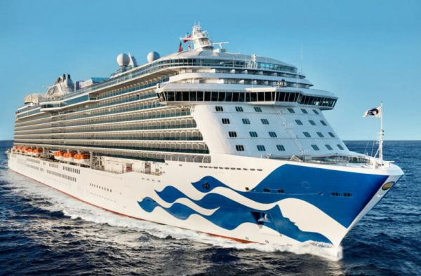The Royal Princess. (Photo courtesy of Princess Cruises)
Two cruise lines announced Tuesday that they’re canceling most of their Alaska sailings this summer, and won’t operate lodges and sightseeing buses in the state as they continue to wrestle with the coronavirus pandemic and its impacts.
The announcements serve another blow to Alaska’s economy, and mean the loss of thousands of seasonal jobs.
“This global outbreak continues to challenge our world in unimaginable ways,” said a statement from Jan Swartz, president of Princess Cruises, a global cruise and tour company.
Princess Cruises says it’s canceling all of its 2020 Princess Alaska Gulf cruise and cruisetours for the season, and more widely extending its cancellation of all of its voyages worldwide through at least the end of June.
Swartz said it’s not viable for the company to operate its five Alaska lodges, trains and buses given the shortened season.
RELATED: State overrules Wrangell’s bid to impose COVID restrictions in anticipation of fishing season
“We deeply regret that we won’t be able to employ the approximately 3,500 teammates who help show our guests the great land each summer,” she said. “Our thoughts are also with all of our small business partners throughout Alaska who we’ve supported every summer for decades.”
Princess Cruises operates lodges in Fairbanks, Cooper Landing, Copper Center and the Denali area.
“We know these decisions will have a large adverse economic impact on the state of Alaska which relies on tourism,” Swartz said.
Get the latest coverage of the coronavirus in Alaska
Swartz said the company remains optimistic that its Emerald Princess and Ruby Princess ships will be able to offer round-trip cruises from Seattle to Southeast Alaska in the late summer. It will re-evaluate those plans in the weeks ahead.
The cruise line had announced in March that it was pausing all of its operations for at least two months. It says it’s offering guests credit or refunds.
Related: Cruise lines are taking bookings for an Alaska cruise season that might not even happen
The Centers for Disease Control and Prevention renewed its no-sail order for cruise ships last week, and it could stay in place for 100 days. The agency is also recommending Americans defer cruise ship travel because passengers are at an increased risk of person-to-person spread of diseases, including COVID-19.
Canada has closed its ports to cruise ships through July 1, and the Port of Seattle has delayed the launch of the cruise season “until the resolution of the public health emergency.”
Citing continued port closures and travel restrictions stemming from the pandemic, Holland America Line also announced Tuesday that it’s suspending all of its global operations and sailings through at least the end of June.
In addition, it’s canceling its Alaska cruises on five ships for the entire summer: the Maasdam, Noordam, Oosterdam, Volendam and Westerdam.
In total, Holland America called off 110 of its sailings to Alaska by Tuesday, about 83%, the company said.
Holland America also canceled land excursions in the state for the season, and says it will not operate The McKinley Chalet Resort, McKinley Explorer rail cars and tour buses this summer.
“These are unprecedented times,” Orlando Ashford, president of Holland America, said in a statement. “Having to delay summer cruising and cancel our land tours for the entire season is the responsible thing to do, yet also very disappointing and a first in our more than 70 years of taking guests to Alaska.”
RELATED: Port of Seattle suspends cruise ship season “until the resolution of the public health emergency.”
The cruise line operates at least two other ships, the Eurodam and Koningsdam, with online itineraries to sail to Southeast Alaska later in the season, in August or September.
Ashford said the company looks “forward to better days and returning to a full summer cruising season in 2021.”
Other cruise lines have also suspended their operations, impacting Alaska, including Viking Cruises and Carnival Cruise Lines, according to Cruise Lines International Association Alaska. The association estimates that 360 of all voyages are now canceled for the 2020 Alaska cruise season, about 60%.
Reach reporter Tegan Hanlon at thanlon@alaskapublic.org or 907-550-8447.

