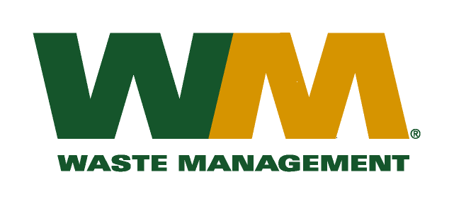
February 28, 2011
Washington Utilities and Transportation Commission
Chandler Plaza Building
1300 S. Evergreen Park Drive SW
P.O. Box 47250
Olympia, WA. 98504-7250

Dear Sirs:
Subject: Waste Management of Skagit County, a division of Waste Management of Washington, Inc.(G-237); Tariff # 17; Docket No. TG-110348

Please find enclosed substitute tariff page number 2 to above referenced docket number. This page is being submitted to correct a clerical error. Please do not re-docket.

If you have any questions or need additional information, please contact me at (425) 814-7840.

Very truly yours,
Michael A. Weinstein
Senior Pricing Manager, Pacific Northwest Market Area

