8113 W. GRANDRIDGE BLVD., KENNEWICK, WASHINGTON 99336-7166
TELEPHONE 509-734-4500 FACSIMILE 509-737-9803
www.cngc.com

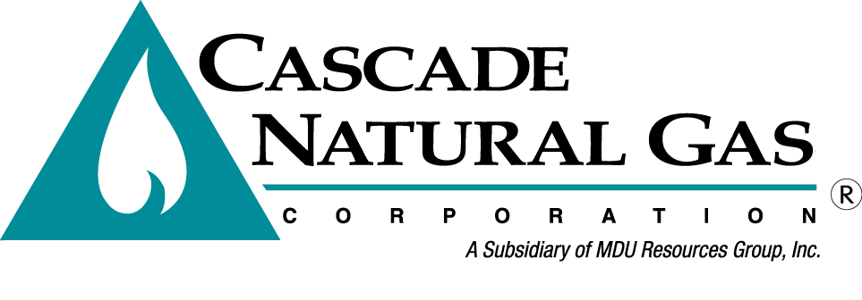
August 1, 2016

Mr. Steven V. King
Executive Director and Secretary
Washington Utilities & Transportation Commission
P.O. Box 47250
Olympia, WA 98504-7250

Re: Advice No. W16-08-01, Compliance Filing
UG-152286, Cascade Natural Gas Corporation General Rate Case

Dear Mr. King,

Cascade Natural Gas Corporation’s (Cascade or Company) submits the attached filing in compliance with Commission Order No. 04, issued in conclusion to the Company’s 2015 general rate case docketed as UG-152286. The Company submits the following revisions to its Tariff WN U-3, which are stated to become effective September 1, 2016:

Thirty-Fifth Revision Sheet No. 2
Twentieth Revision Sheet No. 2-A
Third Revision Sheet No. 7
Fifth Revision Sheet No. 21
First Revision Sheet No. 25
Original Sheet No. 25-A
Original Sheet No. 25-B
Third Revision Sheet No. 301
Fifty-Third Revision Sheet No. 502
Fifty-Eighth Revision Sheet No. 503
Forty-Second Revision Sheet No. 504
Forty-First Revision Sheet No. 505
Fifty-Eighth Revision Sheet No. 511
Thirty-Eighth Revision Sheet No. 512
Fifty-Second Revision Sheet No. 570
Forty-Ninth Revision Sheet No. 577
Original Sheet No. 594
Eighty-First Revision Sheet No. 596
Third Revision Sheet No. 597
Sixteenth Revision Sheet No. 663
Fourth Revision Sheet No. 685-A
Fourth Revision Sheet No. 687

The Company is also withdrawing from Tariff WN-U3 the following sheets in their entirety:

Third Revision Sheet No. 21-C
Fifty-Fourth Revision Sheet No. 541
Fifth Revision Sheet No. 545
Eighth Revision Sheet No. 599
Fifth Revision Sheet No. 664
First Revision Sheet No. 665
Fourth Revision Sheet No. 678
Third Revision Sheet No. 678-A
Second Revision Sheet No. 679
Ninth Revision Sheet No. 681
Substitute Sixth Revision Sheet No. 682
Fourth Revision Sheet No. 683
Substitute Fourth Revision Sheet No. 684
Substitute Third Revision Sheet No. 684-A
Original Sheet No. 699

In accordance with the terms adopted in Commission Order No. 04 to UG-152286, this filing increases the Company’s annual revenues by $4 million or 1.6 percent.

The tariff changes proposed herein are consistent with the tariff revisions proposed in the Direct Testimony of Pamela J. Archer included in the Company’s initial general rate case filing as Exhibit PJA-1T and Exhibit No. PJA-3, and later revised in Revised Exhibit No. PJA-3. The exception to this is Rule 21, Decoupling Mechanism, which is revised in accordance with terms outlined in the stipulated agreement adopted in Commission Order No. 04 issued in Docket No. UG-152286.

This compliance filing does not include a new tariff for the Company’s Washington Energy Assistance Fund (WEAF) Program or a WEAF Cost Recovery adjustment schedule as required per Commission Order No. 04 issued in Docket No. UG-152286. The Company will file the new WEAF tariffs in a subsequent compliance filing that will be submitted in accordance with the Order, no less than ten days prior to the effective date of September 1, 2016. Additional time is necessary to allow the WEAF advisory group, formed as a result of the rate case, time to review the WEAF tariffs before they are submitted to the Commission for approval. However, the Company did list the new WEAF tariffs (Schedules 303 and 593) in the table of contents (sheets 2 and 2A hereto attached) as they will be forthcoming.

This filing also does not include the housekeeping changes to Sheets 595 from Schedule 595, Technical Temporary Adjustments because additional proposed changes to these sheets are proposed in the Company’s Purchased Gas Adjustment (PGA) filing submitted today as Advice No. W16-08-02. Sheet 595 as filed in the PGA includes the housekeeping changes approved per Order No. 04 in UG-152286.

Questions regarding this filing should be directed to Michael Parvinen at (509) 734-4593.

Sincerely,

/s/ Mike Parvinen

Michael Parvinen
Director, Regulatory Affairs

Enclosures

