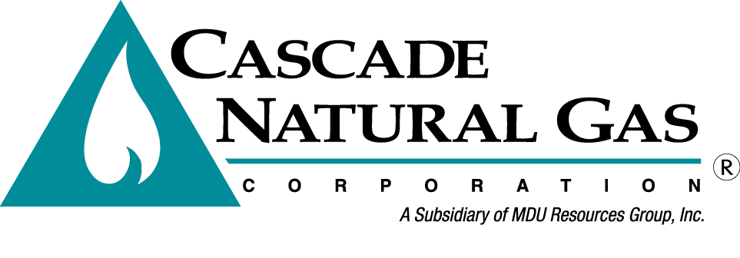 | 8113 W. GRANDRIDGE BLVD., KENNEWICK, WASHINGTON 99336-7166  TELEPHONE 509-734-4500 FACSIMILE 509-737-7166  www.cngc.com

VIA ELECTRONIC MAIL
records@utc.wa.gov

September 30, 2016

Records Center
Washington Utilities and Transportation Commission
1300 S. Evergreen Park Drive SW
Olympia, WA 98504

Re: Advice No. CNG/W16-09-02, Housekeeping

Cascade Natural Gas Corporation’s (Cascade or Company) files the following revisions to its Tariff WN U-3, stated to become effective November 1, 2016

Fifty-Fourth Revision Sheet No. 502
Fifty-Ninth Revision Sheet No. 503
Forty-Third Revision Sheet No.504
Forty-Second Revision Sheet No. 505
Fifty-Ninth Revision Sheet No. 511
Thirty-Ninth Revision Sheet No. 512
Fifty-Third Revision Sheet No. 570
Forty-Ninth Revision Sheet No. 577
Thirty-Sixth Revision Sheet No. 595

The changes made herein are housekeeping in nature and have no impact on overall rates. Earlier this year, the Company filed Advice No. CNG/W16-08-01, a compliance filing adopting the changes approved by the Commission in the Company’s general rate case docketed as UG-152286. In accordance with the terms of the rate case settlement, the rate case changes were filed with a September 1, 2016, effective date to ensure they would become effective concurrently with the changes to gas prices made in the Purchased Gas Adjustment (PGA) filing. The rate case compliance filing could not include information that was not part of the general rate case, and because of the concurrent timing of the two filings, the PGA could not revise tariff sheets included in the rate case compliance filing. The Company handled this by applying the change to gas prices through a Schedule 595 adjustment to the commodity rates as stated in each rate schedule. The Company now removes the adjustment to the Weighted Average Cost of Gas (WACOG) as stated in Schedule 595, Temporary Technical Adjustment, and adds it directly to the commodity rate as stated in each rate schedule. The billing rates are the same as those approved both in the general rate case and the PGE filing.

If you have any questions regarding this report, please contact Maryalice Rosales at (509) 734-4548.

Sincerely,

Michael Parvinen
Director, Regulatory Affairs

