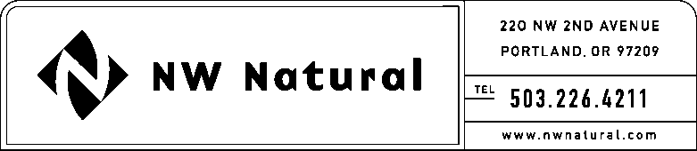

MARK R. THOMPSON
Manager, Rates and Regulatory Affairs
Tel: 503.721.2476
Fax: 503.721.2516
email: mark.thompson@nwnatural.com

September 7, 2016

Steven V. King, Executive Director and Secretary
Washington Utilities & Transportation Commission
1300 S Evergreen Park Drive, SW

Post Office Box 47250
Olympia, Washington 98504-7250

Re: Docket UG-110199 – 2ndP 2016 Semi-Annual Report on Environmental Costs

Northwest Natural Gas Company, dba NW Natural (“NW Natural” or the “Company”), hereby files its second 2016 semi-annual report of environmental costs deferred, in compliance with condition (3)(i) of Order No. 01 in Docket UG-110199.

UBackground

On January 26, 2011, NW Natural filed with the Washington Utilities and Transportation Commission (“Commission”) a petition requesting authorization to defer expenses associated with environmental remediation at the following five Company-owned sites: Gasco, Central Gas Holding, Tar Deposit, Portland Harbor, and Wacker (aka Siltronic).

NW Natural’s predecessor, Portland Gas and Coke Company, produced and sold manufactured gas to Oregon and Washington customers from 1913 to 1956. The Company is now incurring costs related to the investigation and remediation of environmental contamination resulting on properties where gas was either manufactured onsite or nearby, or where there were activities associated with manufactured gas.

Starting in early 2006, NW Natural pursued recovery of insurance for its environmental liabilities from insurance policies that it believed would cover such liabilities. It identified and analyzed all of the liability insurance policies issued between the late 1930s and 1986 which may provide coverage. Most insurers agreed to enter into negotiations in an effort to resolve the claims. In late 2010, NW Natural determined it would not be able to reach settlements within a reasonable period of time, so the Company filed a lawsuit against the insurers seeking a recovery of funds. Eventually, the Company was able to reach a settlement with all insurers. NW Natural issued an 8-K describing these settlements, which was attached to its 1P^{st}P 2014 Semi-Annual report filed in the subject docket. With these settlements, the Company received a total of approximately $150.5 million in insurance receipts.

In Oregon, NW Natural has received approval for a Site Remediation and Recovery Mechanism (SRRM), through which NW Natural recovers the costs of environmental remediation from its Oregon customers. The Public Utility Commission of Oregon (OPUC) has determined that it will allow NW Natural to allocate 96.68% of all remediation costs to Oregon customers, based on the historic proportion of gas that was used in Oregon from the manufactured gas plants NW Natural’s predecessors operated.

Through a previous supplemental petition for an accounting order filed July 17, 2012, in UG-110199, the Company proposed to the Washington Commission an allocation of 3.32% deferred costs to service in Washington. That petition was not acted upon, and NW Natural was informed by Staff that the Commission would not want to entertain this request until the Company actually sought rate recovery in Washington. The Company currently anticipates that it will still request an allocation to Washington customers of 3.32% of its deferred expenses, and the same allocation of insurance proceeds to Washington customers. The table below shows 3.32% of total costs incurred during the timeframe February 1, 2011 through June 30, 2016, for environmental remediation at the following sites: Gasco, Central Gas Holding, Tar Deposit, Portland Harbor, and Wacker (aka Siltronic).

In accordance with Order No. 1 in the subject docket, interest is not being accrued to the deferred balances. However, as stated in the Order, these costs may be eligible for working capital treatment when the Company files its next rate case.
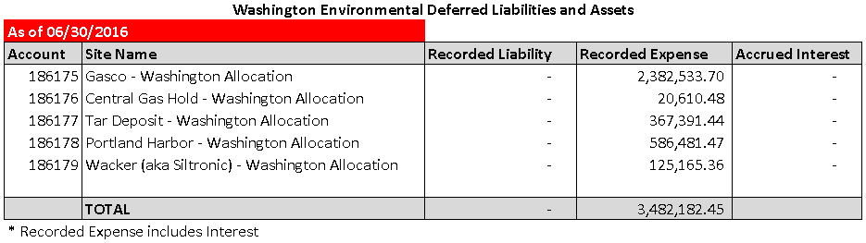

Please note, as stated above, insurance receipts received to date, and allocable to Washington under NW Natural’s proposed allocation more than offset these deferred amounts.

In addition to the above information, NW Natural would be happy to meet with Staff or the Commissioners at your offices to present any further information that would be helpful to the Commission at this time. If you have any immediate questions, please call me direct at (503) 721-2476.

Sincerely,

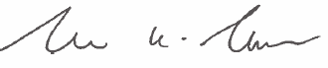

Mark R. Thompson
Manager, Rates and Regulatory Affairs

