July 25, 2013

FILED ELECTRONICALLY VIA WEB PORTAL
Mr. Steven V. King
Acting Executive Director & Secretary
Washington Utilities and Transportation Commission
Post Office Box 47250
1300 S. Evergreen Park Dr. SW
Olympia, Washington 98504-7250

Subject: United States Cellular Corporation – 2013 Annual ETC Recertification
Docket to be assigned

Dear Mr. Danner:

Pursuant to WAC 480-123-060, et seq., U. S. Cellular Corporation ("USCC") hereby files its annual certifications and reports as follows:

ANNUAL ETC CERTIFICATION AND REPORT, with listed Exhibits -

Exhibit A Declaration Certifying Use Of Universal Service Funds

Exhibit B Report on use of federal funds and benefits to customers Confidential

Exhibit C Local service outage report – Confidential

Exhibit D Report on failure to provide service - Confidential

Exhibit E Report on complaints per one thousand handsets or lines Confidential

Exhibit F Declaration Certifying Compliance With Applicable Service Quality Standards and Consumer Protection Rules

Exhibit G Declaration Certifying Ability To Function In Emergency Situations

Exhibit H Declaration Certifying Lifeline Advertising

Exhibit I Samples of advertising and outreach materials

Exhibit J Statement re advertising of service offerings

Exhibit K Schedule of Lifeline Ad Insertion –Confidential

Exhibit L Annual plan for Universal Service support - Confidential

Exhibit M Map that shows where USCC provides commercial mobile radio service signals in Washington - Confidential

Pursuant to WAC 480-07-140, we are making this filing electronically only. In the Confidential portion of the filing, each electronic file will contain, as part of the file name, the word "CONFIDENTIAL." Additionally, each page in the Confidential electronic files will be labeled "Confidential Per WAC 480-07-160." A redacted copy of each confidential exhibit will also be filed.

Pursuant to RCW §80.04.095 enclosures designated as "confidential" contain valuable commercial information, including trade secrets and confidential marketing, cost, or financial information, or customer-specific usage and network configuration and design information. Accordingly, pursuant to RCW §80.04.095 such information should not be subject to inspection or copying under RCW Chapter 42.56. Moreover, the records designated as "confidential" contain valuable formulae, designs, and research data, the disclosure of which would produce private gain and public loss and should be exempt from public disclosure pursuant to RCW 42.56.270(1).

In addition to the undersigned, the following might be directly affected by disclosure of the confidential information:

U. S. Cellular Corporation
8410 West Bryn Mawr Avenue
Chicago, IL 60631
Phone: (773) 864-3167
E-mail: John.Gockley@uscellular.com
Attention: John C. Gockley

If you have any questions please contact the undersigned.

Very truly yours,
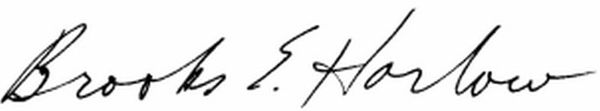
Brooks E. Harlow, P.C.
cc: Ms. Jing Liu
Ms. Stephanie Cassioppi

