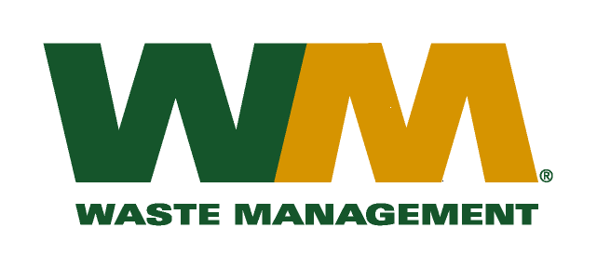

February 18, 2010
Washington Utilities and Transportation Commission
Chandler Plaza Building
1300 S. Evergreen Park Drive SW
P.O. Box 47250
Olympia, WA. 98504-7250
Dear Sirs:
Subject: Waste Management of Greater Wenatchee, a division of Waste Management of Washington, Inc.(G-237); Tariff # 12
Please find enclosed revised tariff pages 2, 22, 24, 33, 34, 36, 38 and 40 for the above-referenced company. The purpose of these tariff page revisions is to renew the assessment of the solid waste fee to residential and commercial customers in unincorporated Douglas County. This fee is charged in accordance with Douglas County Solid Waste Collection Fee Ordinance, C.E. 94-014. As shown on the attached letter from Ron Draggoo, Douglas County Solid Waste Program Director, Waste Management’s “fair share” portion of the fee for 2010 is $165,466. This fee is $18,447 less than the fee assessed in 2009. Accordingly, we are proposing that the fee charged to customers be decreased 6.6% as reflected in the above revised tariff pages. In accordance with WAC 480-70-262 as this tariff filing is to only implement a decrease in the customers’ rates, we are proposing that the effective date of the renewal of this fee be April 1, 2010. These revised tariff pages will have an expiration date of March 31, 2011.
In addition to the letter mentioned above, enclosed for your review are our accounting work papers. Customers will be notified of the change in their fee on their first regularly scheduled billing after the approval of the Commission.
If you have any questions or need additional information, please contact me at (425) 814-7840.
Very truly yours,

Michael A. Weinstein
Senior Pricing Manager, Pacific Northwest Market Area

cc: Will Russell
Clerk of the Board, Douglas County Chair

