VIA ELECTRONIC FILING AND OVERNIGHT MAIL

May 19, 2015

Mr. Steven V. King
Executive Director and Secretary
Washington Utilities and Transportation Commission
P.O. Box 47250
Olympia, WA 98504-7250

Re: PSE Meter and Billing Performance Annual Filing
Docket Nos. UE-111048 and UG-111049 (consolidated)
Dear Mr. King:
Puget Sound Energy, Inc. (“PSE” or the “Company”) submits the following responses to the questions from the staff of Washington Utilities and Transportation Commission’ (“Staff”) on April 29, 2015, regarding PSE’s 2014 Meter and Billing Performance Annual Filing in Docket Nos. UE-111048 and UG-111049 (consolidated). As Staff indicated in its letter, PSE didn’t meet all the standards set forth in the final order of consolidated Docket Nos. UE-111048 and UG-111049 (“Order 08”) although PSE has been making progress on reducing the number of back bills.
The number of back bills has been decreased since 2013, in term of PSE’s overall billing performance. In 2013 PSE issued 17,933,297 bills to customers, 0.016% of these bills were stopped meter related billing corrections. In 2014 PSE issued 17,906,670 bills to customers, the percentage of stopped meter related bills were reduced to 0.014%.
The following responses supplement the information provided in PSE’s 2014 Meter and Billing Performance Report regarding the Meter and Billing Performance issues.
- Please provide PSE’s assessment of the trend identified over the past two years where the Company has been unable to completely attain all the standards established in Order 08.
PSE Response:
For the meters with unassigned energy usage (“UEU”), PSE uses both a time and a usage threshold for identifying UEU meters. After reviewing the exceptional UEU meters in the 2014 reporting period, PSE determined that the time threshold set by PSE to mail a letter to the premise requesting that a customer sign for service was too long. PSE is lowering the time thresholds in 2015 from 9 months to 3 months.
For the stopped meters, PSE had performed analyses in 2014 and 2015 on these meters that were resolved outside of the current Meter and Billing Performance Standards. Based upon the analyses, these exceptional meters can be categorized into two groups: meters with sporadic usage and meters that slow down over time.
The automatic tracking of the stopped meter review process that was used in 2014 was established based upon the requirements of the original meter and billing performance standards in consolidated Docket Nos. UE-072300 and UG-072301 Order 12. These initial performance standards focused on the resolving an identified potential stopped meter. Therefore, the automated process was built to identify meters that were completely stopped for a certain period of time in comparison to prior year. It was not designed to detect if the usage pattern had changed or the meter reads had showed a downward trend as shown in Charts 1 and 2 below.
Chart 1: Sporadic Meter 70714E_00245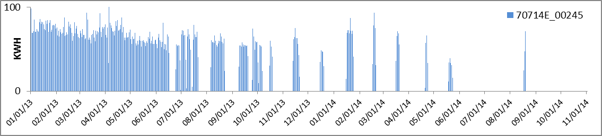
Chart 2: Slow Meter 11201G_00467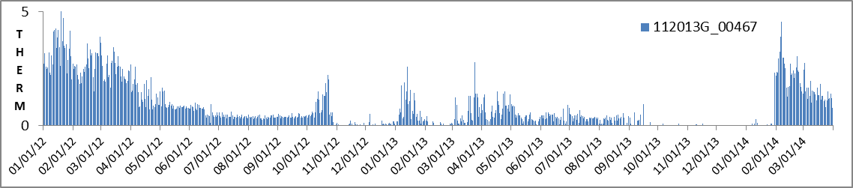
- Please identify PSE’s goals to meet the standards set forth in Order 08 in the future.
PSE Response:
PSE’s goals in 2015 are:
- Maximizing existing meter and billing reporting system to improve effectiveness in light of the new customer information system.
- Reviewing UEU customer notification process to promote timely sign-up with PSE after customer move-in.
- Developing strategies and processes to identify meters with a slow module, and repair/replace the poor performing and sporadic-usage meters by creating new computerized logic models.
- Reviewing current stopped meter and unassigned energy identification processes to determine where improvements can be implemented to expedite the review and investigation processes.
By revising the UEU meter identification thresholds, implementing additional analytics to identify slow or sporadic consumption, and improving the zero consumption identification to overcome the limitations of the prior automated tracking and review process, PSE expects it will be in a better position to meet the performance standards in 2015.

Please contact Mei Cass at (425) 462-3800 for additional information about this filing. If you have any other questions, please contact me at (425) 456-2110.
Sincerely,

Ken Johnson
Director, State Regulatory Affairs

Enclosure

cc: Sharon Wallace – UTC
Roger Kouchi – UTC
Chris Casey – UTC
Thomas Schooley – UTC

