EXHIBIT NO. ___(BKG-1T)
DOCKETS UE-17___/UG-17___
2017 PSE GENERAL RATE CASE
WITNESS: BOOGA K. GILBERTSON

BEFORE THE
WASHINGTON UTILITIES AND TRANSPORTATION COMMISSION

WASHINGTON UTILITIES AND TRANSPORTATION COMMISSION,  Complainant,  v.  PUGET SOUND ENERGY,  Respondent. | Docket UE-17____  Docket UG-17____

PREFILED DIRECT TESTIMONY (NONCONFIDENTIAL) OF

BOOGA K. GILBERTSON

ON BEHALF OF PUGET SOUND ENERGY

JANUARY 13, 2017

PUGET SOUND ENERGY
PREFILED DIRECT TESTIMONY (NONCONFIDENTIAL) OF
BOOGA K. GILBERTSON
CONTENTS
I. INTRODUCTION 1
II. NATURAL GAS SYSTEM INFRASTRUCTURE, SERVICE, AND OPERATIONS 2
III. ELECTRIC INFRASTRUCTURE, SERVICE, AND OPERATIONS 18
IV. CONCLUSION 38

PUGET SOUND ENERGY
PREFILED DIRECT TESTIMONY (NONCONFIDENTIAL) OF
BOOGA K. GILBERTSON

I. INTRODUCTION
Q. Please state your name, business address, and position with Puget Sound Energy.
A. My name is Booga K. Gilbertson. My business address is 10885 NE 4th Street, Bellevue, Washington, 98009-5591. I am Senior Vice President, Operations with Puget Sound Energy (“PSE”).
Q. Have you prepared an exhibit describing your education, relevant employment experience, and other professional qualifications?
A. Yes, I have. It is Exhibit No. ___(BKG-2).
Q. What is the scope of your testimony in this proceeding?
A. My testimony and exhibits in this proceeding will provide an overview of PSE’s approach to providing safe, dependable and efficient gas and electric services for our customers. I will address how PSE plans, delivers, and executes for meeting gas and electric system, regulatory and customer need. I will discuss what PSE has accomplished since 2011 and what benefits have been realized.

II. NATURAL GAS SYSTEM INFRASTRUCTURE, SERVICE, AND OPERATIONS
Q. Please describe PSE’s primary objectives for natural gas operations over the last few years.
A. PSE is dedicated to providing quality customer service and delivering energy safely, dependably, and efficiently. To meet these goals, PSE has identified primary objectives for PSE’s natural gas system infrastructure, service, and operations. These objectives are (i) maintain and improve customer and public safety, (ii) enhance system integrity and reliability, and (iii) meet the growth and service needs and expectations of our customers and communities. A cornerstone for these important objectives is operational excellence. PSE strives for operational excellence by reviewing performance and practices, utilizing performance trends to inform improvements and changes, making work plans and performance transparent in order to measure and confirm progress, and staying attuned to industry practices and policy changes. Examples of how PSE is achieving these objectives are described throughout my testimony.
Q. Please describe how PSE has focused on maintaining and improving customer and public safety.
A. PSE continues to engage our customers and the public in effective safety messaging. Using multi-media platforms, PSE has increased its public awareness and outreach regarding natural gas safety, detection of leaks and damage prevention of assets.
Events across the nation and locally lead PSE to continually review work practices for customer and public safety. For example, industry concerns regarding sewer cross bores were heightened by a St. Paul, Minnesota incident in 2010 which resulted in personnel injury, gas ignition and extensive property damage. A cross bore is the inadvertent intersection of a gas pipeline through a sewer line which can occur when trenchless technology is used for installing pipelines. PSE began analyzing cross bores that were being discovered by plumbers and homeowners and recognized the need to work with the public to proactively prevent potential cross bore hazards. As discussed in more detail later in my testimony, PSE has identified and remediated several hundred cross bores and cleared thousands of properties of potential cross bore risks.
Ensuring public awareness and safety when working around gas pipelines is a priority for the utility industry and PSE. After a reduction in third-party caused damage to PSE pipelines from 2006 to 2010, PSE has experienced a steady rate of third-party damage incidents, averaging 907 per year since 2011, due to increased construction throughout the Puget Sound region. In response, PSE has increased its outreach efforts for public awareness and safety around pipelines (and electrical equipment), by launching a sewer cross-bore information campaign, promoting the state “Call 811 Before you Dig” law and distributing gas safety fliers to residents near new gas installations.
With incidents such as third-party damage, cross bores, or any emergency reported by a customer, contractor or any member of the public, PSE remains committed to making response to odor calls and emergencies a top priority. PSE has maintained an average response time of 31 minutes or less, well within the Service Quality Index (“SQI”) threshold of 55 minutes.
Finally, the increased need to protect both infrastructure and cyber assets have become an ever increasing topic in industry and other forums. The American Gas Association (“AGA”) has identified cybersecurity and physical security as a top 10 priority. In 2016, PSE conducted a vulnerability assessment at five critical gas facilities. Additionally, to support cybersecurity, PSE is participating in both the electric and natural gas down-stream councils of ISACs, or “Information Sharing and Analysis Centers” in order to keep informed of emerging threats. Further, PSE also participates in state level exercises to raise awareness of response capabilities outside of PSE operations.
Q. Please describe how PSE has focused on enhancing system integrity and reliability.
A. A primary objective for PSE is to enhance and maintain pipeline system integrity and reliability. This includes replacing or mitigating key assets that have been identified as a greater risk to the public and the natural gas system as described in PSE’s Distribution Integrity Management Program (“DIMP”) and Transmission Integrity Management Program (“TIMP”) as well as other ongoing programs described in PSE’s Continuing Surveillance Report, which is filed annually with the Washington Utilities and Transportation Commission (“WUTC” or “Commission”).
As an example, in compliance with PSE’s settlement agreement in Dockets PG-030080 and PG-030128, dated January 31, 2005, PSE completed the replacement of all known bare steel pipelines in 2015. PSE is ahead of much of the industry in this regard, as many natural gas utilities are still working to remove this risk from their system.
The unfortunate 2010 pipeline explosion in San Bruno, California, resulting in three deaths and numerous injuries, was a catalyst for process review throughout all aspects of the industry including actions of utilities and underlying regulations and regulatory processes. Following the explosion in California, the WUTC began an investigation as to whether utilities should do more to enhance natural gas safety and, if so, what steps are necessary to accomplish that goal including incentives for early retirement of pipeline with known but managed risks. At the completion of the investigation, the WUTC issued a policy statement, which authorized a new interim recovery mechanism that provides utilities an incentive to accelerate replacement of pipe that presents an elevated risk of failure. PSE is participating in this process and is focused on replacing older DuPont pipes in PSE’s system before failure occurs as well as wrapped steel mains and services.
PSE recognized the opportunity to further maintain and improve the integrity and reliability of its pipeline system when the Washington State Department of Transportation (“WSDOT”) began its viaduct replacement work along the Seattle waterfront. PSE anticipated that this work would have an impact on nearby natural gas pipelines and the customers served from this system. PSE has implemented targeted system upgrades and monitoring plans to address potential ground settlement risk since construction began in 2012.
Q. Please describe how PSE has focused on meeting growth and service needs and expectations of customers and communities.
A. PSE has continued to serve a growing customer base in the region and provide excellent service to a population that expects a safe and reliable natural gas system. PSE has added 45,058 new gas customers and averaged 1.19% customer growth per year from 2011 through 2015. Both population and per capita housing starts are higher in Washington as compared to other parts of the country.
Q. Please describe how PSE has focused on operational excellence and continuous improvement.
A. PSE participates in AGA, WUTC, Pipeline and Hazardous Materials Safety Administration (“PHMSA”), and Department of Transportation (“DOT”) forums and events to stay informed of trends and emerging issues. For example, PSE has participated in industry forums exploring the expanded use of excess flow valves in gas distribution systems to understand and address the regulatory and pipeline safety concerns. As a result, in 2013, PSE standardized the installation of excess flow valves on new residential services and continued to participate in discussions as greater emphasis was placed on this practice, which was ultimately mandated through rulemaking (effective 2017). Information from these forums is reviewed for applicability to PSE’s system, and when appropriate, work practices and plans may be adjusted as a result. PSE values sharing work plans and performance information with its customers unless precluded by specific restrictions. For example, the publically available annual Service Quality and Electric Service Reliability Report highlights PSE’s performance in meeting service quality objectives. PSE also engages in informal discussions with the Commission’s pipeline safety staff to share information about pipeline safety activities and areas of focus. Information about PSE work plans, such as system improvement projects and programs and information about natural gas reliability is available on PSE.com. In addition, PSE submits longer term project plans to cities and counties as part of their comprehensive plans.
Examples of specific improvements that PSE has achieved are discussed later in my testimony.
Q. What processes has PSE put in place to support and implement these key objectives?
A. There are several processes PSE undertakes that support these objectives, including the following:
Planning Process
PSE’s System Planning organization is responsible for evaluating system demands and performance, as well as identifying and scoping system projects that deliver safe and dependable service, meet regulatory requirements, and meet customer needs. The process begins with an analysis of current performance, existing operational challenges, known commitments, and anticipated future need. Planning considerations (inputs) include both internal and external factors, such as customer needs and load growth forecasts (peak, localized, known projects, and overall system growth), reliability performance, aging infrastructure, integration of resources, and timing of municipal sponsored projects. These projects are scored against each other to assess the prioritization of system and customer needs. An analysis is conducted to identify alternatives that will address the challenge. Benefits and costs are then forecasted for each alternative that meets the performance criteria. Planners select and plan for the alternative that best balances customer needs, system performance, regulatory compliance, PSE economic parameters, and local and regional plans. PSE compares the relative costs and benefits of various solutions across multiple factors using the Investment Decision Optimization Tool (“iDOT”) including reliability, safety, current and deferred future costs, capacity addition, and external stakeholder inputs. Total value is optimized across the entire portfolio of system infrastructure projects, which results in a set of capital projects that provide maximum value to PSE customers and stakeholders. While the portfolio of capital projects is considered final, many factors may arise that change PSE’s ability to complete the final portfolio of projects such as public improvement projects that arise or are otherwise changed, adjusted forecasts in load growth, or other external factors such as project delays due to permitting. Although such factors may cause individual projects to change, the total portfolio financial forecast remains within established budget parameters.
DIMP and TIMP
PSE has developed and adheres to its Distribution Integrity Management Program Plan (“DIMP”) and Transmission Integrity Management Program Plan (“TIMP”), which are a critical part of the planning process with respect to pipeline integrity. These plans: (i) integrate reasonable and available information about the pipelines, (ii) consider the likelihood and consequence of failure, (iii) identify and evaluate the appropriate mitigating measures, and (iv) update the program as appropriate. The highest priority risks are addressed and prioritized for funding. As an example, PSE files a Pipeline Replacement Program (“PRP”) that provides transparency as to how PSE addresses the DuPont pipe and older vintage steel wrapped mains and services within the system.
Q. Please explain how these processes drive PSE’s decisions regarding capital investments.
A. PSE’s application of these processes towards its key objectives results in a multi-year plan for capital investment spending. Since 2011, PSE has invested $894 million in its natural gas system. These investments drive improvements in system integrity and reliability resulting in increased public safety through leak and risk reduction. These investments also support customer growth and allow PSE to effectively and safely relocate natural gas infrastructure when it is located in an area that conflicts with public improvement work undertaken by cities and counties. The graph below demonstrates the spending for each of these categories of investments since 2011.
Figure 1. Actual Capital Expenditures by Category: 2011 through 9/30/2016
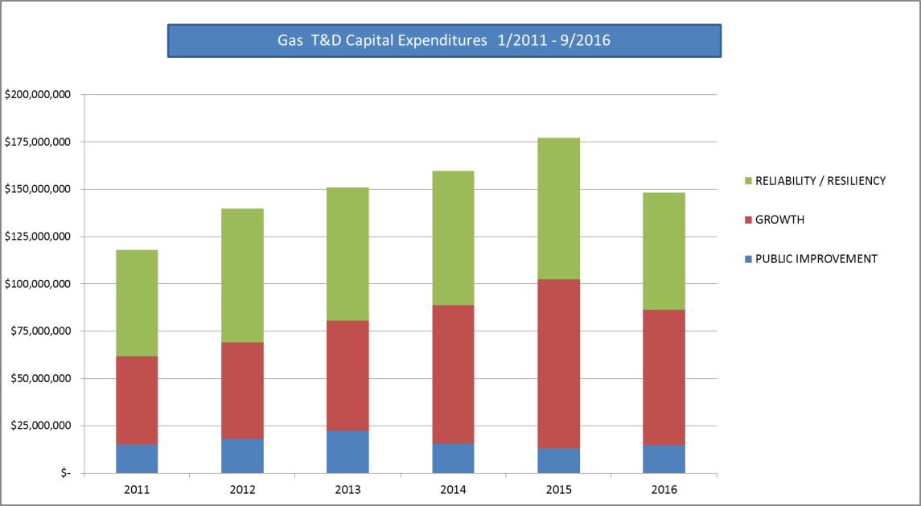
Please see Exhibit No. ___(BKG-3).
Q. What are the key accomplishments and benefits to customers from these processes and investments?
A. Since 2011, PSE has improved the integrity of its gas system, which allows PSE to provide safe, dependable and efficient services to our customers. Key accomplishments are as follows.
- PSE replaced 290 miles of high risk pipe that was more susceptible to leakage including bare steel, wrought iron pipe, older wrapped steel and DuPont pipe. All known cast iron pipe was removed prior to 2011. This work has avoided an estimated 1,200 leaks over the previous five year period.
- PSE added 45,058 new customers over the course of five years, yielding a total of 6% growth in that time period.
- PSE executed 555 gas projects between 2011 and 2015 to deploy or relocate infrastructure that was in conflict with public improvement projects. The working relationships PSE established with regional government entities facilitated greater coordination and avoided potential conflicts.
- PSE identified and remediated 430 sewer cross-bores and cleared 47,831 parcels of a potential cross-bore risk.
- PSE leak surveyed 59,485 miles of main and service pipeline.
Q. What drives changes in the work plan?
A. While the plan and budget envision the completion of specific projects each year, scheduled projects can be impacted by changing requirements of local jurisdictions such as construction windows or restoration requirements, as well as right-of-way challenges and public involvement, all of which can change project timing and cost. Additionally, growth projection changes can cause larger capacity driven projects to be deferred or timing to change. Pipeline safety continuous surveillance activities may reveal unsatisfactory conditions or elevate pipeline risk, which could cause PSE’s work priorities to change and unplanned work to be added. Finally, while customer growth projections are based on many factors, the actual customer work is driven by the requests made and as such can be different than what is planned.
Q. Please describe how PSE confirms that its investments deliver the intended result.
A. One indicator that PSE’s DIMP, TIMP, and pipe replacement programs are meeting the objectives is the decline in the number of active leaks. Since 2011, PSE has seen a decrease in non-hazardous “C” leaks by approximately 61% due to the removal of bare steel pipes and older DuPont pipes, as well as PSE’s work to aggressively repair the C leaks. PSE’s progress in reducing these leaks is shown in the graph below.
Figure 2. Active Leak Reduction
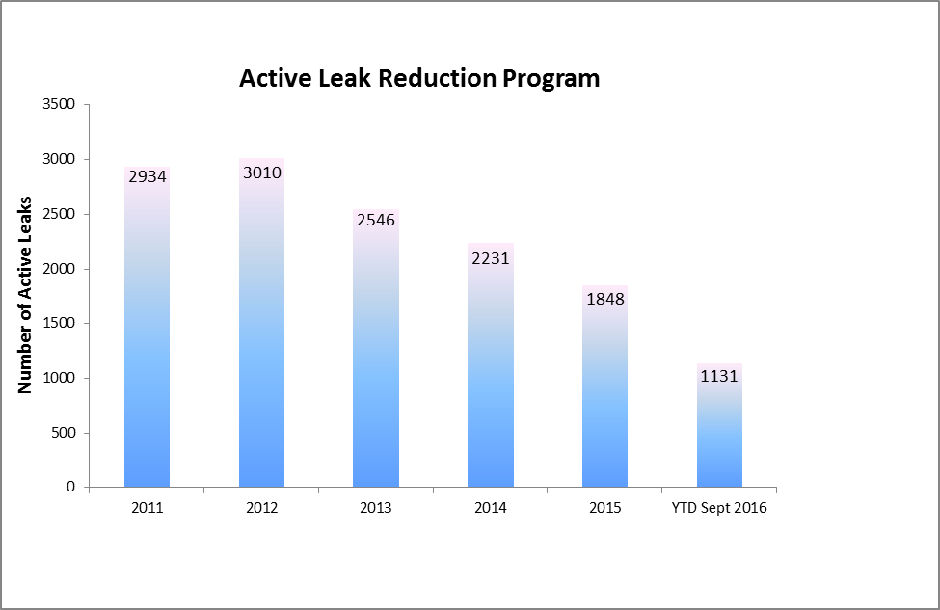

Through the addition of gas infrastructure since 2011, PSE has been able to keep pace with the growing load while decreasing the use of temporary cold weather actions. PSE continues to develop long range plans to ensure pipeline capacity meets demand as the load grows.
Through PSE’s cross bore inspection program, PSE is diminishing both the legacy risk and future risk of cross bores by inspecting areas that have a higher occurrence of historical cross bores and by performing a “post work” camera inspection for cross bores on newly installed pipelines. Further, as a result of PSE’s cross bore awareness outreach and communication efforts, PSE has seen a trended increase of 100% in calls regarding blocked sewer concerns; these results indicate that PSE is providing the opportunity for the public to both prevent damage and address potential safety concerns.
Q. Are there other examples of changes and improvements that have resulted from PSE’s commitment to operational excellence?
A. Yes. PSE’s commitment to operational excellence resulted in several changes and improvements since 2011.
Service Providers
By May 1, 2011 PSE had replaced its historical service provider contracted workforce with Infrasource for construction and maintenance work. Then in 2016, PSE contracted with Hydromax USA (“HUSA”) for leak survey work, replacing Heath and Survey and Analysis, which previously performed this work. These changes brought the integration of improved technology to ensure consistent work performance, including newer technology methane detection devices, improved electronic data recording tools, and advanced GPS tracking equipment.
Structural
In July 2015 PSE transitioned routine preconstruction work, including design, project management and customer interface from its gas and electric service providers to PSE. Since 2000 PSE had utilized a service provider to provide both gas and electric services from customer initiation and project management through construction. In 2014 PSE recognized that a change for the preconstruction work would afford the opportunity to improve customer service and assure sustainable workforce expertise needed for this important work going forward. This change provides PSE greater transparency into the work processes and enables PSE to coordinate all work more effectively. Continuous improvements of work processes will drive additional efficiencies moving forward. Since making this change PSE has seen a 25% reduction in construction related complaints when comparing performance in 2014-2015 to performance in 2015-2016. PSE’s costs for preconstruction work is comparable to costs prior to the transition. The construction scope of work remains with the service providers.
Processes and Work Practices
PSE’s emergency response structure and processes have been enhanced with the full implementation of PSE’s Gas Planning Strategy Committee under the Incident Command Structure as well as through the development of the Gas Incident Investigative Team, which comes together in large incidents to provide strategy and planning beyond making the situation and scene safe.
PSE also participates in the Western Regional Mutual Assistance Agreement, which holds annual mock drills to test the intercompany communication and support processes. These process improvements have increased PSE’s emergency readiness overall through practice and communication tools and improved efficiency by aligning with industry and regional practices.
Increased emphasis on greenhouse gas reduction has resulted in numerous policy changes and proposed regulations at the federal and state level. Industry has responded by participating in voluntary programs to reduce emissions from their operations and PSE has been a part of that through its aggressive reduction of non-hazardous leaks, minimizing construction practices that purge gas to the atmosphere, and driving down third-party damage that creates leaks.
Q. Are there tools that have been helpful for PSE to meet its key objectives and better serve its customers?
A. Yes. PSE believes the Pipeline Replacement Program – Cost Recovery Mechanism (“Gas CRM”) has been instrumental in helping PSE enhance pipeline safety and provide transparency to PSE’s plans and priorities. PSE has ramped up the DuPont pipeline replacement program as a direct result of the Gas CRM. The Commission Policy on Accelerated Replacement of Pipeline Facilities with Elevated Risk (“Accelerated Replacement Policy”) identified several barriers for utilities to replacing elevated risk pipeline expeditiously such as: construction limitations; retaining a sustained qualified workforce due to uncertainty in the amount of pipeline replacement work done year to year; cost, recognizing that this work does not produce new revenue making the economics of pipeline replacement more challenging; and lack of information about location. These barriers have been removed through PSE’s participation in the Gas CRM. The ability to commit resources to this program has reduced project risk by allowing PSE to maintain a qualified workforce focused on pipeline replacement and coordinate more effectively with cities and counties. The ability to mitigate the regulatory lag between investment expenditure and recovery in rates has allowed PSE to focus on this program and ultimately has reduced pipeline safety risk as the higher risk pipe is replaced at an accelerated pace. Additionally, with efforts completed in 2016, PSE has confirmed the location of higher risk pipe. Through this program, PSE has been able to replace 30 more miles per year of aging pipe than it did prior to the Gas CRM implementation, and PSE estimates it has prevented 30 failures of pipe that would cause a leak.
Q. Are there other objectives that are important to PSE in the upcoming years?
A. Yes. PSE’s Automated Meter Reading (“AMR”) system is approximately 15 years old and approaching its end of life. Approximately 300,000 gas modules are projected to have expiring batteries in 2016-2020, based on a 10 year battery life. These battery replacements plus the failure rates for gas modules yield an annual module attrition rate between 8.5%-20% for 2016-2020. Historical annual attrition rates for electric meters are near 1.6% and AMR network equipment is near 4%. The forecast for future gas module failure rates is based on a PSE-commissioned study. As a result, repairing AMR equipment and replacing batteries in the AMR technology, which faces other failures and cannot meet the advanced capabilities customers are seeking, is not reasonable or sustainable. Additionally, PSE’s ability to timely and accurately bill customers becomes more difficult with the failing AMR units, but is enhanced with a transition to AMI. PSE is in the early stages of this replacement effort. PSE’s recovery request will be based on known and measurable costs and benefits when these assets are being placed in service; PSE is not seeking preapproval in this case. PSE’s customers will benefit from this transition in the following ways:
- by the avoided cost of installing and maintaining an obsolete AMR system;
- through decreased energy consumption and bills, as PSE is able to implement more conservation voltage reduction; and
- by increased reliability, as PSE is able to utilize the communication system for implementing distribution automation.
Over time, PSE expects to implement additional features that drive process improvement and enable customer control of advanced options.

III. ELECTRIC INFRASTRUCTURE, SERVICE, AND OPERATIONS
Q. Please describe PSE’s primary objectives for electric operations over the last few years.
A. PSE is dedicated to providing quality customer service and delivering energy safely, dependably, and efficiently. Primary objectives for electric operations are similar to ones for natural gas operations and allow us to achieve these important goals. These objectives are (i) maintain and improve customer and public safety, (ii) enhance system reliability and resiliency, and (iii) meet the growth and service needs and expectations of our customers and communities. Operational excellence is a cornerstone for how PSE addresses these important objectives for electric operations. PSE strives for operational excellence by reviewing performance and practices, utilizing performance trends to inform improvements and changes, making work plans and performance transparent to confirm progress, and staying attuned to industry practices and policy changes.
Examples of how PSE is achieving these objectives are described throughout my testimony.
Q. Please describe how PSE has focused on maintaining and improving customer and public safety.
A. PSE complies with all applicable safety regulations and implements policies and procedures for the safe delivery of electricity. Each year, PSE continues to commit resources and further engage our customers and the public in effective safety messaging utilizing multi-media platforms. Since 2011, PSE has increased its public awareness and outreach effort regarding safety around downed power lines and damage prevention, to help keep the public safe.
To enhance regional safety along public roads, PSE coordinates with local and regional governments to relocate electric infrastructure out of hazardous locations. For example, in 2012 PSE entered into an agreement with the WSDOT to proactively relocate poles and structures within state designated clear-zones. The location of identified poles and structures potentially poses a safety concern relative to WSDOT Target Zero goals which aims for zero highway deaths by 2030.
Events like storms, vehicle/pole accidents, and third-party damage can create the potential to put the public at risk. PSE continues to be highly responsive to emergency situations. For example, when outages and emergencies occur, PSE responds swiftly by identifying the problem and works to restore power. In 2015, the average time from customer call to arrival of field technician was 54 minutes, which is within the SQI threshold of 55 minutes.
The Critical Infrastructure Protection Standards within the North American Electric Reliability Corporation (“NERC”) Reliability Standards are just one set of standards that is driving greater security over critical electric infrastructure. PSE is committed to meeting these standards and has taken appropriate measures that protect PSE’s system and customers. PSE made security enhancements both for physical as well as electronic security of its critical locations. To address physical security, PSE installed tall, barbed wire fences and security cameras. PSE also enhanced and secured entry systems into critical sites as identified in NERC standards. To address cybersecurity, PSE installed infrastructure with firewalls, password protections and implemented continuous training for all employees on identification and process for reporting any suspicious activities or sabotage.
Q. Please describe how PSE has focused on enhancing system reliability and resiliency.
A. Reliable power is increasingly important to customers and essential for business, schools, hospitals, manufacturing, and homes. We know that our customers depend on reliable power more than ever due to increased use of electronics for work, education, security, and recreation. To achieve greater reliability, PSE continues to assess and invest in its transmission and distribution infrastructure and replace or rehabilitate key assets in its aging infrastructure. PSE is committed to improving reliability and enhancing customer satisfaction. Its continued efforts to modernize the grid and install or upgrade equipment throughout its territory are some steps PSE has taken to improve reliability and resiliency. Specific examples are discussed later in this testimony.
As directed by the President through memorandum on January 9, 2014, the Department of Energy initiated a Quadrennial Energy Review delivering the first focus on the nation’s infrastructure for transmitting, transporting, and delivering energy. The findings note the continued need for infrastructure that supports movement towards a more modern grid to facilitate the reliability and resilience that enable functions across all other critical infrastructures.
On a local state level, Governor Jay Inslee launched, on November 4, 2016, a new Resilient Washington subcabinet charged with addressing major disruptions, including to utility services, in a catastrophic seismic or tsunami event. The subcabinet will rely heavily on the expertise of the Washington State Seismic Safety Commission that, in a 2012 report, set specific target states of recovery for critical services and utility sectors including for transmission and distribution systems.
PSE is committed to harden its delivery system such that damage during extreme weather or other natural caused events is minimized. Its investment in resiliency technologies aligns with the customer’s desires and needs, and with increased national, state, and industry focus on reliability and resiliency of the electric grid. PSE continues to develop plans and strategies to extend the life of its aging assets and ensure their adequate and timely replacements or rehabilitation aligning its strategic planning and improvement initiatives with the consumer’s interest.
PSE meets NERC Reliability Standards, which require plans and infrastructure that ensure the reliability of the Bulk Electric System (transmission systems operated at voltages of 100 kV or higher) and meet the electricity needs of end-use customers even when unexpected equipment failures occur. Plans must be implemented that prevent widespread cascading outages in the Bulk Electric System under certain contingency conditions. These standards drive the impact analysis of both near and long term system performance and resource allocation for demand growth and timely implementation of needed infrastructure improvements. By complying with NERC standards PSE also contributes to the reliability of the region’s interconnected transmission system.
Q. Please describe how PSE has focused on meeting growth and service needs of customers and communities.
A. Since 2011, PSE has added 23,760 new electric customers, averaging 0.5% growth per year (through 2015) and forecasts 1.2% growth over the next few years. PSE has in place an Integrated Resources Plan and operational strategies to address this growth demand. Even with PSE’s successful conservation programs and an overall low growth rate, there are still areas of stronger localized growth (i.e., 1.5% growth in King County) that require PSE to develop reliability solutions to accommodate growth and meet our customers electrical needs.
Q. Please describe how PSE has focused on operational excellence and continuous improvement.
A. PSE participates in various industry organizations, forums, events, and activities to ensure that we are aware of best practices, and continually improving our practices and learning with others. For example, PSE is active with the Institute of Electrical and Electronics Engineers, which allows PSE to stay current on best practices and standards with respect to transmission and distribution system operations. PSE also participates in Western Energy Institute forums to discuss electric operations and business strategies.
As discussed earlier in this testimony, PSE values sharing work plans, project and performance information unless precluded by specific restrictions. The publically available annual Service Quality and Electric Service Reliability Report not only highlights PSE’s performance in meeting service quality objectives, but also provides extensive information about PSE’s reliability performance, reliability programs, and customer reliability complaints and inquiries. Information about system improvement projects and programs and information about electric system reliability is available on PSE.com. In addition, PSE inputs longer term project plans to local governments as part of their comprehensive plans.
Other examples of improvements PSE has made to key processes include storm and emergency management, providing information to customers about the status of outages, and improved customer experience for new customer construction work. These improvements have resulted in better service and lower costs for our customers and they are discussed later in my testimony.
Q. What processes has PSE put in place to support and implement these key objectives?
A. PSE utilizes the same planning process for both gas and electric infrastructure planning as described earlier in my testimony.
In comparison with the pipeline distribution and transmission integrity management programs, PSE implements similar strategies for managing its electric assets and aging infrastructure. PSE’s Aging Infrastructure Replacement Program addresses aging equipment that creates the greatest risk to reliability by assessing the potential consequence of failure and the likelihood of failure based on life cycle curves. PSE’s Electric Asset Management Strategy documents the population, on-going maintenance activities, and end of life criteria for elements of the electric infrastructure. When end of life criteria are met, projects are proposed to replace or extend the life of the asset in alignment with the planning process described above.
Q. Please explain how these processes drive PSE’s decisions regarding capital investments.
A. PSE applies these processes to its key objectives and develops a multi-year plan that sets forth the planned capital expenditures. Since 2011, PSE has invested $1,323 million in capital expenditures to enhance the electric system. These investments primarily drive improvements in system reliability, support customer growth, and allow PSE to effectively and safely relocate electric infrastructure located in areas affected by public improvement work undertaken by local jurisdictions. Figure 3 shows expenditures from 2011 through September 30, 2016 according to the following spending categories: Reliability, Growth and Public Improvement.
Figure 3. Actual Capital Expenditures by Category: 2011 through 9/30/2016
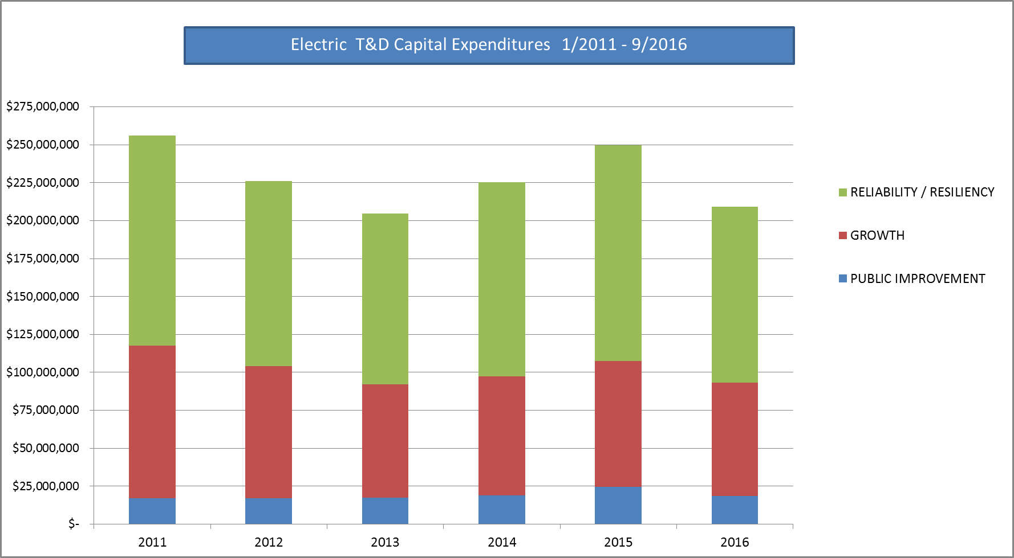
Please see Exhibit No. ___(BKG-3)
Q. What are the key accomplishments and benefits to customers from these processes and investments?
A. Since 2011, PSE has made significant investments that allow us to provide safe, dependable, and efficient services that focus on our customers. Key accomplishments and associated benefits are as follows:
- PSE has implemented targeted reliability such as installing tree wire, which is a tough thick-coated power line capable of withstanding contact with tree branches that would otherwise cause an outage, or installing recloser switches that sense a fault on a power line and automatically attempt to re-energize the line if the fault is no longer present. As a result of these investments, an estimated 184,000 non-storm customer power interruptions have been avoided since 2011. In other words, an estimated 184,000 customers have not experienced an outage that they would have otherwise experienced without PSE’s reliability improvements.
- PSE has hardened its electric system through proactively replacing 6,595 poles and treating 53,335 poles with a fumigant to extend their useful life. Additionally, by replacing or remediating 246 miles of underground electric distribution cable, an estimated 34,000 customer interruptions have been avoided.
- PSE added 23,760 new customers over the course of five years, yielding a total of 2.2% growth in that time period, and scaled and upgraded its infrastructure to support this growth.
- PSE executed 750 electric projects between 2011 and 2015 to deploy or relocate infrastructure that was in conflict with public improvement projects. The working relationships PSE established with regional government entities facilitated greater coordination and avoided potential conflicts.
- As discussed in the Prefiled Direct Testimony of Michael Mullally, PSE installed a 2.5MW battery system in Glacier, to enhance system reliability in the area and provide power to customers in the event of an outage.
- As part of its reliability efforts, PSE is piloting new technologies for improved reliability such as: Tripsavers, which replace traditional fuses with single phase reclosers that attempt to reclose after a fault; and Tollgrade Sensors, which help to identify fault location beyond the switch for troubleshooting on-going reliability issues.
PSE remains dedicated to improving the reliability and resiliency of its system; however, PSE must balance system performance and improvements with costs to ensure the greatest value is achieved.
Q. What drives changes in the work plan?
A. The work plan can change for the same reasons as described earlier in my testimony relative to gas infrastructure work. Additionally, for the electric system, storms and emergencies can significantly impact PSE’s scheduled work plan. For example, in 2015 PSE experienced five major storms which resulted in 18 days of weather related regional system outages. When these storm-related events and outages occur, PSE redirects its focus from planned system work to emergency work and adjusts its work plan accordingly.
Q. Please describe how PSE confirms that its reliability investments deliver the intended result.
A. PSE validates the efficacy of the investments made by examining the performance before and after a project has been completed. This process is called “backcasting.” It evaluates a sample of the reliability work performed to confirm benefit realization. The conditions that created the reliability concern may not reoccur until sometime in the future (i.e., similar wind or storm events); therefore, the benefits are confirmed a few years after the projects are completed.
Q. Please provide some examples of reliability improvements that PSE has achieved.
A. Table 1 below summarizes backcasting results for cable replacement, tree wire installation, and #6 copper wire replacements between 2010 and 2014. This analysis shows that the investments have provided reliability benefits as expected 95-100% of the time. With these investments an estimated 52,300 customer interruptions are prevented each year under similar conditions.
Table 1. Backcasting Data
2010-2014 work |  | Planned Estimate |  | Actual(After Construction) |  | Outages Saved | % outage benefit achieved
Program | # of Projects Studied | Customer Interrupts | Outages | Customer Interrupts | Outages
CRP - Cable Replacement | 156 | 8,429 | 115 | 0 | 0 | 115 | 100%
Tree wire | 38 | 35,729 | 51 | 2,427 | 3 | 49 | 95%
#6 Copper Wire Replacement | 29 | 8,142 | 19 | 201 | 1 | 18 | 96%
As discussed in this testimony, PSE has been making effective reliability investments; however, PSE has seen an increase in both tree related and equipment failure caused outages despite these reliability investments. PSE’s reliability performance for non-storm power outage duration (“SAIDI”) and the number of power outages (“SAIFI”) is generally below the performance of regional peers. A comparison of Washington regulated utilities (PSE, PacifiCorp WA, and Avista) as well as Seattle City Light and Portland General Electric is shown in Figure 4.
Figure 4. SAIDI and SAIFI Comparison among Utilities
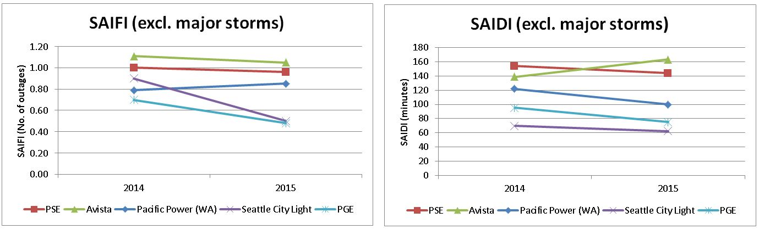
Q. Please describe what steps can be taken to further improve reliability.
A. PSE’s reliability work over time has been successful as demonstrated by backcasting data. However, there is still progress to be made if PSE is to drive sustainable improvements beyond historic levels. PSE has been experiencing an increase in tree and vegetation outages by approximately 23% a year since 2013. With 75% of PSE’s circuits having trees along them, a more aggressive and targeted approach to system hardening is necessary in order to make an impact on reliability beyond historic levels.
PSE has invested approximately $314 million between 2011 and September 2016 on planned reliability improvements specifically targeted at reducing the number and frequency of outages. Of this amount, $50 million has been spent on targeted reliability improvements on what PSE has identified as its “worst performing circuits” and $104 million has been spent on the underground cable replacement program.
PSE’s worst performing circuits are published in the annual Service Quality and Electric Service Reliability Report. PSE has made progress on improving the reliability of it worst performing circuits and has reduced the percentage of contribution that these circuits have on customer minutes interrupted (“CMI”) by 2-4% per year. However, reliability problems on these circuits can be difficult and more costly to resolve as they tend to be long radial circuits or on right-of-way that is more difficult to work in and requires solutions that may be more costly. Further, PSE must balance investments needed to drive improved reliability on other poorer performing localized “pockets” of the electric system. In other words, to maintain overall system reliability PSE must also make investments on subsections of the electric system that are not located on the worst performing circuits.
Relative to equipment failure, PSE is experiencing an increase in power outages that are caused by underground cable failures at a rate of 8% a year since 2013. Most cable failures are occurring due to deteriorating high molecular weight (“HMW”) cable that was installed prior to 1982. PSE knows where these assets are located and has been replacing this HMW cable since 1990 as it fails. In 2016 PSE ramped up replacement due to the increasing failure rate, beginning the plan for accelerating the replacement of the entire population. A more sustained and aggressive approach to replacing this underground cable will result in reductions to cable caused power outages.
Q. Are there mechanisms or programs that could allow PSE to increase electric reliability and serve its customers better?
A. Yes. A model similar to the Gas CRM would be beneficial in enhancing PSE’s electric reliability. By allowing PSE to recover prudently incurred costs related to the repair, improvement, and replacement of specific, targeted aging infrastructure through an electric cost recovery mechanism would allow PSE to maintain and improve the efficiency, safety, reliability and resiliency of the existing infrastructure at a faster pace than done historically.
Q. What are the specific, targeted investments on which an Electric Cost Recovery Mechanism would focus?
A. PSE proposes an Electric Cost Recovery Mechanism focus on (i) accelerated replacement of underground distribution HMW cable, and (ii) aggressively addressing the worst performing distribution circuits.
Q. What are the reasons for focusing on these two areas?
A. There are several reasons why PSE proposes to focus on these two areas of targeted investment.
Securing needed resources and commitment to long-term efforts
First, while PSE has been addressing both aging underground cable and the worst performing circuits, the work plans vary from year to year and the lack of consistency in the amount of work performed creates construction and efficiency challenges. A consistent work plan would lead to more efficient scheduling, engineering, and working with stakeholders as well as allowing PSE to consistently secure qualified workers to meet the work plan necessary to address reliability.
Commitment with permitting agencies
Given the ever increasing need to work with local and state agencies, PSE has found it, at times, challenging to align the proper permitting and access needs with our plans and intentions to meet work schedules. For example, a majority of the solutions for the worst performing circuits are located along state right-of-way which requires significant coordination with the state Target Zero efforts. A focused, long-term initiative to address these circuits would facilitate more effective coordination with these state and local agencies.
Holistic portfolio of work
PSE’s current prioritization methodology, described earlier in my testimony, prioritizes reliability improvements that have the greatest benefits for the cost. This generally focuses reliability investments on circuits and locations with more customer density, but tends to constrain investment on circuits that have a lower number of customers. A structured mechanism would provide an incentive for investment in identified areas that may otherwise take PSE a substantial amount of time or resources to address, such as with the worst performing circuits. It would also provide incentive to address the failure prone underground cable before it fails, saving the customer from an unnecessary inconvenience and impact due to an outage.
Transparency
PSE believes overall greater transparency to its reliability work plan would bring increased collaboration and support to addressing these concerns. PSE envisions a process that would allow the Commission and Commission Staff the opportunity to provide feedback on investment plans as they relate to reliability and customer expectations.
Through these efforts, PSE will reduce the risk to projects and costs, and over time see a reduction to customer outages.
Q. Is PSE proposing an Electric Reliability Plan and associated Cost Recovery Mechanism?
A. Yes. Please see the Prefiled Direct Testimony of Catherine A. Koch, Exhibit No. ___(CAK-1CT), for the details of PSE’s proposal. In summary, PSE seeks approval of: 1) an Electric Reliability Plan that will target and accelerate replacement of HMW cable and improve the worst performing circuits, thereby reducing the number of outages and length of outages; and 2) a Cost Recovery Mechanism, which would allow for more consistent work planning and an accelerated recovery of the increased investment. PSE’s work plan with this mechanism could support replacement of approximately 160-195 miles per year of underground cable, as compared to PSE’s current performance of approximately 50-70 miles of underground cable replacement per year, and would also address approximately 40 of the worst performing circuits annually.
Q. What are examples of continuous improvements and what has been the benefit for customers?
A. PSE’s commitment to operational excellence resulted in several improvements since 2011.
Processes
Since the January 2012 storm, PSE has made significant improvement in its emergency response approach and has modeled the incident command structure that many companies and public agencies use to help manage emergencies. Clear roles and responsibilities are consistent from location to location and from event to event. PSE can quickly scale up or down as needed. Annually, PSE conducts training for all storm roles and practices using a mock storm event. As emergency events are anticipated, PSE forecasts likely scenarios based on the best information available and prepares for what is likely to be needed in terms of logistics, equipment, people, and advanced communication. Through these forecasts, as well as enhanced training, greater emphasis on storms, and the increased number of mock drills, PSE is better positioned to respond to storm events in a timely and effective manner. PSE participates in mutual assistance plans that allow PSE to quickly scale its workforce, if needed, to manage the largest emergencies. Table 2 below shows that PSE has made strides in restoring more customers earlier in storm events.
Table 2. Percentage of customer restoration in storm events
Event Date | Storm Name | Event Duration (Hours: Minutes) | 25% into Storm | 50% into Storm | 75% into Storm
1/18/2012 - 1/28/2012 | January 2012 Storm Event | 261:58 | 42% | 82% | 98%
8/29/2015 - 9/4/2015 | August 2015 Storm Event | 151:00 | 86% | 95% | 98%
11/17/2015 - 11/21/2015 | November 2015 Storm Event #1 | 106:00 | 80% | 97% | 99%
Operational Technologies
By mid-2013, PSE completed the implementation and integration of an Outage Management System with the Customer Information System for use in predicting outages and improving estimation of and communication about restoration time to customers. With this technology, PSE is now able to make information about customer outage status available to customers through a variety of channels. During non-storm conditions, PSE has become more accurate in estimating power outage restoration for its customers. PSE is now within 58 minutes on average of its estimated power outage restoration time, which is down from 88 minutes in 2015.
Structural
As discussed in the natural gas section of this testimony, PSE has made a significant change in insourcing the project management, design, and customer interface for new construction and the preconstruction of electric and gas work. PSE has strengthened core expertise and overall customer service through this change.
Q. Are there other objectives that are important to PSE in the upcoming years?
A. Yes. PSE has been applying smart grid technologies across its system for several years and intends to further advance this objective in the upcoming years. For example, automated switching was installed in the 1970s, and automated meter reading was first installed in 1998 on PSE’s systems. As technology advances and is adopted by customers, PSE intends to ramp-up its grid modernization more aggressively, as envisioned by the industry, customers, and the State through its regulatory monitoring of smart grid initiatives. While keeping focused on the important elements of security, PSE will consider improvements that advance information technology, customer information and energy empowerment, and electric infrastructure. Replacement of the obsolescent AMR technology, as previously discussed, is a foundational step to enabling future customer and reliability benefits. Reliability improvements from enabled technologies like distribution automation and integration of new sources of supply will be key considerations as PSE tackles the worst performing circuits. There are broader benefits to customers and operational resilience gained by these efforts.

IV. CONCLUSION
Q. Does this conclude your testimony?
A. Yes it does.

Average for 2011 through 2015, 858 damages occurred through October, 2016.
Industry Works to Secure Natural Gas Supplies in Light of Increased Vulnerabilities - Dan Rueckert & Tom Strickland, March 12, 2015, breaking energy.com
isaccouncil.net
49 CFR Part 192 enacted August 2, 2011 require gas distribution companies to have developed a risk based approached to evaluating the safety conditions that affect pipelines.
National Transportation Safety Board Accident Report PAR-11-01.
AGA Chairman Tells Senate “Safety Is Our Core Value and Top Priority” -Terry McCallister, Chairman and Chief Executive Officer of WGL Holdings and Washington Gas and Chairman of the American Gas Association for 2015, September 29, 2015.
Commission Policy on Accelerated Replacement of Pipeline Facilities with Elevated Risk - Docket UG-120715, ¶ 12 (December 31, 2012).
Commission Policy on Accelerated Replacement of Pipeline Facilities with Elevated Risk - Docket UG-120715 (December 31, 2012).
Id, ¶ 58.
Older plastic pipes manufactured by DuPont may be prone to leaks and possible failure due to their age, composition, and manner of installation.
Washington State Economic and Revenue Forecast Council.
Submitted annually to the WUTC.
http://pse.com/inyourcommunity/pse-projects/system-improvements/Pages/default.aspx.
http://pse.com/aboutpse/SystemReliability/Pages/Gas-Reliability.aspx.
See, e.g., Docket PG-131839, Docket UG-120715.
Note 2016 actuals represent January 1 to September 30 only.
Implemented by PSE’s Business Continuity and Emergency Management Dep’t.
EPA Natural Gas STAR Methane Program.
Pipe susceptible to brittle-like cracking due to manufacturing or location of pipe can be more serious than a corrosion failure.
2015 Annual Puget Sound Energy Service Quality and Electric Service Reliability Report p. 6.
https://www.whitehouse.gov/the-press-office/2014/01/09/presidential-memorandum-establishing-quadrennial-energy-review
http://energy.gov/sites/prod/files/2015/04/f22/QER-ALL%20FINAL_0.pdf
http://www.governor.wa.gov/news-media/inslee-launches-new-resilient-washington-subcabinet-preparation-big-one
http://mil.wa.gov/uploads/pdf/seismic-safety-committee/RWS%20final%20report.pdf
Submitted annually to the WUTC.
http://pse.com/inyourcommunity/pse-projects/system-improvements/Pages/default.aspx
http://pse.com/aboutpse/SystemReliability/Pages/Electric-Reliability.aspx
Note 2016 actuals represent January – September 30.
Annualized based on five-year, non-storm outage history.
Annualized data.
While this comparison shows relative performance between utilities, there are variances in the way utilities calculate these measures and in the geography, topography, and weather that affect the results. For example about 75% of PSE right-of-way is flanked with trees whereas Seattle City Light serves customers in urban/suburban areas with many less trees.
Due to the process and data changes associated with implementing an outage management system (“OMS”) and geographic information system (“GIS”) in 2013, this comparison is made using post OMS data.
Average 2011-2015.
WAC 480-100-505.

