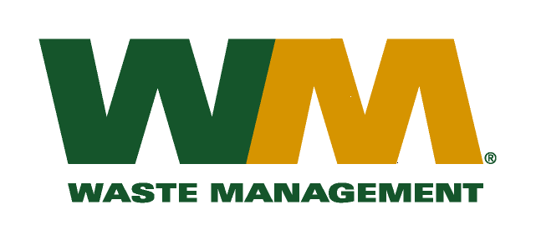
June 22, 2010
Washington Utilities and Transportation Commission
Chandler Plaza Building
1300 S. Evergreen Park Drive SW
P.O. Box 47250
Olympia, WA 98504-7250

Subject: Waste Management – Northwest, a division of Waste Management of Washington, Inc. (G-237); Tariff # 17 – TG-090759
Dear Sirs:
Enclosed are revised pages 2, 21, 22, 25, 26 and 27 to the above-referenced tariff. The purpose of these tariff revisions is to reflect the new expiration date for the customer rebates in the above referenced docket. .
If you have any questions or need additional information, please contact me at (425) 814-7840.
Very truly yours,

Mike Weinstein
Senior Pricing Manager, Pacific Northwest Market Area

cc: Dean Kattler
Nathan Caroll
Sego Jackson, Snohomish County Solid Waste Division
Matt Zybas, Snohomish County Solid Waste Division

