October 12, 2016  Via Electronic Filing and FedEx  David W. Danner  Chairman  Washington Utilities and Transportation Commission  1300 S. Evergreen Park Drive SW  Olympia, WA 98504 |  | Elizabeth Thomas  liz.thomas@klgates.com  T 1 206 370 7631

Re: | Docket No. UE-161123
Dear Chairman Danner:
Attached for filing in the above-referenced docket please find the following on behalf of Microsoft Corporation:
- Prefiled Direct Testimony of Irene Plenefisch, Exhibit No.___(IP-1T), along with accompanying Exhibit No.___(IP-2); and
- Prefiled Direct Testimony of Gary S. Saleba, Exhibit No.___(GSS-1T), along with accompanying Exhibit Nos.___(GSS-2) through ____(GSS-5).
Certain information in this filing is confidential per WAC 480-07-160 and has been designated accordingly.
Thank you.
Sincerely yours,
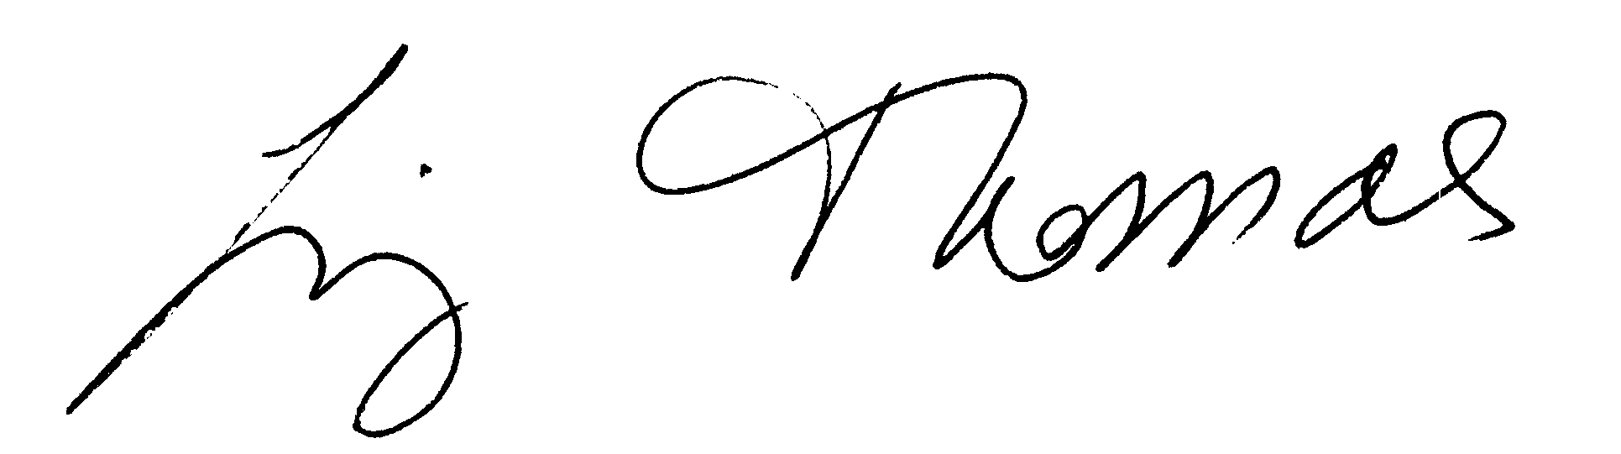
Elizabeth Thomas
Attachments
Cc: Jim Stanton
Irene Plenefisch
Tim Osborn
Jason Kuzma
Lisa Gafken, Public Counsel

