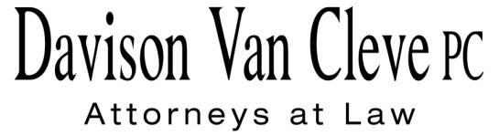
TEL (503) 241-7242 ● FAX (503) 241-8160 ● mail@dvclaw.com
Suite 400
333 S.W. Taylor
Portland, OR 97204

February 11, 2014

Via Email and Federal Express

Mr. Steven V. King
Acting Executive Director
Washington Utilities & Transportation Commission
1300 S. Evergreen Pk. Dr. S.W.
P. O. Box 47250
Olympia, WA 98504-7250

Re: WUTC v. Avista Utilities
Docket No. UE-140188

Dear Mr. King:

Enclosed for filing in the above-referenced docket, please find an original and twelve (12) copies of the Petition to Intervene of the Industrial Customers of Northwest Utilities.

Thank you for your assistance, and please do not hesitate to contact our office with any questions.

Sincerely,

/s/ Jesse Gorsuch
Jesse Gorsuch
Enclosures

cc: Service List

CERTIFICATE OF SERVICE

I hereby certify that I have this day served the attached Petition to Intervene upon all parties in this proceeding by sending a copy via electronic mail and by mailing a copy via First Class U.S. Mail, postage prepaid, to the following parties at the following addresses.
DATED this 11th of February, 2014.
Davison Van Cleve, P.C.

/s/ Jesse Gorsuch
Jesse Gorsuch

AVISTA CORPORATION  DAVID. J. MEYER  KELLY O. NORWOOD  PO BOX 3727  1411 E. MISSION AVE,  MSC-27  SPOKANE, WA 99220-3727  david.meyer@avistacorp.com  Kelly.norwood@avistacorp.com  WASHINGTON STATE  ATTORNEY GENERAL’S  OFFICE – PUBLIC COUNSEL DIVISION  SIMON J. FFITCH  LISA W. GAFKEN  800 5TH AVENUE, SUITE 2000  SEATTLE, WA 98104-3188  simonf@atg.wa.gov  lisaw4@atg.wa.gov | WASHINGTON UTILITIES & TRANSPORTATION COMMISSION  DONALD T. TROTTER  BRETT P. SHEARER  1400 S. EVERGREEN PARK DRIVE S.W.  P.O. BOX 40128  OLYMPIA,WA 98504-0128  dtrotter@utc.wa.gov  bshearer@utc.wa.gov

