October 22, 2012

David W. Danner, Executive Director and Secretary
Washington Utilities and Transportation Commission
1300 S. Evergreen Park Dr. SW
P. O. Box 47250
Olympia, Washington 98504-7250

RE: Washington Utilities and Transportation Commission v. NECC Telecom, Inc.
Commission Staff’s Response to Application for Mitigation of Penalties
Docket UT-120987

Dear Mr. Danner:

On July 31, 2012, the Washington Utilities and Transportation Commission issued a $2,100 Penalty Assessment in Docket UT-120987 against NECC Telecom, Inc. for 21 violations of Washington Administrative Code (WAC) 480-120-382, which requires competitively classified telecommunications companies to furnish annual reports to the commission no later than May 1 each year.

On August 13, 2012, NECC Telecom, Inc. wrote the commission requesting mitigation of penalties (Mitigation Request). In its Mitigation Request, NECC Telecom, Inc. does not dispute that the violation occurred. The company states, “Due to the transition between compliance companies and our previous company, Thompson Reuter dropping the ball on us. We no longer due business with them.”

It is the company’s responsibility to ensure that the regulatory fee and the annual report are filed by the May 1 deadline. On February 29, 2012, Annual Report forms and Regulatory Fee packets were mailed to all regulated competitively classified telecommunications companies. In addition to other information, the cover letter informed the regulated company it must complete the annual report form, pay any regulatory fees and return the material by May 1, 2012, to avoid enforcement action. On May 14, 2012, the commission mailed a letter to those companies that had not yet filed an annual report notifying them that, to date, they had incurred a penalty of $800. The letter went on to explain that companies who filed their annual reports no later than May 25, 2012, would receive mitigated penalties of $25 per day, with an additional $25 per day for each instance in the previous five years that the company received a penalty for filing a late report.

NECC Telecom, Inc. did not file its annual report by May 31, 2012, which is 21 business days past the deadline of May 1, 2012. The penalty is $100 per day, for a maximum penalty of $2,100. NECC Telecom, Inc. became regulated in September 2002 and received a penalty of $100, in 2006 for filing a delinquent annual report.

Based on the company’s delinquent annual report filing in the past, staff does not support mitigating the assessed penalty and recommends the request be denied.

If you have questions regarding this recommendation, please contact Mathew Perkinson, Compliance Investigator, at (360) 664-1105 or at mperkinson@utc.wa.gov.

Sincerely,

Sharon Wallace, Assistant Director
Consumer Protection and Communications

Attachment A
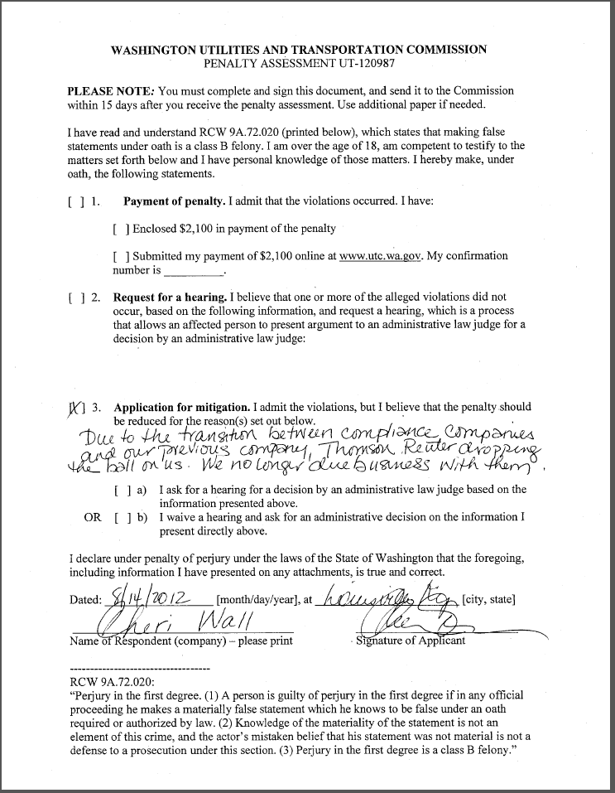
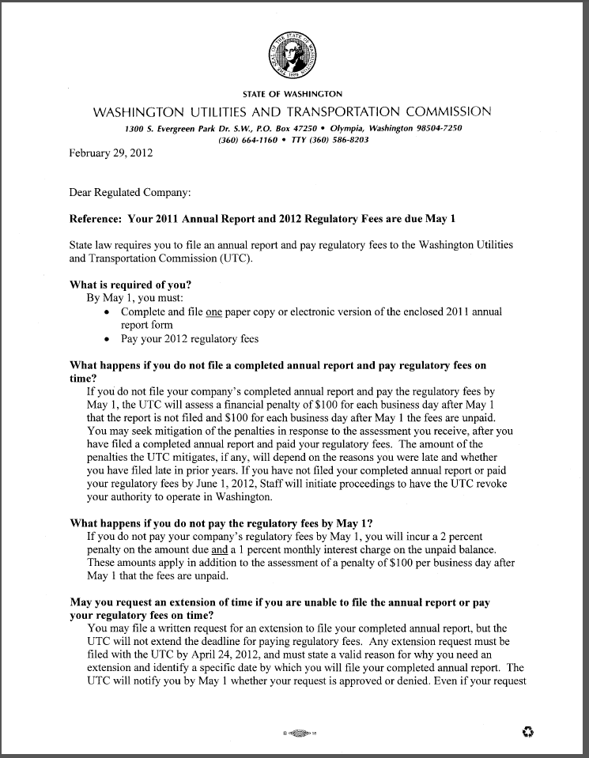
Attachment B
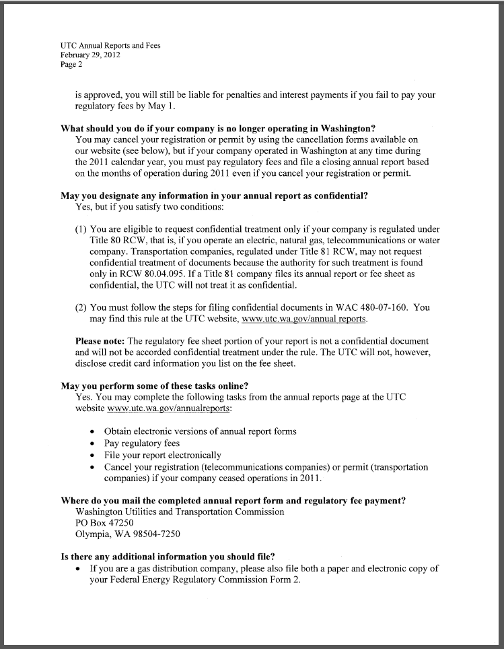
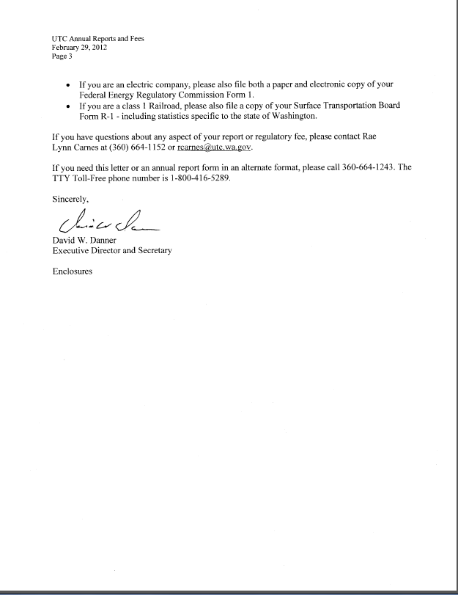

Attachment C
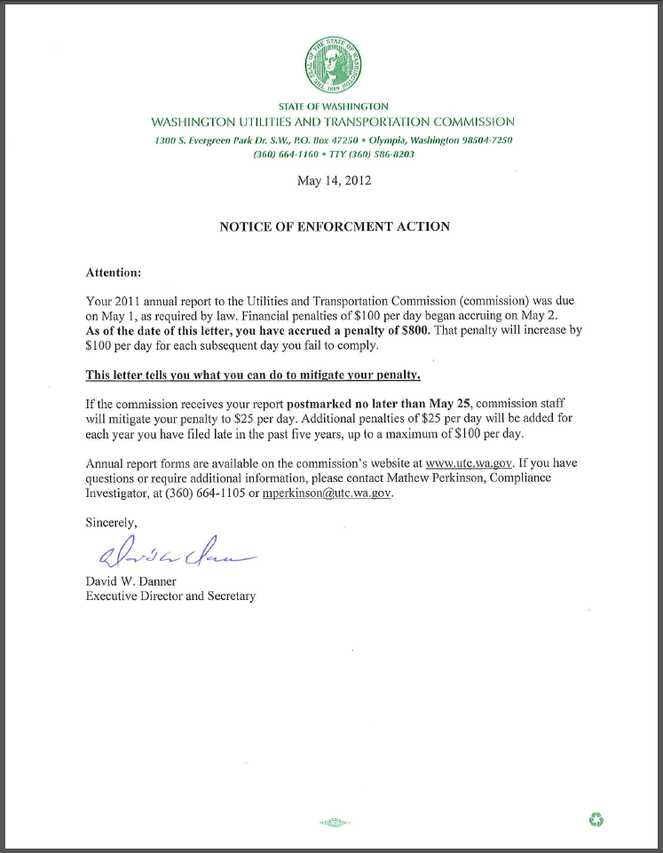

See attachment A for a copy of NECC Telecom, Inc.’s Mitigation Request.
See attachment B for a copy of the letter sent to all regulated companies on February 29, 2012.
See attachment C for a copy of the enforcement letter sent to the company on May 14, 2012.

