September 28, 2012

David W. Danner, Executive Director and Secretary
Washington Utilities and Transportation Commission
1300 S. Evergreen Park Dr. SW
P. O. Box 47250
Olympia, Washington 98504-7250

RE: Washington Utilities and Transportation Commission v. Tuebor, Inc.
Commission Staff’s Response to Application for Mitigation of Penalties
Docket UT-121017

Dear Mr. Danner:

On August 1, 2012, the Washington Utilities and Transportation Commission issued a $2,100 Penalty Assessment in Docket UT-121017 against Tuebor, Inc. for 21 violations of Washington Administrative Code (WAC) 480-120-382, which requires competitively classified telecommunications companies to furnish annual reports to the commission no later than May 1 each year.

On August 10, 2012, Tuebor, Inc. wrote the commission requesting mitigation of penalties (Mitigation Request). In its Mitigation Request, Tuebor, Inc. disputes the violations occurred. The company states, “Tuebor ceased offering service in November 2010, and no longer intends to retain authority in the State of Washington. Accordingly, we respectfully request that the Commission cancel TUEBOR’S authority effective immediately.”

A company that went out of business during the prior year but did not cancel its commission-issued permit or registration is not required to file an annual report or pay a regulatory fee. Therefore, the company is not subject to any penalties. Tuebor, Inc. failed to notify the commission it no longer intended to retain authority or cancel its permit, which is why the company received a penalty notice.

Based on the above mentioned information, staff recommends waiving any and all penalties related to Tuebor, Inc.’s 2011 annual report.

If you have questions regarding this recommendation, please contact Mathew Perkinson, Compliance Investigator, at (360) 664-1105 or at mperkinson@utc.wa.gov.

Sincerely,

Sharon Wallace, Assistant Director
Consumer Protection and Communications

Attachment A

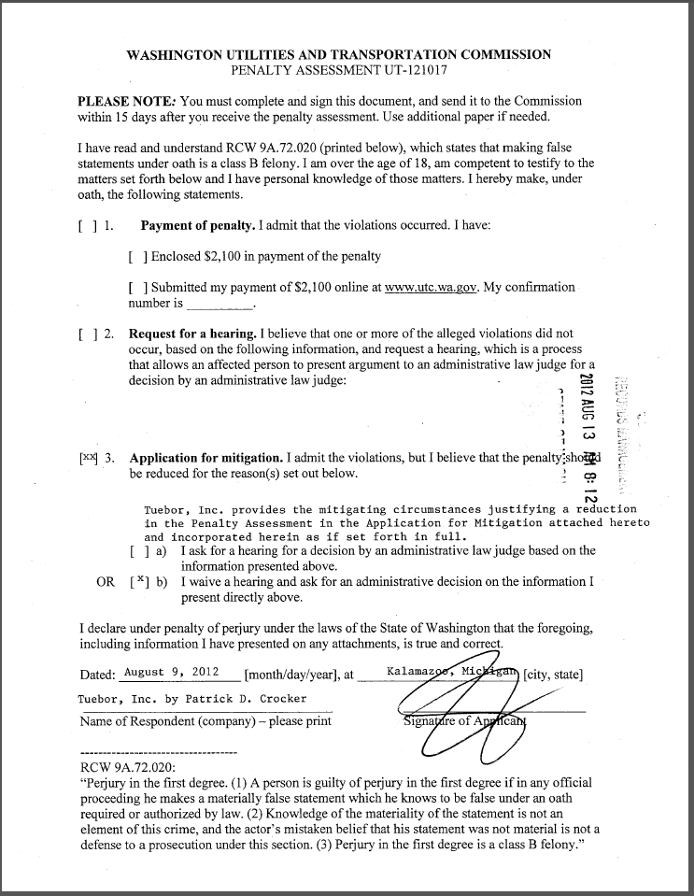
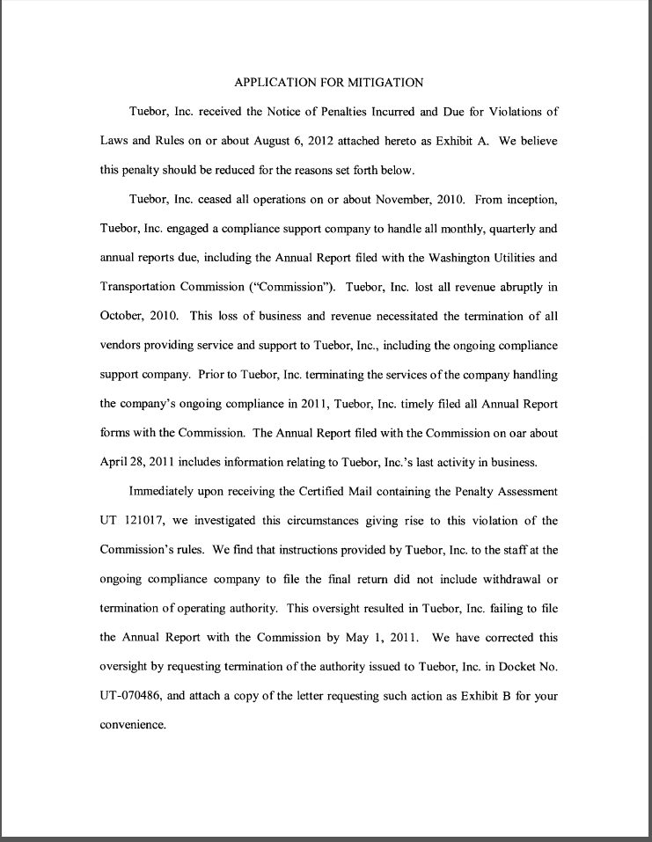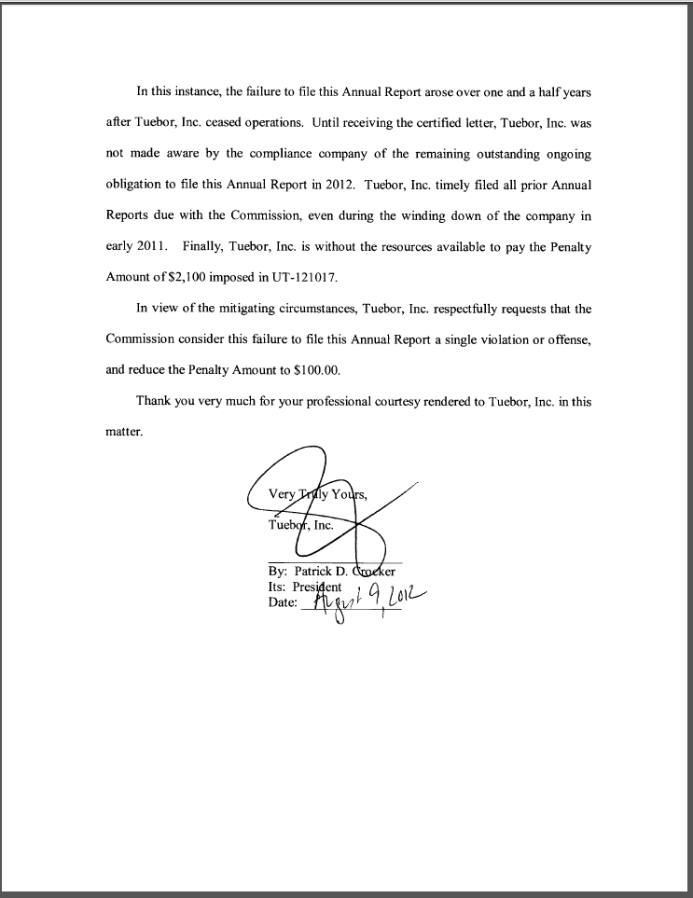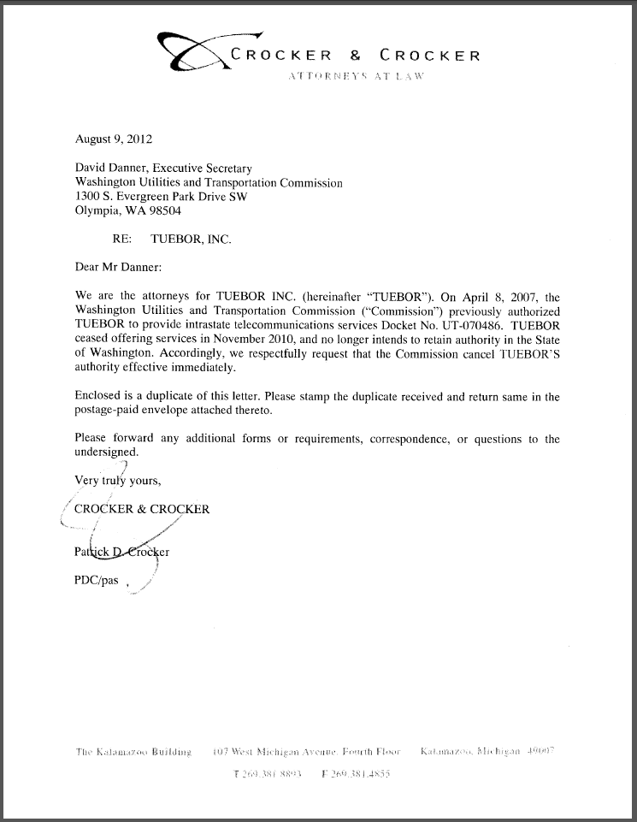

See attachment A for a copy of Tuebor, Inc.’s Mitigation Request.

