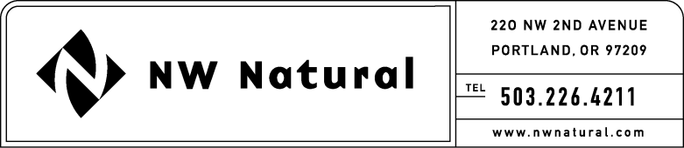
JENNIFER GROSS
Tariff and Regulatory Compliance
Tel: (503) 226-4211, ext. 3490
Fax: (503) 503-721-2516
jgg@nwnatural.com

Facsimile:

August 28, 2014

Steven V. King, Executive Director and Secretary
Washington Utilities & Transportation Commission
1300 S. Evergreen Park Drive, S.W.
P.O. Box 47250
Olympia, Washington 98504-7250

RE: UG-131473, NW Natural’s 2014 IRP Work Plan, Supplement No. 2

Northwest Natural Gas, dba NW Natural (“NW Natural” or the “Company”), herein files Supplement No. 2 to its 2014 Integrated Resource Plan Work Plan that was submitted August 12, 2013, in compliance with Washington Administrative Code 480-90-238.

If you have any questions regarding this plan, please contact me at 1-503-226-4211, extension 3590.

Sincerely,

/s/ Jennifer Gross

Jennifer Gross

enclosures

