Stephanie E. L. McCleery
stephanie.mccleery@klgates.com
T +1 503 226 5779
F +1 503 553 6279

June 29, 2015

Via FedEx and Electronic Submission
Washington Utilities & Transportation Commission
Attn: Steve King
1300 S. Evergreen Park Drive S.W.
Olympia, WA 98504-7250

Re: | In the Matter of the Formal Complaint by Frontier Communications Northwest Inc. against Puget Sound Energy, Inc. Regarding Unjust and Unreasonable Utility Pole Attachment Rates
Dear Mr. King,
Enclosed please find Frontier Communications Northwest Inc.’s Formal Complaint against Puget Sound Energy, Inc., with said enclosures.
Please do not hesitate to contact us should you have any questions.
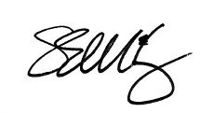
Best regards,
Stephanie E. L. McCleery
Enclosures

