July 13, 2016

Mr. Steven King
Executive Director and Secretary
Washington Utilities and Transportation Commission
1300 South Evergreen Park Drive SW
Olympia WA 98504-7250

RE: 2016 ETC Certification and Reports – Request for Certification Pursuant to WAC 480-123-060 and 47 C.F.R. §54.314 for Ellensburg Telephone Company d/b/a FairPoint Communications

Dear Mr. King:

Pursuant to WAC 480-123-060, Ellensburg Telephone Company d/b/a FairPoint Communications (“Company”) hereby requests that the Washington Utilities and Transportation Commission (“Commission”) certify to the Federal Communications Commission and the Universal Service Administrative Company that the Company has met the requirements of 47 C.F.R. § 54.314 for eligibility for continued receipt of federal high-cost funds.

The certifications and reports specified in WAC 480-123-060, WAC 480-123-070 and WAC 480-123-080 were filed on July 1. The enclosed replacement affidavit is being submitted in support of this request.

Sincerely,
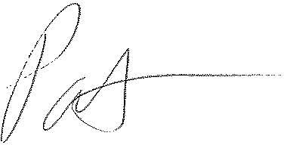
Patrick L. Morse
Senior VP Governmental Affairs
FairPoint Communications
P: 620-227-4409
F: 620-227-8576

