November 13, 2013

VIA WUTC WEB PORTAL AND REGULAR MAIL

Mr. Steven V. King
Executive Director and Secretary
Washington Utilities and Transportation Commission
P.O. Box 47250
Olympia, WA 98504-7250

Re: TC-120323 Unopposed Motion of Shuttle Express, Inc. for Extension of Time to Seek Administrative Review of Initial Order

Dear Mr. King:

Enclosed for filing in the above-referenced docket are the original and five (5) copies of the Unopposed Motion of Shuttle Express, Inc. for Extension of Time to Seek Administrative Review of Initial Order, with Certificate of Service.

If you have any questions, please feel free to contact the undersigned.

Respectfully submitted,

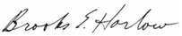

Brooks E. Harlow
Counsel for Shuttle Express, Inc.

cc:
ALJ Adam E. Torem (via email only)
Parties of Record

Enclosures
Docket TC-120323
CERTIFICATE OF SERVICE

I hereby certify that I have this day served the attached Unopposed Motion of Shuttle Express, Inc. for Extension of Time to Seek Administrative Review of Initial Order upon the persons and entities listed on the Service List below via e-mail and by depositing a copy of said document in the United States mail, addressed as shown on said Service List, with first class postage prepaid.

DATED at McLean, Virginia this 13th day of November, 2013.

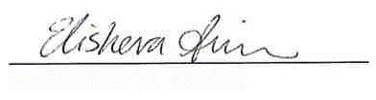 ELISHEVA W. SIMON
Commission Staff | Jennifer Cameron-Rulkowski  Assistant Attorney General  1400 S. Evergreen Park Drive S.W.  P.O. Box 40128  Olympia, WA 98504-0128 | jcameron@utc.wa.gov

