Cliff Notes Version of TE-161295

Steve Valentinetti & Team consider it “Continued Discrimination, Retaliation and Cover-Up” for the WUTC, Commission, Staff, AG’s office or whoever to continue after 3 years to hold Steve Valentinetti “Out of Business”. RCW 81.70.230(2). A certificate must be issued to any applicant who establishes proof of safety fitness and insurance coverage.
The Brief Hearing April 20th 2017 TE-161295 was not and should not be about discrimination, AMI Coaches or Airline Shuttle or Steve Valentinetti but the AG’s office directed the hearing. Washington State Law clearly states; A certificate must be issued to any applicant who establishes proof of safety fitness and insurance coverage. The real language of RCW 81.70.230. GO VIP met the insurance requirements of 5 million and proof, entry into a compliant Drug & Alcohol program, driver’s files, maintenance files, company policy & procedures, annual inspection etc. The words “any applicant who establishes proof of safety fitness and insurance coverage” is not subjective to whether you are black or white, nice to the WUTC or not, or if the applicant has filed a civil rights complaint or suit against the DOT or not but we are happy to show our hand since the DOT is so blatantly obvious. If your 24 year accident free transportation business that had established a great reputation for safe, professional, cost effective on-time service was torn apart by the Washington State Utilities and Transportation Commission by issuing false violations then holding the company out of business three years 3 years without any sort of review, you wouldn’t be respectful or nice either. There is no question this was a Racial driven attack by substandard WUTC employees.
AAG Robersons statement – Even if the Commission agreed that collaterally estopping Go VIP from contesting the violations amounted to legal error, or Steve Valentinetti’s companies had shown that it had not committed any regulatory violations, it should still deny the petition and affirm Order 01. Why would someone say that unless they are retaliating against the person?
Now, 3 years later the Attorney General’s office is attempting to protect the WUTC from a business interuption lawsuit is trying to discredit Steve Valentinetti by making statements that contain the words criminal, fraudulent, history of non-compliance, can’t be trusted, contradictory statements & unpersuasive evidence. These same tactics were used the WUTC and the FMCSA to obtain their goal to stop Steve Valentinetti from ever obtaining a Federal Contracts or large customers again by casting a shadow on Mr. Valentinetti’s ethics. AAG Roberson thinks the Commission is to LAZY to read the law for themselves and will just conform to whatever he says. Steve Valentinetti hopes that is not true and the Commission does it’s job and reviews or allows a hearing with evidence, witnesses, industry professionals etc.
Some Examples DOT with customers –
- University of Washington, “watch out for Valentinetti, he is under Federal Investigation”. “We can’t talk about the issues but I would keep him away from the kids”
- Chief Sealth International High School – “How did you get tangled up with Mr. Valentinetti”?
- Hainan Airlines – “Valentinetti is sleeping with one of your flight attendants” What? “Steve is Fu___ing one of your flight attendants”, “We don’t particularly like him. If you chose to keep using his company your landing rights may be compromised”
- Comfort Suites hotel – “better start looking for someone else”
- EVA Airlines – “Mr. Valentinetti is under investigation for crimes we can’t talk about”
- Amtrak – I just spoke with the driver who told me……

Some Examples DOT/AG writing –
- First, companies owned and operated by Mr. Valentinetti have a history of violating federal regulations
- also the insurance coverage that passenger carriers must maintain
- meaning that companies owned and operated have a history of violating state safety and insurance rules
- Mr. Valentinetti incorporated Go VIP and applied for a permit to evade the orders forbidding AMI and Airline Shuttle from operating to mask or conceal the history of non-compliance by companies Mr. Valentinetti has owned and operated.

One should take notice that the DOT’s / AG’s office written rants are just that. The DOT /AG’s office has been unable to prove in court/hearing or show, prove one thing that Steve Valentinetti has written has been false and likewise the DOT / AG has not been able to even identify or prove that even one of the violations are true. The DOT/AG knows they will lose any live challenge against evidence, witnesses, and definitions of law so the AG waits and writes for the record. Without question the commission should see that the AG’s office tried to cover up the largest false violation by WUTC’s David Pratt that carried a $25,000 fine and “Out of Business” forever “AMI Coaches does not have the authority as an Interstate carrier of passengers”. Pratt and the WUTC knowing the statement was false, if not before they sent it to Amtrak they knew 3 days later, refused to retract this damaging letter as Pratt & the WUTC believed Valentinetti & team were foreigners. (WUTC’s John Foster MCLE Special Investigator said it himself) “stick to Town Cars like the rest of your people”, “If you don’t change your attitude I will have you deported also”.

- WUTC’s David Pratt (May 15th 2013) letter to Rob Eaton, Director of Government Affairs Amtrak (in Pennsylvania) stating “AMI Coaches does not have the authority as an Interstate carrier of passengers”. We contacted AMI Coaches about this and recommended that the company follow up with the FMCSA to register as an Interstate carrier of passengers”.
- Commission Staff (“Staff”) deferred consideration of Go VIP’s application until the company provided all the necessary information, including proof of insurance. DOT staff poisoned the well of commercial insurance thinking we would be unable to get insurance after their phone calls to the insurance companies. Yes companies will testify.
- For reasons set out below, Staff recommends that the Commission deny Go VIP’s application.
RCW 81.70.230(2) requires the Commission to issue a charter party or excursion carrier certificate to an applicant that establishes proof of safety fitness and insurance coverage. WAC 480-30-121
These allegations, if not satisfactorily rebutted, support findings that Go VIP LLC is not fit to operate as a charter or excursion carrier, for two reasons. At TE-161295 AAG Roberson tried to knowingly illegally stop Steve from contesting the violations
Go VIP, may request a hearing to contest the factual allegations set out in this notice. DOCKET TE-161295 NOTICE OF INTENT TO DENY APPLICATION FOR CERTIFICATE;

WAC 480-30-221 adopts by reference a number of the federal regulation - WAC 480-30-011 = 49 CFR 13506

AMI Coaches
24 passenger bus, insured to 5 million, D & A in place from 2012 confirmed by WUTC’s Ray Gardner (Nov 2012) & WUTC’s John Foster (June 2013)
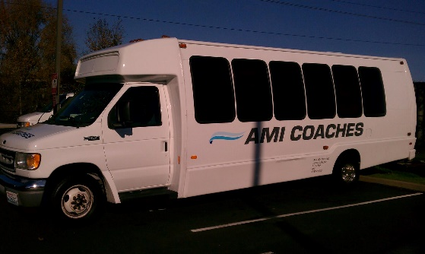
WUTC Authority November 2012, FMCSA Interstate Authority March 2013, - $5M insurance, US Health Works D & A Pre-employment & random. 1 motor coach, 1 - 24 pax bus, 2 vans passed inspection by WUTC’s Ray Gardner. (Nov 2013) Within 3 months of operation AMI Coaches booming success grew to 5 buses and took multiple sports team contracts from lackadaisical Starline and MTR Western including the Amtrak’s Emergency Service (Federal Contract).
False Violations against AMI Coaches - Staff makes the following factual allegations based on its review and investigation of the application. Did staff investigate or did Roberson?

* Authority to Operate $25,000 fine – oh, the WUTC forgot this one hoping it would go away because it is David Pratts false letter to Amtrak trying to stop AMI Coaches from taking another contract from their friends. proven false at TE-161295, see evidence
(1) did not have the necessary substance and alcohol testing program; proven false at TE-161295, see evidence
(2) knowingly allowed, required, permitted, or authorized an employee to operate a passenger carrying vehicle without the proper endorsement or intrastate restrictions during an interstate trip; False
(3) made a fraudulent or intentionally false entry on an annual inspection form; , knowingly false trying to shut down AMI Coaches, inspector or the DOT can’t remember why he wrote that.
(4) permitted drivers to make trips before receiving negative drug testing results; Driver were entered in 2 other CDL employer D & A pools. AMI Coaches has 30 days per law to add the new driver to our own pool.
(5) permitted drivers to make trips without a valid medical certificate; False
(6) failed to inquire about the driving records of drivers; False
(7) failed to make records of duty status; and False
(8) operated motor vehicles which were not periodically inspected as required. False, level 5 annual inspections were done by WUTC’s Ray Gardner

Airline Shuttle -

NON-CMV, NON CDL 14 passenger Hotel Crew Van, Insured to 1.5million, D & A not required but we added it anyway. Anyone with a Washington Drivers License can drive this vehicle (Vin# 1725) without drug testing as it is not a CDL Vehicle.
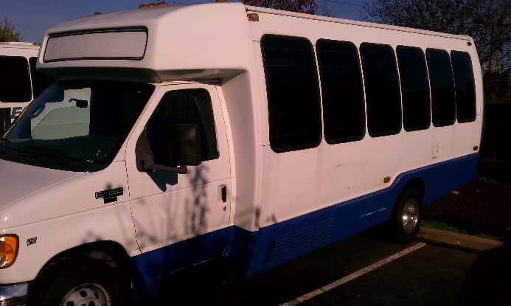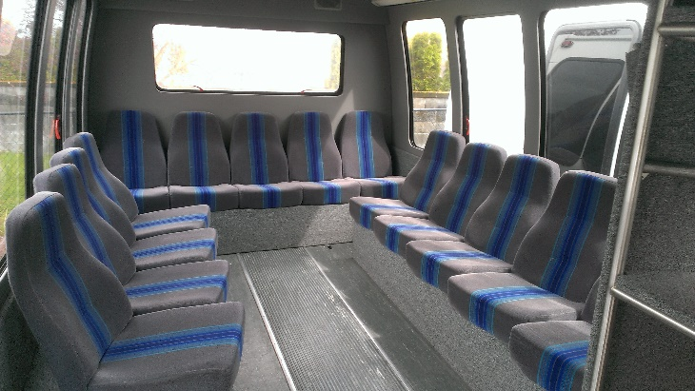
WAC 480-30-011 Exempt operations (State)
(6) Persons owning, operating, controlling, or managing taxi cabs, hotel buses, or school buses, when operated as such.
(9) Transporting transient air flight crew or in-transit airline passengers between an airport and temporary hotel accommodations
(11) Transporting passengers who have had or will have had a prior or subsequent movement by air

49 U.S. Code § 13506 - Transportation exemptions (Federal)
(3) a motor vehicle owned or operated by or for a hotel and only transporting hotel patrons between the hotel and the local station of a carrier;
(A) transportation of passengers by motor vehicle incidental to transportation by aircraft;
(10) a motor vehicle carrying not more than 15 individuals in a single, daily roundtrip to commute to and from work;

(1) did not have the necessary substance and alcohol testing program, proven false at TE-161295, see evidence
(2) failed to maintain proof of insurance at its principle place of business, proven false at TE-161295, see evidence
(3) operated a passenger carrier vehicle without the necessary levels of insurance, proven false at TE-161295, see evidence
(4) failed to make records of duty status, proven false at TE-161295, see evidence
(5) failed to maintain driver qualification files, proven false at TE-161295, see evidence
(6) failed to keep inspection and vehicle maintenance records, proven false at TE-161295, see evidence
(7) failed to require drivers to prepare driver vehicle inspection reports, proven false at TE-161295, see evidence
(8) operated motor vehicles which were not periodically inspected, proven false at TE-161295, see evidence
(9) failed to update its MCS-150 form, and Airline Shuttle is a hotel van and doesn’t need to have an MCS 150
(10) operated motor vehicles without the required marking. proven false at TE-161295, see evidence, Airline Shuttle is a hotel van and doesn’t need to have MC # CH # ES #, GVW or DOT #. It’s a hotel van.

Airline Shuttle - 3 years and 6 Corrective Action Plans later, still shut down without a hearing…….
- 1.5 insurance proven
- D & A proven – not needed for 14 passenger van but had anyway
- No DVIR’s – hotels don’t need DVIR’s
- Retain RODS (records of duty status) hotel vans don’t have to use DVIR’s or keep gas receipts.
- Improper van marking – Hotel vans don’t need DOT #’s or GVW etc.
- Anyone with a valid WSDL can drive a non-CDL hotel van w/o Drug and Alcohol testing (even though we had it)

Steve Valentinetti – 24 years companies accident free
GO VIP

