Agenda Date: October 27, 2011
Item Number: B4

Docket: TG-111681

Company Name: Mason County Garbage Company, Inc., G-88

Staff: Dave Gomez, Deputy Assistant Director

Recommendation
Staff recommends the commission issue a complaint and order suspending revisions to the company’s tariffs and allowing monthly recyclable commodity revenue adjustments filed by the company on September 16, 2011, as revised on October 17, 2011, and revenue sharing to become effective on November 1, 2011, on a temporary basis, subject to refund.

Discussion
On September 16, 2011, Mason County Garbage Company, Inc. (Mason or company), filed with the Washington Utilities and Transportation Commission (commission) revisions to its currently effective Tariff No. 13, designated as Tariff pages 1, 21 and 21A. The company filed replacement pages 21 and 21A on October 17, 2011, to revise the monthly recyclable commodity revenue adjustment originally filed on September 16, 2011. The stated effective date is November 1, 2011.
In its filing of September 16, 2011, Mason proposes to increase the amount it pays to single family customers for the value of the recyclable materials that the company collects in its residential recycling collection service. The monthly credit for single family customers would increase from $1.75 to $2.13. The company also requested the commission allow it to retain thirty percent of the revenue it receives from the sale of recyclable materials that it collects in its residential single-family recycling collection service from November 1, 2011, to October 31, 2012.
RCW 81.77.185 states that the commission shall allow a solid waste collection company collecting recyclable materials from residential single and multi-family customers to retain “up to fifty percent of the revenue paid” to the company for the material if the company submits a plan to the commission that is certified by the appropriate local government authority as being consistent with the local government solid waste plan and that demonstrates how the revenues will be used to increase recycling. The remaining revenue must be passed through to residential single and multi-family customers.
On September 16, 2011, Mason filed a letter, signed by company representative, Richard P. Fredrickson and John A. Cunningham, Interim Program Manager for Mason County Utilities and Waste Management, confirming continuance in the 2011-2012 plan year of the revenue sharing plan approved in 2010-2011. The 2010-2011 plan sets forth actions that Mason will take to increase recycling using recyclable commodity revenues retained by the company. The plan calls for thirty percent of the actual value of retained recyclable commodity revenue to be awarded to the company on the basis of:
  - Criteria “A” Detail - Meeting or exceeding data monitoring and reporting requirements - 10 percent award;
  - Criteria “B” Detail - Achieving and demonstrating an increase in recycling per household per month, year-over-year - 10 percent award; and
  - Criteria “C” Detail - Assisting the county in providing and operating a glass recycling box at county transfer stations – 10 percent award.
Mason’s filing of September 16, 2011, also included a letter from John A. Cunningham where he stated that the company had demonstrated to the satisfaction of Mason County that it had met the goals and objectives specified in the 2010-2011 plan.
Absent in the letter of September 16, 2011, was certification by Mason County (county) that the 2011-2012 plan is consistent with the county’s solid waste management plan and that the plan demonstrates how the revenues will be used to increase recycling. On October 19, 2011, the county filed with the commission its certification of the 2011-2012 plan which included an updated performance plan criteria scorecard from the one used in 2010-2011. The updated scorecard reflects new dates and objectives required for the company to retain thirty percent of the of the actual value of retained recyclable commodity revenue for the 2011-2012 plan period.
Staff examined the data submitted by the company in its filing of September 16, 2011, and concluded that the company had failed to achieve the performance requirements specified in the 2010-2011 approved plan, specifically Criteria “B” Detail. Table 1 below shows that to receive the full ten percent award, Mason would have had to increase household recycle pounds per-month to 31.85 pounds. The company’s actual result was 31.19 pounds per household. Consequently, the company must refund to customers $8,491.
On October 11, 2011, the company filed revised pages 21 and 21A to increase the monthly recyclable commodity revenue adjustment from $2.13 to $2.39, reflecting the refund. On October 19, 2011, the county notified staff that it concurred with the reduction in retained revenue. Table 2 below shows the amounts Mason retained and spent as part of its 2010-2011 plan.

Table 1, Mason County’s 2010 – 2011 Company Recycling Plan: Single-Stream Recycling Program Scorecard
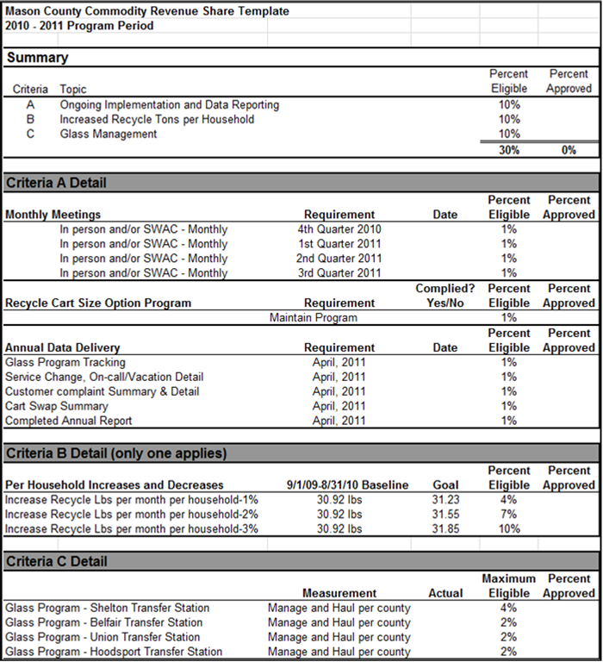

Table 2, 2010-2011 Recyclable Commodity Revenue Retained vs. Revenue Spent
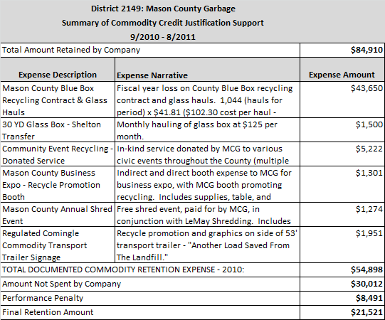

WAC 480-70-351 (1) provides, “[T]he commission encourages solid waste collection companies to develop programs intended to increase recycling. The commission will, among other things, consider whether a proposed program:
        - Provides an incentive to the party who controls the actions or behaviors that the program intends to change;
        - Defines measurable outcomes reasonably attributable to the proposed program; and
        - May have any unintended results or consequences.”
Staff notes that the company did not spend $30,012 (35 percent) of the retained revenue, and the company proposes to keep $21,521 (25 percent) of the retained revenue only because staff found the company had failed to meet a performance standard. Retained revenue is defined as a percentage (thirty percent in this case) of total revenue. Because total revenue increases or decreases with the change of tons collected and prices paid, the amount of retained revenue will also change. The potential for even greater amounts of unspent retained revenue exits if tons or prices increase. This issue is demonstrated in Dockets TG-111674 and TG-111672, revenue sharing filings by companies that share common ownership with Mason, that reported unspent retained revenue of $505,131, or 52 percent of retained revenue. Staff believes that the amount of Mason’s unspent revenue is an unintended result or consequence of the Company’s 2010-2011 plan and is otherwise contrary to the public interest. Further, Staff contends that there are no changes or safeguards in Mason’s proposed 2011-2012 plan that would prevent even greater unspent revenues. Consistent with WAC 480-70-351, the Commission should consider whether the proposed 2011-2012 plan may, likewise, have any unintended results or consequences.
Mason has not yet demonstrated the proposed revenue sharing is fair, just, reasonable and sufficient and, as a result, might injuriously affect the rights and interests of the public. Staff therefore recommends that the commission issue a complaint and order suspending revisions to Mason's Tariff No. 13, allowing monthly recyclable commodity revenue adjustments filed on September 16, 2011, as revised on October 17, 2011, and revenue sharing on a temporary basis, subject to refund.
Staff recommends the commission issue a complaint and order suspending revisions to Mason’s Tariff No. 13, allowing monthly recyclable commodity revenue adjustments filed on September 15, 2011, as revised on October 17, 2011, and revenue sharing on a temporary basis, subject to refund.
Conclusion
Issue a complaint and order suspending revisions to the company’s tariffs and allowing monthly recyclable commodity revenue adjustments filed by the company on September 16, 2011, as revised on October 17, 2011, and revenue sharing to become effective on November 1, 2011, on a temporary basis, subject to refund.

