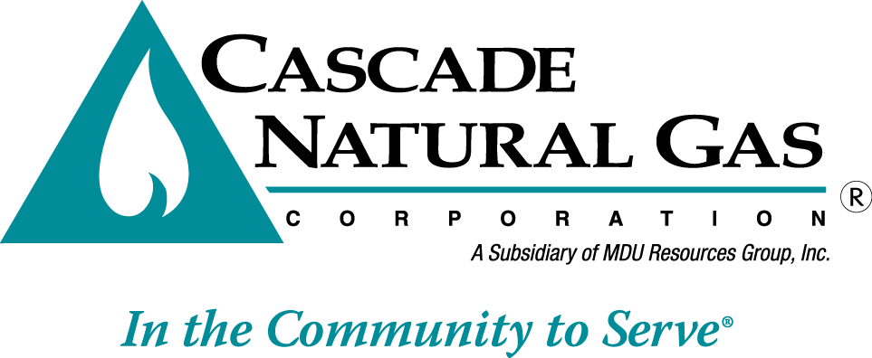
October 18, 2017 CNG/W17-09-04
8113 W. GRANDRIDGE BLVD., KENNEWICK, WASHINGTON 99336-7166
TELEPHONE 509-734-4500 FACSIMILE 509-737-9803
www.cngc.com

Mr. Steven V. King
Executive Director and Secretary
Washington Utilities & Transportation Commission
P.O. Box 47250
Olympia, WA 98504-7250

Re: UG-171009, Supplemental filing
Washington Energy Assistance Fund (WEAF) Program

Cascade Natural Gas Corporation (Cascade or the Company) submitted Advice No. W17-09-04 on September 29, 2017. The Company herewith files the following replacement sheet to that filing.

First Revision of Sheet No. 593

This replacement sheet is stated to become effective with service on and after November 1, 2017. All other sheets in Advice No. W17-09-04 (UG-171009) remain as initially filed on September 29, 2017.

The purpose of this supplemental filing is to revise the Schedule 593, Washington Energy Assistance Fund (WEAF) Program Cost Recovery rate in accordance with conversations with Commission Staff. Included in this filing are revised Attachments A and B. Attachment A, which shows program revenues and expenditures for the program year, is updated to include the financials for the final month of the program year. Attachment B, which shows how the Schedule 593 rate was derived, is revised to include the actual program year carryover. The methodology for determining the rate is also revised per conversations with Staff.

The change proposed herein to Schedule 593 decreases rates to all rate classes by 0.19%. The average
residential customer using 58 therms per month will see a decrease of $0.10 per month, the average bill
decreasing from $51.64 to $51.54 per month. The average commercial customer using 296 therms per
month will see a decrease of $0.43 per month, the average bill decreasing from $236.59 to $236.16 per
month.

This filing submitted electronically includes the following two files:

UG-171009, Advice No. W17-09-04 Supplement, CLtr, 10.18.17.pdf
UG-171009, Advice No. W17-09-04 Supplement, Sch 593, 10.18.17.pdf
UG-171009, Advice No. W17-09-04 Supplement, Sch 593 Leg, 10.18.17.pdf
UG-171009, Advice No. W17-09-04 Supplement, Attch A, 10.18.17.xlsx
UG-171009, Advice No. W17-09-04, Supplement, Attch B, 10.18.17.xlsx

If you have any questions, please contact Jennifer Gross at 509.734.4635.

Sincerely,

/s/ Michael Parvinen

Michael Parvinen
Director, Regulatory Affairs
Cascade Natural Gas Corporation
8113 W Grandridge Blvd
Kennewick, WA 99336-7166
michael.parvinen@cngc.com

Attachments

