July 3, 2014

Steven V. King, Executive Director and Secretary
Utilities and Transportation Commission
1300 S. Evergreen Park Dr. SW
P.O. Box 47250
Olympia, WA 98504-7250

RE: Washington Utilities and Transportation Commission v. Mark Doubravsky Trucking, Inc.

Commission Staff’s Response to Application for Mitigation of Penalties TV-140967

Dear Mr. King:

On June 5, 2014, the Utilities and Transportation Commission issued a $200 Penalty Assessment in Docket TV-140967 against Mark Doubravsky Trucking, Inc. for 2 violations of Washington Administrative Code (WAC) 480-15-480, which requires household goods carrier companies to furnish annual reports to the commission no later than May 1 each year.¹

On June 19, 2014, Mark Doubravsky Trucking, Inc. wrote the commission requesting mitigation of penalties (Mitigation Request).² In its Mitigation Request, Mark Doubravsky Trucking, Inc. does not dispute that the violation occurred. The company provided the report had been set aside without any regulatory fees due with family medical issues arising. The company was under the impression the postmark date of May 1 would be accepted as the received date, but recognizes the instructions were specific to the requirement of being received by the commission by May 1.

It is the company’s responsibility to ensure that the regulatory fee is paid and the annual report is filed by the May 1 deadline. On February 28, 2014, Annual Report packets were mailed to all regulated household goods companies. The instructions for annual report completion page of the annual report informed the regulated company that it must complete the annual report form, pay the regulatory fees, and return the materials by May 1, 2014, to avoid enforcement action.

On May 5, 2014, Mark Doubravsky Trucking, Inc. filed the 2013 annual report with no regulatory fees due. The company has been active since July 18, 2005. No prior violations of

UTC Annual Reports
July 3, 2014
Page 2

WAC 480-15-480 are on commission record. Staff supports the company’s request for mitigation and recommends the penalty be waived due to the compelling reasons set forth by the company and prior filing compliance.

If you have any questions regarding this recommendation, please contact Amy Andrews, Regulatory Analyst, at (360) 664-1157, or aandrews@utc.wa.gov.

Sincerely,

Sondra Walsh, Director
Administrative Services

ATTACHMENT A
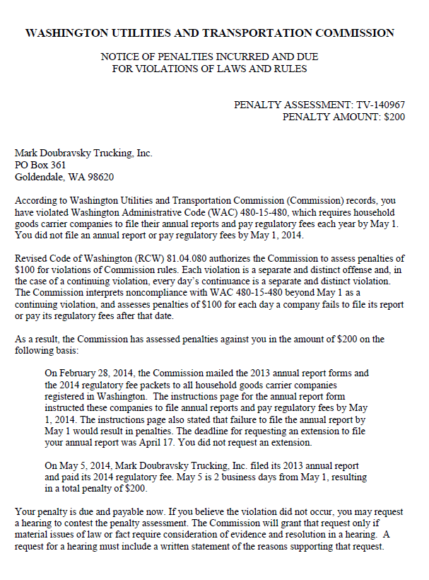

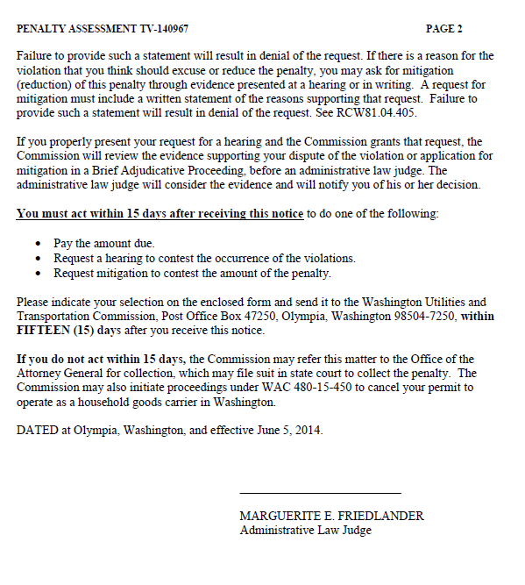

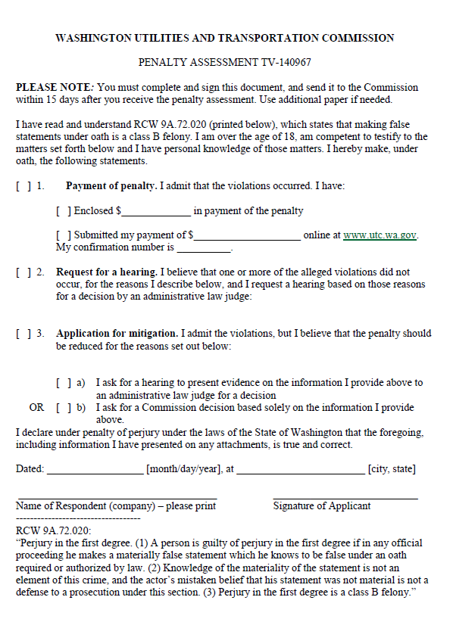

ATTACHMENT B
