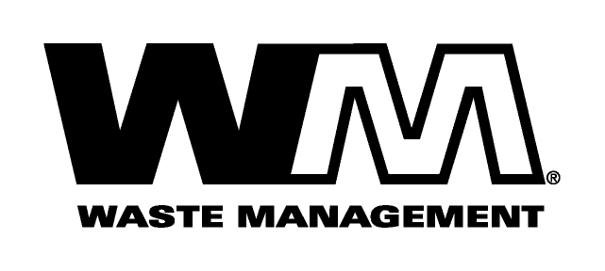

December 1, 2008

Dear Valued Customer,

Our goal at Waste Management is to provide you with the highest quality solid waste service. We value your business.

Like all of us, the garbage industry is faced with many challenges today. Rising costs for labor, disposal, fuel and other general operating expenses have resulted in increased costs for us to provide collection services.

These costs have risen considerably since our last general rate increase, nearly six years ago. Accordingly, we have applied for an increase in rates, subject to the review and approval of the Washington Utilities and Transportation Commission (U.T.C.). The U.T.C. regulates the rates and services of Solid Waste companies operating in the unincorporated areas of Washington. The U.T.C., upon completing its investigation, could approve rates that may vary from the proposed rates shown on the back of this letter. If approved, the new rates would become effective January 1, 2009.

To comment on this filing, be added to the U.T.C.’s mailing list, or ask questions about the ratemaking process, please use the contact information below. You may also comment in person at the U.T.C.’s open meeting in Olympia at 9:30 a.m. on December 11, 2008, or by using the “Public Comment” feature at the U.T.C.’s web site, at http://www.utc.wa.gov/comment. The U.T.C. is scheduled to make a decision at its open meeting on December 23.

If you are unable to attend an open meeting in person, the U.T.C. has a bridge line that enables you to participate or listen by telephone. Call (360) 664-1234 for instructions the day before the open meeting.

Washington Utilities and Transportation Commission
Post Office Box 47250, Olympia, WA 98504-7250
E-mail:
comments@utc.wa.gov
Telephone: 1-800-562-6150

At Waste Management, we are committed to finding new and innovative ways to provide high quality solid waste services at the most cost effective rates. As the industry leader, we will continue to work diligently to develop and implement the most efficient collection systems available and whenever possible, pass any recognized cost savings on to our customers.

As always, we are dedicated to responsive customer service. Should you have any questions, please give us a call at 1(877) 466-4668. Thank you for your understanding and support. We appreciate your business and look forward to providing you with the best possible service.

Respectfully,

Waste Management of Spokane

