June 26, 2014

Steven V. King, Executive Director and Secretary
Utilities and Transportation Commission
1300 S. Evergreen Park Dr. SW
P.O. Box 47250
Olympia, WA 98504-7250

RE: Washington Utilities and Transportation Commission v. Moving & Storage Solutions, Inc.

Commission Staff’s Response to Application for Mitigation of Penalties TV-140973

Dear Mr. King:

On June 5, 2014, the Utilities and Transportation Commission issued a $900 Penalty Assessment in Docket TV-140973 against Moving & Storage Solutions, Inc. for 9 violations of Washington Administrative Code (WAC) 480-15-480, which requires household goods carrier companies to furnish annual reports to the commission no later than May 1 each year.¹

On June 12, 2014, Moving & Storage Solutions, Inc. wrote the commission requesting mitigation of penalties (Mitigation Request).² In its Mitigation Request, Moving & Storage Solutions, Inc. does not dispute that the violation occurred. The company states, “I am asking for relief of penalty payments on the basis that it was simply a mistake in thinking it was filed and it ended up on the bottom of a stack and was never sent out. I believe we have always been on time over the last 10 years or so since we have been doing this report.”

It is the company’s responsibility to ensure that the regulatory fee is paid and the annual report is filed by the May 1 deadline. On February 28, 2014, Annual Report packets were mailed to all regulated household goods companies. The instructions for annual report completion page of the annual report informed the regulated company that it must complete the annual report form, pay the regulatory fees, and return the materials by May 1, 2014, to avoid enforcement action.

On May 14, 2014, Moving & Storage Solutions, Inc. filed the 2013 annual report and paid the required regulatory fees and late payment penalty. The company has been active since August 14, 2007. Moving & Storage Solutions, Inc. previously missed the deadline for filing its annual
UTC Annual Reports
June 26, 2014
Page 2

report and paying its regulatory fees for the 2012 annual report year. The company received an automatic mitigation to $25 per day for the 2012 report. Due to the prior violation and the company not presenting any compelling information, staff does not support any mitigation.

If you have any questions regarding this recommendation, please contact Amy Andrews, Regulatory Analyst, at (360) 664-1157, or aandrews@utc.wa.gov.

Sincerely,

Sondra Walsh, Director
Administrative Services

ATTACHMENT A
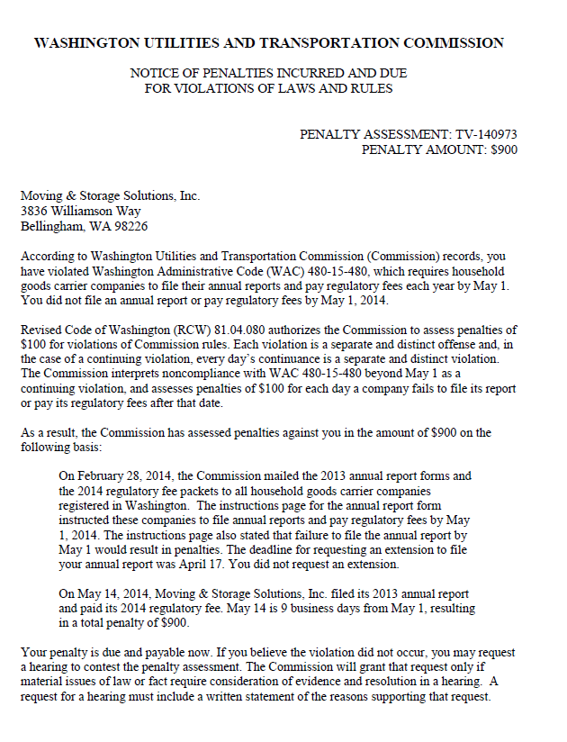

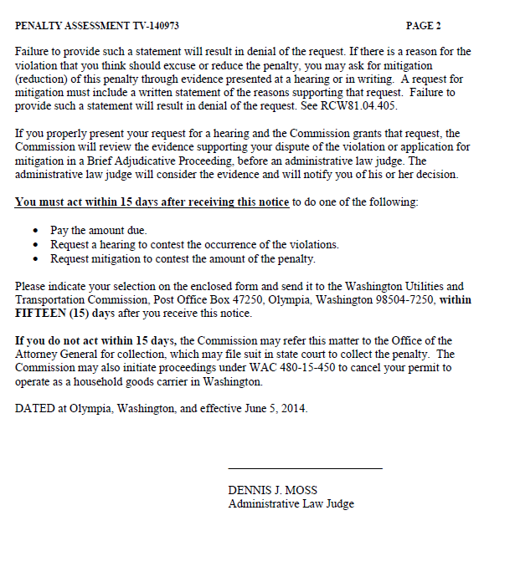

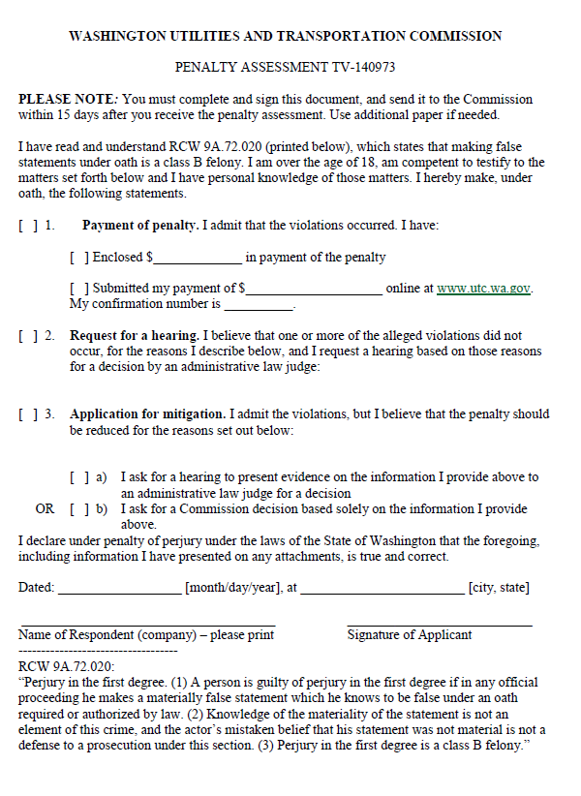

ATTACHMENT B
