Mr. Steven V. King, Executive Director and Secretary
Washington Utilities and Transportation Commission
Attn: Records Center
PO Box 47250
Olympia WA 98504-7250

Re: Correction of Ticket Agent Agreements for Lotto Global (USA) and Paramount Hotel Seattle (Docket TC-152204)
SpeediShuttle Washington, LLC (Certificate C065854).

Dear Mr. King:

SpeediShuttle Washington, LLC herby requests to amend Docket TC-152204 ticket agent agreements as follows:

- Please replace page three of the agreements with the attached Replacement Page 3 - Lotto Global.pdf to provide the correct net rates.
- Please replace pages 7 and 8 of the agreements with the attached Replacement Pages 7-8 - Paramount Hotel.pdf to include the expiration date for the agreement.

We apologize for any inconvenience.

Should you have any questions or comments, please contact:
Jack Roemer
SpeediShuttle Washington, LLC
1237 S. Director St.
Seattle, Washington 98108
Phone – 206-456-6787
Fax – 206-566-5982
jackr@speedishuttle.com

Thank you for your consideration.

Respectfully,
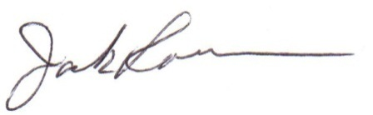
H. Jack Roemer
Chief Financial Officer

