Mark S. Reynolds
NW Region Vice President, Public Policy
1600 7th Avenue, Room 1506
Seattle, Washington 98191
(206) 345-1568

September 18, 2014

Mr. Steven King
Executive Director and Secretary
Washington Utilities and Transportation Commission
1300 S. Evergreen Park Drive SW
Olympia, WA 98504-7250

RE: Docket No.UT-131949
CenturyLink QC Washington Confidential Performance Assurance Plan Compliance Filing

Dear Mr. King:

Pursuant to new requirements in the decision on Docket No. UT-131949, approving Qwest Corporation d/b/a CenturyLink QC’s Petition to modify the Performance Assurance Plan and Performance Indicator Definitions, CenturyLink is supplying the following confidential reports to the Commission:

Confidential Reports:
Clec_271_exhibit(14_state_pid)_excel_all_wa_jul14.xls - Individual CLEC performance report for payment-eligible and diagnostic PIDs
P271_PAP_SUMST_WA_jul2014.xls - Individual CLEC payment report for payment-eligible PIDs with payments

The confidential files are protected under WAC 480-07-160 as they contain CLEC-specific information that is competitively sensitive. Also included is a redacted version of the files with confidential information removed.

Please let me know if you have any questions about this information.

Sincerely,
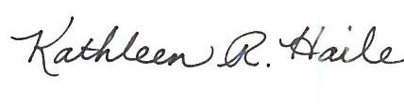
For Mark S. Reynolds
Attachment

