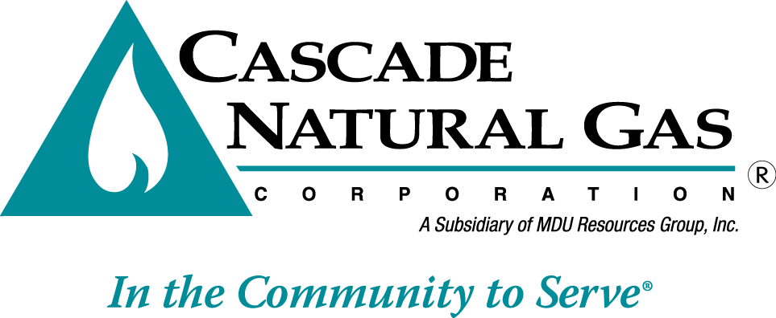

August 4, 2016

Mr. Steven V. King
Executive Director and Secretary
Washington Utilities & Transportation Commission
P.O. Box 47250
Olympia, WA 98504-7250

Re: UG-160972 Cascade Natural Gas PGA and TTA Cover Letter

Dear Mr. King:

Cascade noticed an error on the second page, last paragraph of the PGA and TTA cover letter that was filed on August 1, 2016.

In that cover letter, we had stated ($2.92) as an overall impact to an average residential customer using 49 therms of gas per month. The amount is actually a ($4.23) overall impact for residential customers.

The ($2.92) represents the overall decrease to those same customers using 49 therms including both the PGA adjustments and the change from most recently completed rate case UG-152286.

If you have any questions, please direct them to me at (509) 734-4593.

Sincerely,

Michael Parvinen
Director, Regulatory Affairs

