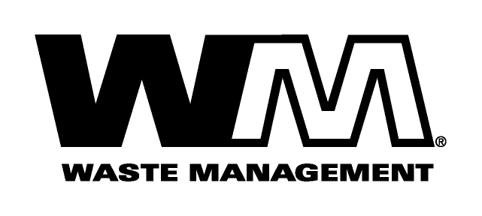

October 31, 2008

Washington Utilities and Transportation Commission
Chandler Plaza Building
1300 S. Evergreen Park Drive SW
P.O. Box 47250
Olympia, WA. 98504-7250

Subject: Waste Management of Spokane, a division of Waste Management of Washington, Inc. (G-237); Tariff No. 16
Enclosed herein, you will find our new Tariff No.16 for the above-referenced company. This tariff replaces Waste Management of Spokane Tariff No.15. In this new tariff, we are requesting adjustments to our rates attributed to the cost of a new collection facility, increased disposal, maintenance, labor, fuel and other operating and administrative costs since our last general rate increase on February 1, 2003. Furthermore, we are requesting that we complete the process that we began more than five years ago when we last received a general rate increase to have uniform rates throughout the Spokane area. Consequently, the amount of the rate increases to residential customers will vary depending on where they reside in our service territory. Generally this new tariff, if approved by the commission, would increase Company revenue by approximately $2.3 million and collectively, residential and commercial rates by 9.8%. This new tariff is being filed with a proposed effective date of January 1, 2009.
Enclosed for your review is an electronic copy of our accounting workpapers and sample customer notices. Customer notices will be mailed on or before December 1, 2008.
We are also requesting that all financial data submitted with this filing which is stamped “Confidential” be treated as such per WAC 480-09-015 as its release may adversely affect non-regulated Waste Management operations and entities.
If you have any questions or need additional information, please contact me at (425) 814-7840.
Respectfully,

Michael A. Weinstein
Senior Pricing Manager, Pacific Northwest Market Area

cc: Tim Crosby
Steve Wulf
Joe Krukowski
Clerk of the Board, Spokane County Chair

