https://www.cbc.ca/news/canada/north/skagway-coronavirus-cruise-ship-season-1.5498107

Skagway, Alaska, preparing for 'worst-case scenario' cruise ship season

Social Sharing
- Facebook
- Twitter
- Email
- Reddit
- LinkedIn

'At stake is more than just a cruise ship season,' says mayor of Skagway, Alaska
Steve Silva · CBC News · Posted: Mar 16, 2020 6:00 AM CT | Last Updated: March 16
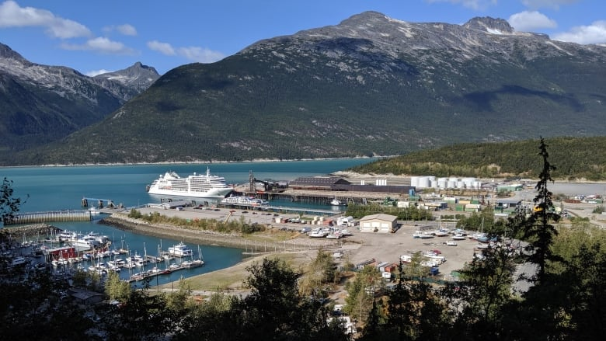
Skagway, Alaska, pictured in 2019. The community is about a two-hour drive from Whitehorse, and many cruise ship passengers visit Yukon through Skagway. (Steve Silva/CBC)
1
comments
The forecast for the upcoming and economically crucial cruise ship season — if one occurs at all — at an Alaskan community, near Yukon, is significantly more modest than previous years'.
"We've been hoping for the best but preparing a worst-case scenario," Skagway Mayor Andrew Cremata said on Friday.
"Everyone's reeling, and that goes for the rest of the nation."
The community is about a two-hour drive from Whitehorse, and many cruise ship passengers visit Yukon through Skagway.
On Friday, the federal Transportation Minister Marc Garneau announced that cruise ships with 500 people or more on board, including crew members, won't be allowed to dock at Canadian ports between April 2 and July 1.
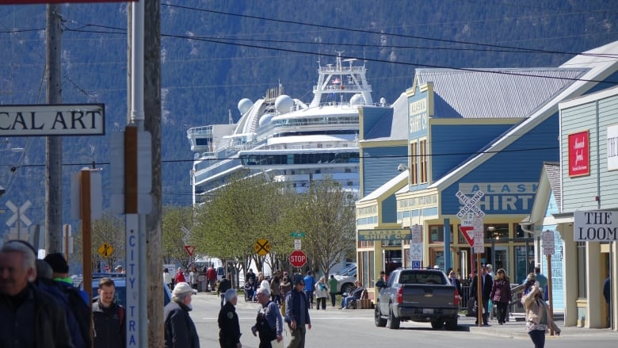
A file photo of a cruise ship in Skagway, Alaska. Cruise ship season in Skagway usually runs between approximately May to October. (Claudiane Samson/Radio-Canada)
The move is one of several meant "to prevent the spread of COVID-19," he tweeted.
Cruise ships that visit Skagway can carry thousands of passengers, and Cremata said his understanding is that, now, no cruise ships will stop in Skagway.
- Yukon tourism operators brace for impact of COVID-19 this summer
The reason why Canada's decision is a problem for cruise lines is because of U.S. law, he said. Foreign-flagged cruise ships have to stop at the port of a foreign country when travelling between U.S. destinations.
So, in this context, a trip between Alaska and Washington state would require a stop at a port in British Columbia, for example.
Skagway Mayor Andrew Cremata said on Friday that they are preparing a worst-case scenario. (Submitted by Andrew Cremata)
"We're putting some pressure on our federal delegation to see if they could persuade congress to override that law for a certain period of time so that, potentially, vessels could leave the Port of Seattle, and we would still get cruise ships in front of that July 1 date, but that's up in the air," Cremata said.
"And it also hinges on what happens with the Port of Seattle. If the Port of Seattle does a similar closure, then that whole effort is moot anyway. So we're bracing for not having any cruise ships until after July 1."
Cruise ship season in Skagway usually runs between approximately May to October. Cremata said the community was expecting a record 1,100,000 visitors and 454 cruise ship visits this year.
If the ships returned by July 1, that would leave about 60 per cent of the cruise ship season intact, he said, but there would be fewer passengers and cruise lines may only send 50 per cent of their ships.
Skagway's population was 1,148 last July, according to the U.S. Census Bureau.
"At stake is more than just a cruise ship season here, because so many of our year-round businesses and year-round residents rely on seasonal income to be able to survive through the winter months," Cremata said.
"We have to protect the fabric of our community by doing whatever we can to ensure the viability of our year-round businesses."
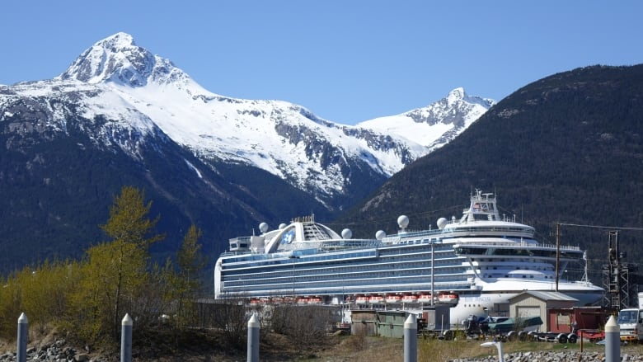
A cruise ship in Skagway, Alaska. Skagway's population was 1,148 last July, according to the U.S. Census Bureau. (Claudiane Samson/Radio-Canada)
A task force has been created to try to figure out the repercussions on local small businesses, along with what economic assistance they may need to stay afloat.
"We do have rainy day funds for just this kind of situation, and it is raining," Cremata said.
- Yukon, Alaska officials in talks on future of Skagway ore dock
He said he thinks the municipal government has more than $25 million in reserves, which would keep it running for several years.
The municipal government hasn't yet determined how those funds will be used, but it will look at using them to create an economic stimulus package.
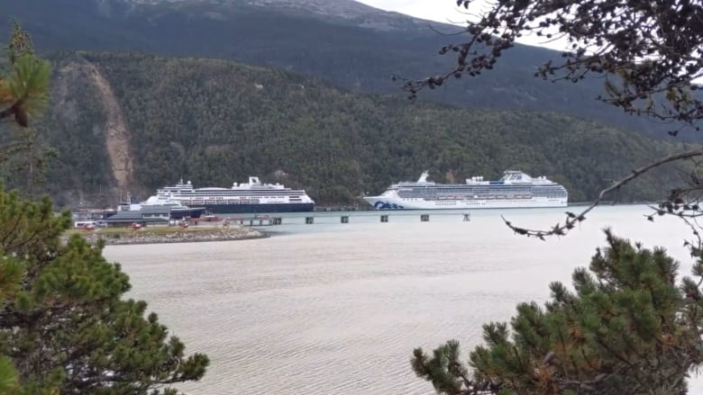
The community of Skagway has been talking about diversifying its economy, including through expanding its industrial port said Mayor Andrew Cremata. (Steve Silva/CBC)
Once the government is confident the community is healthy and protected, the intention is to direct more advertising dollars for a closer audience, including people in other Alaskan communities, Seattle, and Yukon, Cremata said.
He suggested getting to experience the community in a far less tourist-heavy atmosphere as a selling point.
The community has also been talking about diversifying its economy, including through expanding its industrial port, Cremata said.
CBC's Journalistic Standards and Practices|About CBC News

