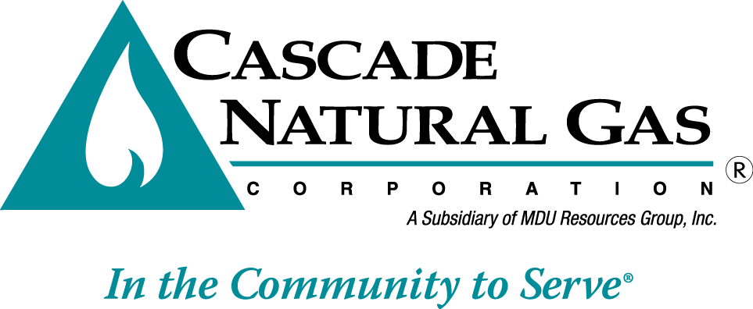
June 15, 2017
8113 W. GRANDRIDGE BLVD., KENNEWICK, WASHINGTON 99336-7166
TELEPHONE 509-734-4500 FACSIMILE 509-737-9803
www.cngc.com

Records Center
Washington Utilities and Transportation Commission
1300 S. Evergreen Park Drive SW
Olympia, WA 98504

Re: UG- 170670 Advice No. W17-06-01, Supplementary Filing

On May 31, 2017, Cascade Natural Gas Corporation (Cascade or the Company) filed Advice No. W17-05-01, which was docked as UG-170670. Upon Staff request, the Company now files the following replacement sheet stated to become effective with service on and after June 30, 2017:

Fourth Revision Sheet No. 302-A

All other sheets submitted with the initial filing remain as filed.

The purpose of this supplemental filing is to correct errors on Sheet 302-A. First, a missing margin code is added. Second, the page is reformatted so that all the text on the page fits within the margins. Finally, the demand control ventilation measure is corrected as being an incentive of $20, not $12, as stated in the support material, and margin codes denote this is a new measure.

This submission includes the following two files, which are revised Sheet No. 302-A and the legislative version of Sheet 302-A:

UG-170670, CNGC 302-A Trf, 6.15.17.pdf
UG-170670, CNGC 302-A Leg Trf, 6.X1517.pdf

Any questions regarding this document should be directed to Monica Cowlishaw, Manager of Energy Efficiency and Community Outreach, at (360)-788-2357 or monica.cowlishaw@cngc.com.

Sincerely,

/s/ Michael Parvinen

Michael Parvinen
Director, Regulatory Affairs
Cascade Natural Gas Corporation
8113 W Grandridge Blvd
Kennewick, WA 99336-7166
michael.parvinen@cngc.com

Attachment

