July 11, 2014

Steven V. King, Executive Director and Secretary
Utilities and Transportation Commission
1300 S. Evergreen Park Dr. SW
P.O. Box 47250
Olympia, WA 98504-7250

RE: Washington Utilities and Transportation Commission v. Telecom North America, Inc.

Commission Staff’s Response to Application for Mitigation of Penalties UT-140918

Dear Mr. King:

On June 2, 2014, the Utilities and Transportation Commission issued a $200 Penalty Assessment in Docket UT-1404918 against Telecom North America, Inc. for 2 violations of Washington Administrative Code (WAC) 480-120-382, which requires telecommunications companies to furnish annual reports to the commission no later than May 1 each year.¹

On June 30, 2014, Telecom North America, Inc. wrote the commission requesting mitigation of penalties (Mitigation Request).² In its Mitigation Request Telecom North America, Inc. does not dispute that the violation occurred. The company states, “I had my task setup to be completed by May 1st of every year. It was an oversight that I only postmarked by May 1st and not received as the previous years we always filed our report ahead of time. This year I made a note that the annual report has to be received by May 1st and I set my task reminder 2 week earlier than that. Please let me know if the penalty can be removed as we always filed our reports on time and we are in good standing.”

It is the company’s responsibility to ensure that the regulatory fee is paid and the annual report is filed by the May 1 deadline. On February 28, 2014, Annual Report packets were mailed to all regulated telecommunication companies. The instructions for annual report completion page of
the annual report informed the regulated company that it must complete the annual report form, pay the regulatory fees, and return the materials by May 1, 2014, to avoid enforcement action.

UTC Annual Reports
July 11, 2014
Page 2

On May 5, 2014 Telecom North America, Inc. filed its completed annual report with no regulatory fees due. The company has been active since September 6, 2002. No previous violations of WAC 480-120-382 are on commission record. Staff does not support the company’s request to waive the penalty. However, as this is the first delinquent filing for Telecom North America, Inc., staff does support mitigation of the penalty to $25 per day for a total assessed penalty of $50.

If you have any questions regarding this recommendation, please contact Amy Andrews, Regulatory Analyst, at (360) 664-1157, or aandrews@utc.wa.gov.

Sincerely,

Sondra Walsh, Director
Administrative Services

ATTACHMENT A
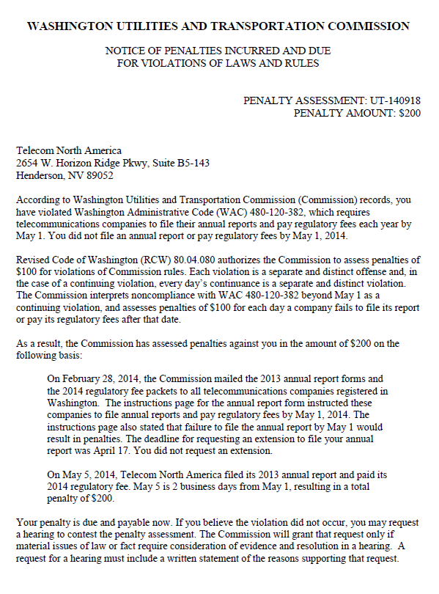

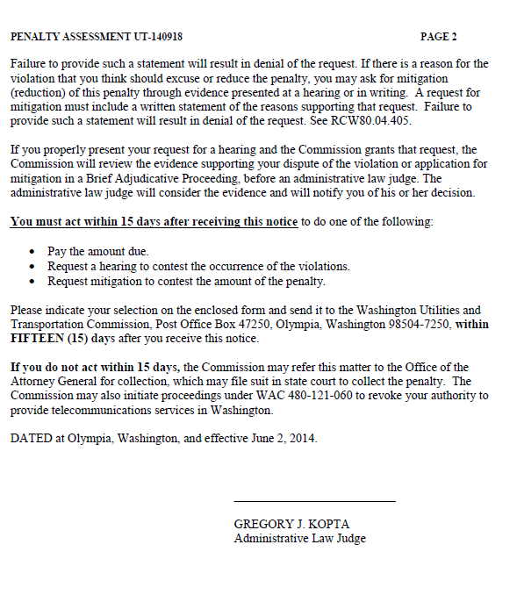

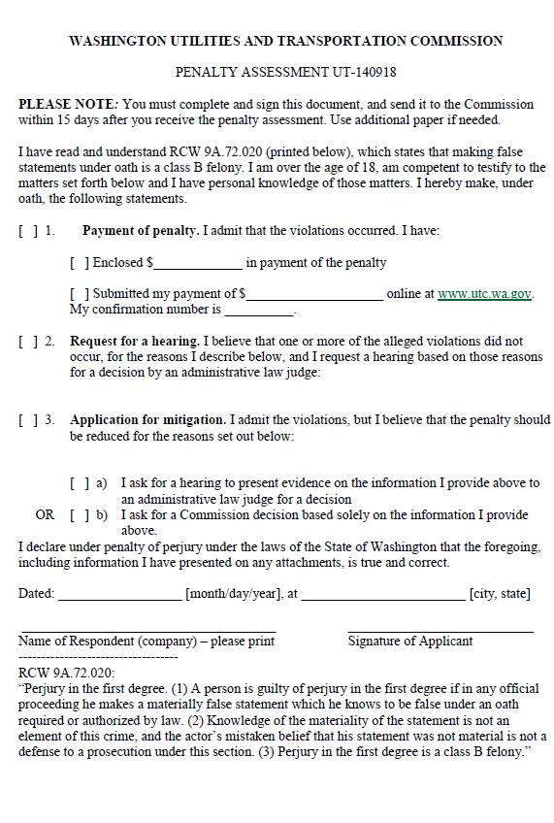

ATTACHMENT B
