December 4, 2012

David W. Danner, Executive Director and Secretary
Washington Utilities and Transportation Commission
1300 S. Evergreen Park Dr. SW
P. O. Box 47250
Olympia, Washington 98504-7250

RE: Washington Utilities and Transportation Commission v. Primus Telecommunications, Inc.
Commission Staff’s Response to Application for Mitigation of Penalties
Docket UT-121000

Dear Mr. Danner:

On July 31, 2012, the Washington Utilities and Transportation Commission issued a $2,100 Penalty Assessment in Docket UT-121000 against Primus Telecommunications, Inc., (Primus) for 21 violations of Washington Administrative Code (WAC) 480-120-382, which requires competitively classified telecommunications companies to furnish annual reports to the commission no later than May 1 each year.

On November 2, 2012, Primus wrote the commission requesting mitigation of penalties (Mitigation Request). In its Mitigation Request, Primus does not dispute that the violation occurred. The company states, “I respectfully request your consideration for relief of the penalty imposed on the attach invoice of $2,100 for filing an incomplete tax return for not including the regulatory fee schedule and financial statements document. According to our records, we mailed a check of $383.93, along with the 2011 Telecommunication Companies Annual Report on April 27, 2012 to comply with the deadline for filing this return. We thought we had filed the return on time. However, we did have a turnover of employees during the month of April and it appears there was an unintentional omission of some required schedules. In this context, we believe this penalty relief is justified on the basis that this is the first time this error occurred, that our intent to file on line was substantiated by our filling, and that we have taken steps to make sure this will not be repeated in the future. We have also complied by sending all the additional documents to complete this return. The penalty for the amount $2,100 is excessive for filing a partial return in which in any case had a total tax due to the State of Washington of only $383.93. We believe that this is out of proportion to the actual tax due and unfair to Primus Telecommunication for a minor and unintentional error. As a result, it would appear that this situation qualifies for relief of penalties or at least a reduction of amount due according to the base of the tax due. Primus always makes every effort to comply with filing and remitting our taxes before the due date. We have an excellent record of compliance with the Washington State
Utilities. Based on these factors, I would appreciate your consideration for relief of the penalty for filing an incomplete return.”

It is the company’s responsibility to ensure that the regulatory fee and the annual report are filed by the May 1 deadline. On February 29, 2012, Annual Report forms and Regulatory Fee packets were mailed to all regulated competitively classified telecommunications companies. In addition to other information, the cover letter informed the regulated company it must complete the annual report form, pay any regulatory fees and return the material by May 1, 2012, to avoid enforcement action. On May 14, 2012, the commission mailed a letter to those companies that had not yet filed an annual report notifying them that, to date, they had incurred a penalty of $800. The letter went on to explain that companies who filed their annual reports no later than May 25, 2012, would receive mitigated penalties of $25 per day, with an additional $25 per day for each instance in the previous five years that the company received a penalty for filing a late report.

On May 24, 2012, staff from the commission’s Financial Services office emailed Primus stating, “I received the Annual Report for Primus Telecommunications for Washington State. It is lacking both the enclosed regulatory fee calculation schedule and the financial documents. Both are a requirement for the report to be complete. Please complete the attached form and submit both the balance sheet and income statement as soon as possible.”

On August 3, 2012, a certified card addressed to Primus was signed, which delivered the penalty assessment dated July 31, 2012.

On September 25, 2012, Primus responded emailing the commission’s Financial Services office stating, “Please attached find [sic] the Fee calculation schedule and financials.” Following that email, Primus contacted the commission by telephone and asked how it could recourse its penalty assessment. Primus stated it submitted its annual report but the report was missing a section. Commission staff informed Primus, if the report was missing information when it was submitted, it is incomplete and a penalty is appropriate. Commission staff also informed Primus it was past the period for review and provided Primus with the commission’s records center email, if it still wished to provide its request for mitigation or hearing. Commission staff told Primus, based on the company failing to submit its request for mitigation within the review period, it would recommend against mitigation.

On November 1, 2012, Primus contacted the commission by telephone. Primus said it just received an invoice regarding it penalty, number 1271-4, in Docket UT-121000 and it wanted to know if there was anything it could do to mitigate its penalty. Commission staff found Primus already contacted the commission on September 25, 2012, and it was provided information on requesting mitigation or requesting a hearing. Commission staff again, told Primus it is outside the period for review, however it could submit something in writing explaining its circumstances. Commission staff provided the records center email and the commission’s physical and mailing address.

On November 6, 2012, commission staff reviewed the commission’s Annual Report Tracking System, (ARTS) and verified the report was received on April 30, 2012, and the report was completed on September 25, 2012.

Primus filed its completed annual report on September 25, 2012. Primus did not file its annual report by May 31, 2012, which is 21 business days past the deadline of May 1, 2012. The penalty is $100 per day for a total of $2,100. Primus became regulated in September 1999 and has never received a penalty for filing a delinquent annual report in the past.

Commission staff does not support mitigating the assessed penalty of $2,100 because Primus failed to file its response within the 15 day timeframe required for the commission to consider mitigation or August 18, 2012. Primus submitted its request for mitigation 92 days from the day it received its penalty assessment. Primus did not file the documents required to complete its annual report until September 25, 2012, or 147 days past the deadline of May 1.

If you have any questions, please contact Mathew Perkinson, Compliance Investigator, at (360) 664-1105 or at mperkinson@utc.wa.gov.

Sincerely,

Sharon Wallace, Assistant Director
Consumer Protection and Communications

Attachment A

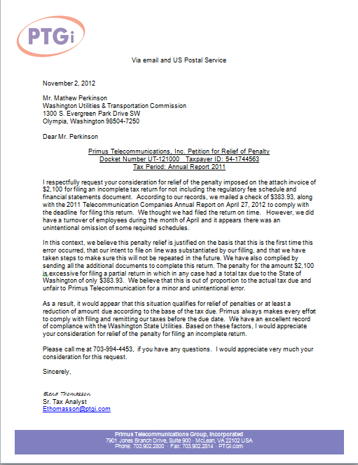
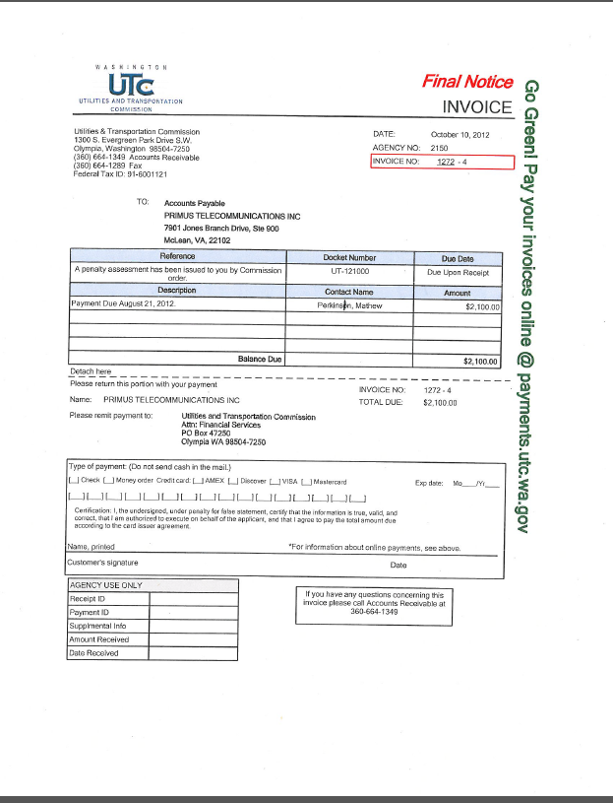
Attachment B
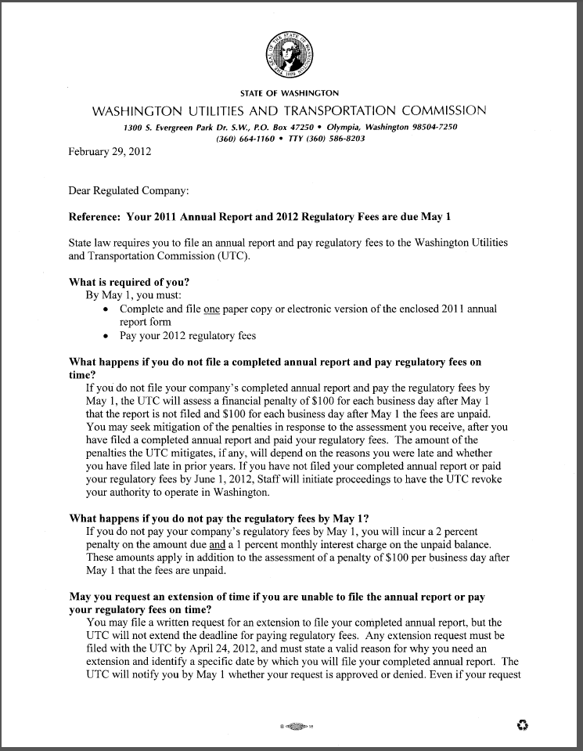
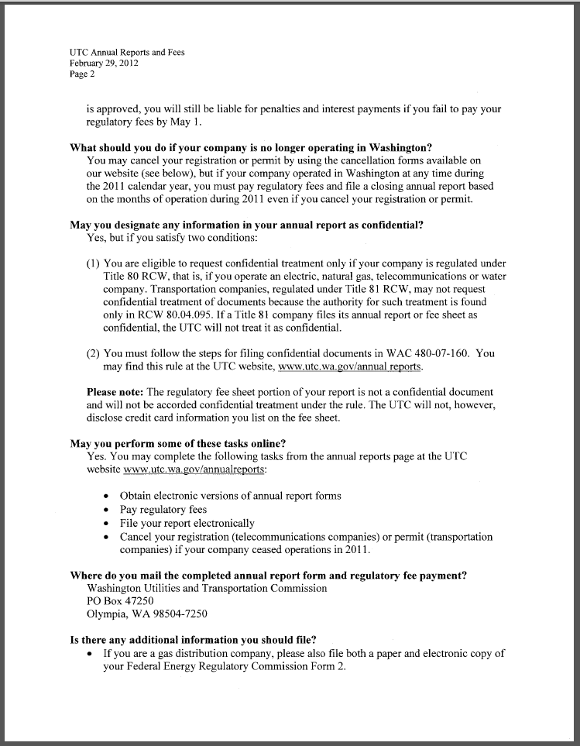

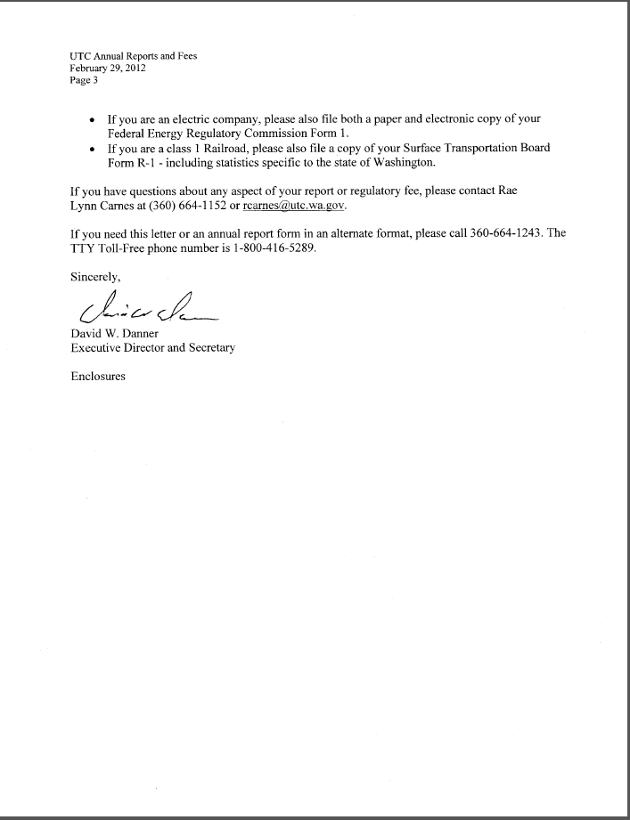

Attachment C

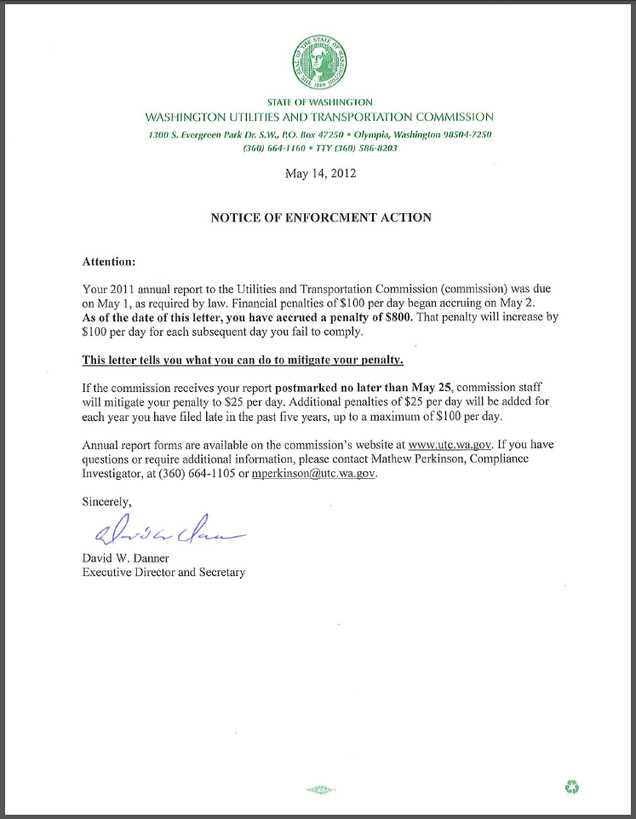t

See attachment A for a copy of Primus Telecommunications, Inc.’s Mitigation Request.
See attachment B for a copy of the letter sent to all regulated companies on February 29, 2012.
See attachment C for a copy of the enforcement letter sent to the company on May 14, 2012.

