SECTION 13
GLOSSARY AND MISCELLANEOUS REFERENCES

GLOSSARY OF TERMS AND ACRONYMS

ABBTM
Add-in product to the SENDOUT™ model that facilitates the ability to model gas price and load uncertainty (driven by weather) into the future. ABBTM utilizes a Monte Carlo approach in combination with the linear programming approach in SENDOUT™.

ACEEE
American Council for an Energy-Efficient Economy.

ACHIEVABLE POTENTIAL
Represents a realistic assessment of expected energy savings recognizing and accounting for economic and other constraints that preclude full installation of every identified conservation measure.

AECO INDEX
Alberta Canada natural gas trading price.

AFUE
Annual Fuel Utilization Efficiency. Thermal efficiency measure of combustion equipment like furnaces, boilers, and water heaters.

AMA
Asset Management Agreement. An arrangement that an LDC may enter into with a marketing company to assist with transportation and storage assistance.

ANNUAL MEASURES
Conservation measures that achieve generally uniform year round energy savings independent of weather temperature changes. Annual measures are also often called base load measures.

ARRA
The American Recovery and Reinvestment Act of 2009.

AVOIDED COST
Marginal Cost of serving the next unit of demand, which is saved through conservation efforts.

BACKHAUL SERVICE
A transaction where gas is transported the opposite direction of normal flow on a unidirectional pipeline.

BASELOAD
As applied to natural gas, a given demand for natural gas that remains fairly constant over a period of time, usually not temperature sensitive.

BASE LOAD MEASURES
Conservation measures that achieve generally uniform year round energy savings independent of weather temperature changes. Base load measures are also often called annual measures.

BNG
Bio natural gas and typically refers to a gas produced by the biological breakdown of organic matter in the absence of oxygen.

BRITISH THERMAL UNIT (BTU)
The amount of heat required to raise the temperature of one pound of pure water one degree Fahrenheit under stated conditions of pressure and temperature; a therm (see below) of natural gas has an energy value of 100,000 BTUs and is approximately equivalent to 100 cubic feet of natural gas.

CC&B
Customer Care and Billing. Internal billing data for Cascade Natural Gas.

CD
Contract Demand

CITY GATE (ALSO KNOWN AS GATE STATION OR PIPELINE DELIVERY POINT)
The point at which natural gas deliveries transfer from the interstate pipelines to Cascade’s distribution system

CNG
Compressed Natural Gas

CNGC
Cascade Natural Gas Corporation

COMPRESSION
Increasing the pressure of natural gas in a pipeline by means of a mechanically driven compressor station to increase flow capacity.

COMPRESSOR
Equipment which pressurizes gas to keep it moving through the pipelines.

CONSERVATION MEASURES
Installations of appliances, products or facility upgrades that result in energy savings.

CONTRACT DEMAND
The maximum daily, monthly, seasonal or annual quantities of natural gas, which the supplier agrees to furnish, or the pipeline agrees to transport, and for which the buyer or shipper agrees to pay a demand charge.

COP
Coefficient of Performance

CORE CUSTOMERS
Residential, firm industrial and commercial gas customers who require utility gas service.

COST EFFECTIVNESS
The determination of whether the present value of the therm savings for any given conservation measure is greater than the cost to achieve the savings.

CPI
Consumer Price Index, as calculated and published by the U.S. Department of Labor, Bureau of Labor Statistics

DAY GAS
Gas that can be purchased as needed to cover demand in excess of the base load.

DEKATHERM
Unit of measurement for natural gas; a dekatherm is 10 therms, which is one thousand cubic feet (volume) or one million BTUs (energy).

DEMAND‐SIDE MANAGEMENT (DSM)
The activity pursued by an energy utility to influence its customers to reduce their energy consumption or change their patterns of energy use away from peak consumption periods.

DEMAND‐SIDE RESOURCES
Energy resources obtained through assisting customers to reduce their "demand" or use of natural gas. Also represents the aggregate energy savings attained from installation of conservation measures.

DSM
Demand-Side Management

DTH
Unit of measurement for natural gas; a dekatherm is 10 therms, which is one thousand cubic feet (volume) or one million BTUs (energy).

EBB
Electronic Bulletin Board

EIA
Energy Information Administration

ENTITLEMENTS
Flow management tool used by upstream pipelines, in conjunction with OFOs.

EXTERNALITIES
Cost and benefits that are not reflected in the price paid for goods or services.

FEDERAL ENERGY REGULATORY COMMISSION (FERC)
The government agency charged with the regulation and oversight of interstate natural gas pipelines, wholesale electric rates and hydroelectric licensing; the FERC regulates the interstate pipelines with which Cascade does business and determines rates charged in interstate transactions.

FERC
Federal Energy Regulatory Commission

FIRM SERVICE OR FIRM TRANSPORTATION
Service offered to customers under schedules or contracts that anticipate no interruptions; the highest quality of service offered to customers.

FOM
First of the Month price; supply contracts entered into on a short term basis to cover expected demand for that month.

FORCE MAJEURE
An unexpected event or occurrence not within the control of the parties to a contract, which alters the application of the terms of a contract; sometimes referred to as "an act of God;" examples include severe weather, war, strikes, pipeline failure and other similar events.

FUEL IN KIND (FUEL LOSS)
A statutory percent of gas based on the tariff from the pipeline that is lost and unaccounted for from the point of where the gas was purchased to the citygate.

FUGITIVE METHANE EMISSIONS
Natural Gas that escapes the system during drilling, extraction and/or transportation of gas.

GAS TRANSMISSION NORTHWEST (GTN)
A subsidiary of TransCanada Pipeline which owns and operates a natural gas pipeline that runs from the Canada/USA border to the Oregon/California border. One of the six natural gas pipelines Cascade transacts with directly.

GHG
Greenhouse Gas

GMS
Gas Management System

GTN
Gas Transmission Northwest

HEATING DEGREE DAY (HDD)
A measure of the coldness of the weather experienced, based on the extent to which the daily average temperature falls below 60 degrees Fahrenheit; a daily average temperature represents the sum of the high and low readings divided by two.

HENRY HUB
The physical location found in Louisiana that is widely recognized as the most important pricing point in the United States. It is also the trading hub for the New York Mercantile Exchange (NYMEX).

INJECTION
The process of putting natural gas into a storage facility; also called liquefaction when the storage facility is a liquefied natural gas plant.

INTERRUPTIBLE SERVICE
A service of lower priority than firm service offered to customers under schedules or contracts that anticipate and permit interruptions on short notice; the interruption happens when the demand of all firm customers exceeds the capability of the system to continue deliveries to all of those customers.

INTERSTATE PIPELINE
A federally regulated company that transports and/or sells natural gas across state lines.

IOU
Investor owned utility.

IRP
Integrated Resource Plan; the document that explains Cascade’s plans and preparations to maintain sufficient resources to meet customer needs at a reasonable price.

JACKSON PRAIRIE
An underground storage project jointly owned by Avista Corp., Puget Sound Energy, and NWP; the project is a naturally occurring aquifer near Chehalis, Washington, which is located some 1,800 feet beneath the surface and capped with a very thick layer of dense shale.

KORP
Kingsvale-Oliver Reinforcement Project

LDC
Local Distribution Company. LDCs are regulated utilities involved in the delivery of natural gas to consumers within a specific geographic area.

LIQUEFIED NATURAL GAS (LNG)
Natural gas that has been liquefied by reducing its temperature to minus 260 degrees Fahrenheit at atmospheric pressure.

LINEAR PROGRAMMING
A mathematical method of solving problems by means of linear functions where the multiple variables involved are subject to constraints; this method is utilized in the SENDOUT® Gas Model.

LNG
Liquefied natural gas. Natural gas that has been liquefied by chilling. It is liquefied to reduce its volume and thereby facilitate bulk storage and transport.

LOAD FACTOR
The average load of a customer, a group of customers, or an entire system, divided by the maximum load; can be calculated over any time period.

LOAD FORECAST
A forecast, an estimate, or a prediction of how much gas will be needed for residences, companies, and other institutions in the future.

LOAD MANAGEMENT
Seek to lower peak demand during specific, limited time periods by temporarily curtailing usage or shifting usage to other time periods. Load management reduces system peak demand very well, but can have little or no effect on total energy use. Its effects are temporary and of short duration.

LOAD PROFILE
Pattern of a customer’s gas usage, hour to hour, day to day, or month to month.

LOOPING
The construction of a second pipeline parallel to an existing pipeline over the whole or any part of its length, thus increasing the capacity of that section of the system.

LRC
Lowest Reasonable Cost. Methodology used when evaluating alternatives to determine the optimal solution to a given problem.

MCF
A unit of volume equal to a thousand cubic feet.

MDDO
Maximum Daily Delivery Obligation

MDQ
Maximum Daily Quantity

MONTE CARLO ANALYSIS
A type of stochastic mathematical simulation which randomly and repeatedly samples input distributions (e.g. reservoir properties) to generate a results distribution.

MOU
Memorandum of understanding.

NAESB
North American Energy Standards Board.

NAÏVE FORECAST
A methodology used for predicting future demand when the results from a regression analysis do not show enough of a correlation between actual demand and our forecast model. This forecast is performed by using the previous year’s demand multiplied by a growth factor.

NATIONAL ENERGY BOARD
The Canadian equivalent to the Federal Energy Regulatory Commission (FERC).

NATURAL GAS
A naturally occurring mixture of hydrocarbon and non-hydrocarbon gases found in porous geologic formations beneath the earth's surface, often in association with petroleum; the principal constituent is methane, and it is lighter than air.

NEEDLE PEAKING RESOURCE
Utilized during severe or “arctic” cold weather.

NEPA
National Environmental Policy Act

NEW YORK MERCANTILE EXCHANGE (NYMEX)
An organization that facilitates the trading of several commodities including natural gas.

NGV
Natural Gas Vehicles

NOMINATION
The scheduling of daily natural gas requirements.

NON-COINCIDENT PEAK
The sum of two or more peak loads on individual systems that do not occur in the same time interval. Meaningful only when considering loads within a limited period of time, such as a day, week, month, a heating or cooling season, and usually for not more than 1 year.

NON-CORE CUSTOMER
Large customers who contract with a third party for supply and upstream pipeline capacity. Cascade provides distribution services. Typical customers include large commercial, industrial, cogeneration, wholesale, and electric generation customers.

NORTHWEST PIPELINE CORPORATION (NWP)
A principal interstate pipeline serving the Pacific Northwest and one of six natural gas pipelines Cascade transacts with directly. NWP is a subsidiary of The Williams Companies and is headquartered in Salt Lake City, Utah.

NORTHWEST POWER AND CONSERVATION COUNCIL
Consist of two members from each of the four Northwest states, Oregon, Washington, Idaho and Montana, to develop a regional plan.

NOVA GAS TRANSMISSION (NOVA)
See TransCanada Alberta System

NWBOP
Northwest Builder Option Packages

NWGA
Northwest Gas Association

NWP
Williams-Northwest Pipeline

NYMEX
New York Mercantile Exchange

NYMEX HH
New York Mercantile Exchange Henry Hub
OFO
Operation Flow Order is an order issued by an upstream pipeline to alleviate conditions, among other things that threaten the safe operations or integrity of the pipeline, or the maintenance of operations required to provide efficient and reliable firm service. The pipeline ability to deliver anticipated quantities and maximize efficiency and capacity utilization is often dependent upon marinating project flow patterns (e.g. receipts, deliveries and balances). Violations or familiar to comply with an OFO can result in the pipeline leveling penalties to offending shippers.

OFF-SYSTEM
Any point not on or directly interconnected with a transportation, storage, and/or distribution system operated by a natural gas company within a state.

ON SITE
At the point of injection.

OPAL (OPAL HUB)
Natural Gas trading hub in Lincoln County, WY

PASCAL
The SI unit of pressure, equal to one Newton per square meter.

PCGP
Pacific Connector Gas Pipeline Project

PEAK DAY
The greatest total natural gas demand forecasted in a 24-hour period used as a basis for planning peak capacity requirements.

PEAK DAY GAS
Gas that is purchased in a peak day situation to serve demand that cannot be satisfied by base or day gas.

PRICE ELASTICITY
Economic concept which recognizes that customer consumption changes as prices rise or fall.

PSI
Pounds per Square Inch. This is the standard unit of measure when determining how much pressure is being applied when gas is flowing through a pipe

PTCS
Performance Tested Comfort Systems

PVRR
Present Value of Revenue Requirement

REAL
Discounting method that excludes inflation.

REGASIFICATION RESOURCE
Process by which LNG is heated, converting it to a gaseous state. Designed for vaporizing LNG where and when it will be used.

REGULATOR STATION
A point on a distribution system responsible for controlling the flow of gas from higher to lower pressures

RENEWABLE FUEL
A power source that is continuously or cyclically renewed by nature, i.e. solar, wind, hydroelectric, geothermal, biomass or similar sources of energy.

ROCKIES INDEX
Natural gas trading price near the Rocky Mountains.

SATELLITE LNG FACILITIES
A facility for storing and vaporizing LNG to meet relatively modest demands at remote locations or to meet short-term peak demands. LNG is usually trucked to such facilities.

SEASONAL PEAKING SERVICE
The delivery of gas, firm or interruptible, sold only during certain times of the year, generally when there are not high system demands.

SENDOUT®
Natural gas planning system from Ventyx; a linear programming model used to solve gas supply and transportation optimization questions.

SERVICE TERRITORY
Territory in which a utility system is required or has the right to provide natural gas service to ultimate customers.

SPOT MARKET GAS
Natural gas purchased under short-term agreements as available on the open market; prices are set by market pressure of supply and demand.

STANDBY
Support service that is available, as needed, to supplement a consumer, a utility system or to another utility to replace normally scheduled power that becomes unavailable.

STORAGE
The utilization of facilities for storing natural gas which has been transferred from its original location for the purposes of serving peak loads, load balancing and the optimization of basis differentials; the facilities are usually natural geological reservoirs such as depleted oil or natural gas fields or water-bearing sands sealed on the top by an impermeable cap rock; the facilities may be man-made or natural caverns. LNG storage facilities generally utilize above ground insulated tanks.

SUMAS INDEX
Natural Gas trading price near the city of Sumas, which is on the Washington/Canadian border approximately 25 miles from the Pacific Ocean.

SWAP
Parties agree to exchange an index price for a fixed price over a defined period

SYNERGI
Engineering software used to theoretically model piping and facilities to represent current pressure and flow conditions, while also predicting future events and growth.

TARIFF
A published volume of regulated rate schedules plus general terms and conditions under which a product or service will be supplied.

TEA-POT
Microsoft Excel-based modeling tool to determine the Technical/Economic/Achievable Potential savings of various proposed DSM programs.

TECHNICAL ADVISORY GROUP (TAG)
Industry, customer and regulatory representatives that advise Cascade during the IRP planning process.

TECHNICAL POTENTIAL
An estimate of all energy savings that could theoretically be accomplished if every customer that could potentially install a conservation measure did so without consideration of market barriers such as cost and customer awareness.

THERM
A unit of heating value used with natural gas that is equivalent to 100,000 British thermal units (BTU); also approximately equivalent to 100 cubic feet of natural gas.

THROUGHPUT
The total of all natural gas volume moved through a pipeline system, including sales, company use, storage, transportation and exchange.

TRANSCANADA ALBERTA SYSTEM
Previously known as NOVA Gas Transmission; a natural gas gathering and transmission corporation in Alberta that delivers natural gas into the TransCanada BC System pipeline at the Alberta/British Columbia border; one of six natural gas pipelines Cascade transacts with directly.

TRANSCANADA BC SYSTEM
Previously known as Alberta Natural Gas; a natural gas transmission corporation of British Columbia that delivers natural gas between the TransCanada-Alberta System and GTN pipelines that runs from the Alberta/British Columbia border to the United States border; one of six natural gas pipelines Cascade transacts with directly.

TRANSPORTATION GAS
Natural gas purchased either directly from the producer or through a broker and is used for either system supply or for specific end-use customers, depending on the transportation arrangements; NWP and GTN transportation may be firm or interruptible.

TRC
Total Resource Cost

TSA
Transportation Service Agreement

TURN-BACK CAPACITY
When natural gas shippers, upon expiration of their contract(s) for pipeline capacity do not renew capacity rights, in whole or in part, with the original pipeline.

UPSTREAM PIPELINE CAPACITY
The pipeline delivering natural gas to another pipeline at an interconnection point where the second pipeline is closer to the consumer.

W&P
Woods & Poole, independent firm that specializes in long-term county economic and demographic projections

WINTER GAS SUPPLIES
Gas supply purchased for all (base gas) or part (day gas) of the heating season.

WITHDRAWAL
The process of removing natural gas from a storage facility, making it available for delivery into the connected pipelines; vaporization is necessary to make withdrawals from an LNG plant.

WUTC
Washington Utilities and Transportation Commission

ZONE
A geographical area. A geological zone, however, means an interval of strata of the geologic column that has distinguishing characteristics from surrounding strata.

ZONE - IRP
For modeling purposes, Cascade’s distribution system is divided into several zones. These zones are generally based on where the upstream pipelines have major compressor stations, have been historical upstream pipeline constraint or in specific weather areas. Where appropriate the Zone-IRP is separated by state. Please see the following chart that references the CityGate/location to the appropriate IRP zone.

DESCRIPTION | METER | ZONEID | PIPELINE
7TH DAY ADVENTIST FARM TAP | ADVENSCH | ZONE 10 | NWP
A & M RNDERING | AMRENDER | ZONE 30-W | NWP
A&W FEED LOT FARM TAP | AWFEED | ZONE 20 | NWP
ABERDEEN/HOQUIAM/MCCLEARY | ABRNDHOQ | ZONE 30-S | NWP
ACME | ACME | ZONE 30-W | NWP
ALCOA, WENATCHEE | ALCOA | ZONE 11 | NWP
ARLINGTON | ARLINGTN | ZONE 30-W | NWP
ATHENA/WESTON | ATHENA | ZONE ME-OR | NWP
BAKER | BAKER | ZONE 24 | NWP
BELLINGHAM II | BLLINGII | ZONE 30-W | NWP
BELLINGHAM/FERNDALE | BLHAM | ZONE 30-W | NWP
BEND TAP | BEND | ZONE GTN | GTN
BREMERTON (SHELTON) | BREMERTON | ZONE 30-S | NWP
BRULOTTE HOP RANCH | BRULOTTE | ZONE 10 | NWP
BURBANK HEIGHTS | BURBANKH | ZONE 20 | NWP
CASTLE ROCK | CASTLERK | ZONE 26 | NWP
CHEMCIAL LIME | CHEMLIME | ZONE 24 | NWP
CHEMULT | CHEM | ZONE GTN | GTN
DEHANNS DAIRY FARM TAP | DEHANDRY | ZONE 10 | NWP
DEMING | DEMING | ZONE 30-W | NWP
FINLEY | FINLEY | ZONE 20 | NWP
GILCHRIST TAP | GILC | ZONE GTN | GTN
GRANDVIEW | GRDVEW | ZONE 10 | NWP
GREEN CIRCLE FARM TAP | GRENCIRL | ZONE 26 | NWP
HERMISTON | HERMSTON | ZONE ME-OR | NWP
HUNTINGTON | HTINGTON | ZONE 24 | NWP
KALAMA FARM TAP | KALAMA | ZONE 26 | NWP
KALAMA NO. 2 | KALAMA2 | ZONE 26 | NWP
KAWECKI, WENATCHEE | KAWECKI | ZONE 11 | NWP
KENNEWICK | KENEWICK | ZONE 20 | NWP
KOMOS FARMS TAP | KOMO | ZONE GTN | GTN
LA PINE TAP | LAPI | ZONE GTN | GTN
LAMBERT'S HORTICULTURE | LAMBERTS | ZONE 10 | NWP
LAWRENCE | LAWRENCE | ZONE 30-W | NWP
LDS CHURCH FARM TAP | LDSCHURC | ZONE 30-W | NWP
LONGVIEW-KELSO | LONGVIEW | ZONE 26 | NWP
LYNDEN | LYNDEN | ZONE 30-W | NWP
MADRAS TAP | MADR | ZONE GTN | GTN
MENAN STARCH | MEMANSTR | ZONE 20 | NWP
MILTON FREEWATER | MILFREE | ZONE ME-OR | NWP
MISSION TAP | MISSION | ZONE ME-OR | NWP
MOSES LAKE | MOS LAKE | ZONE 20 | NWP
MOUNT VERNON | MTVERNON | ZONE 30-W | NWP
MOXEE CITY | MOXEE | ZONE 11 | NWP
NORTH BEND | NBEND | ZONE GTN | GTN
NORTH PASCO METER STATION | NPASCO | ZONE 20 | NWP
NYSSA-ONTARIO | NYSSA | ZONE 24 | NWP
OAK HARBOR/STANWOOD | OAKHAR | ZONE 30-W | NWP
OTHELLO | OTHELLO | ZONE 20 | NWP
PASCO | PASCO | ZONE 20 | NWP
PATERSON | PATERSON | ZONE 26 | NWP
PENDLETON | PENDLETN | ZONE ME-OR | NWP
PLYMOUTH | PLYMTH | ZONE 20 | NWP
PRINEVILLE TAP | PRVL | ZONE GTN | GTN
PRONGHORN TAP | PRONGHORN | ZONE GTN | GTN
PROSSER | PROSSER | ZONE 10 | NWP
QUINCY | QUINCY | ZONE 11 | NWP
REDMOND TAP | REDM | ZONE GTN | GTN
RICHLAND | RICHLAND | ZONE 20 | NWP
SANDVIK, KENNEWICK | SANDVIK | ZONE 20 | NWP
SEDRO/WOOLLEY ET AL. | SEDRO | ZONE 30-W | NWP
SELAH | SELAH | ZONE 11 | NWP
SOUTH BEND | S BEND | ZONE GTN | GTN
SOUTH HERMISTON TAP | SHRM | ZONE GTN | GTN
SOUTH LONGVIEW FIBRE | SOLONG | ZONE 26 | NWP
STANFIELD CITY TAP | STTAP | ZONE GTN | GTN
STEARNS TAP | STEA | ZONE GTN | GTN
SUMAS, CITY OF | SUMASC | ZONE 30-W | NWP
SUNNYSIDE | SUNSIDE | ZONE 10 | NWP
TOPPENISH ET AL. (ZILLAH) | TOPENISH | ZONE 10 | NWP
U & I SUGAR, MOSES LAKE | UI SUGAR | ZONE 20 | NWP
UMATILLA | UMATILLA | ZONE ME-WA | NWP
WALLA WALLA | WALLA | ZONE ME-WA | NWP
WENATCHEE | WENATCHE | ZONE 11 | NWP
WOODLAND WA | WOODLAND | ZONE 26 | NWP
YAKIMA CHIEF FARMS | YAKCHFRM | ZONE 11 | NWP
YAKIMA FIRING CENTER | YAKFIRCR | ZONE 11 | NWP
YAKIMA/UNION GAP | YAKIMA | ZONE 11 | NWP

Figure 13-1: Map – AECO Hub Storage
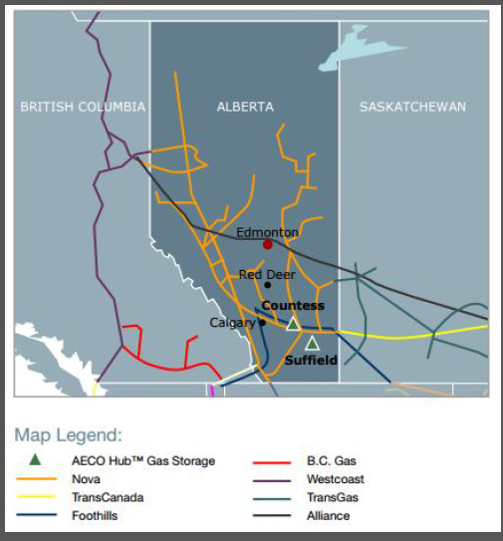

Figure 13-2: Map – California Storage Map
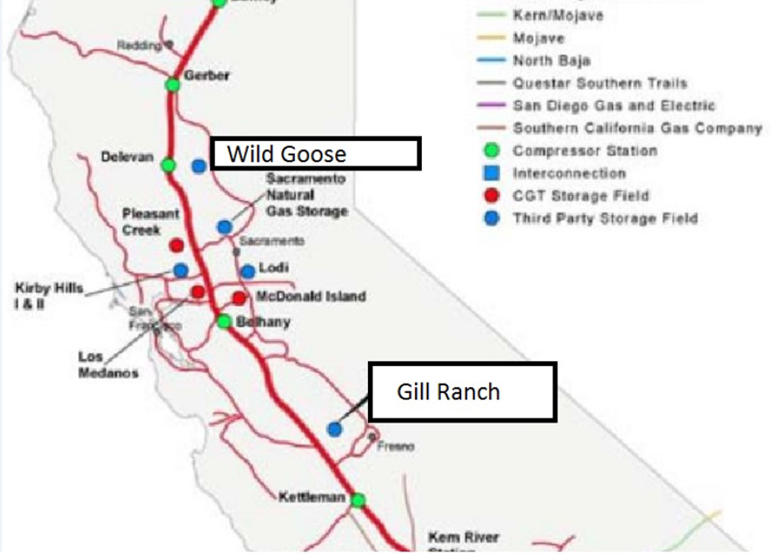

Figure 13-3: Map – Cascade Natural Gas Pipeline System
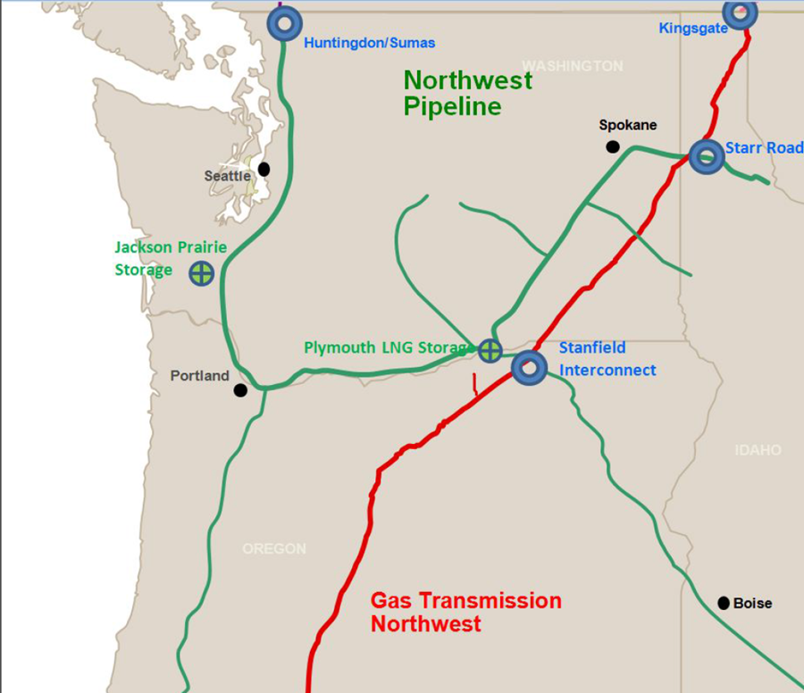

Figure 13-4: Map – Foothills-British Columbia Map
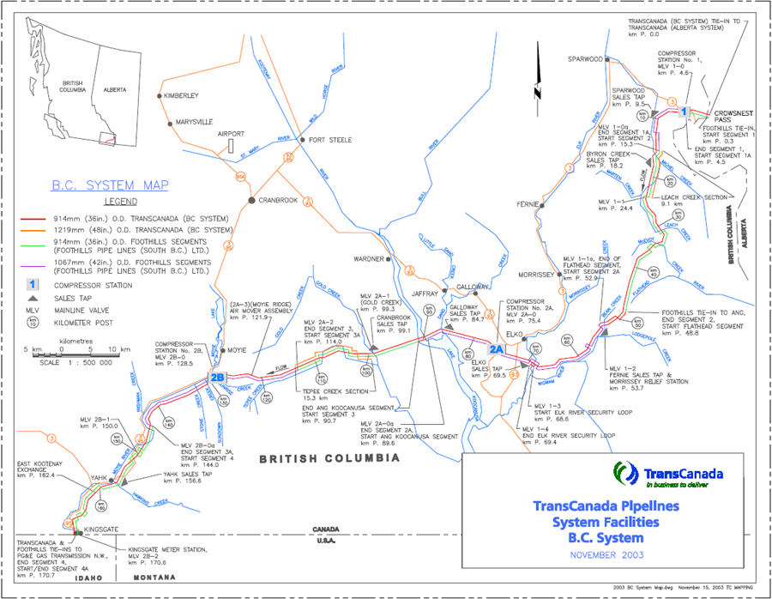

Figure 13-5: Map – Foothills-British Columbia Map 2
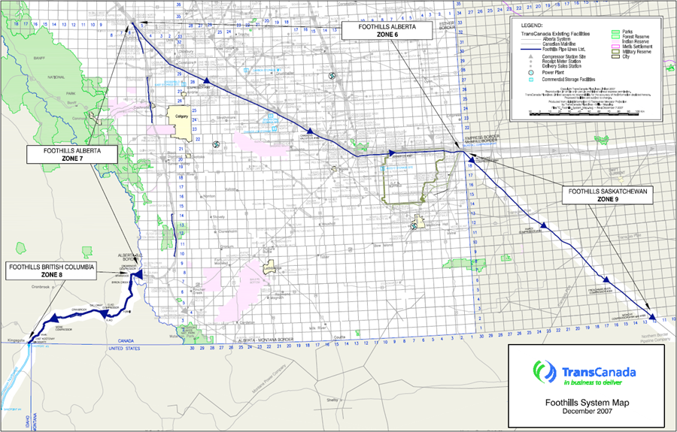

Figure 13-6: Map – GTN System Map
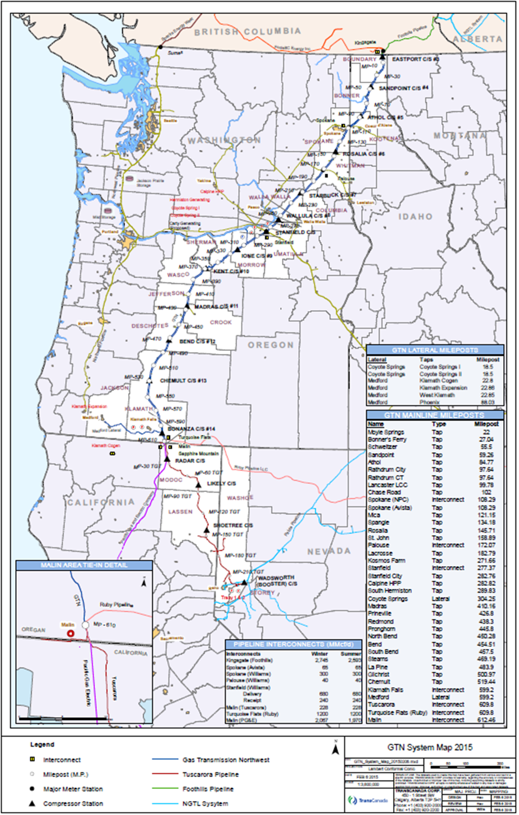
Figure 13-7: Map – NGTL Delivery System Map
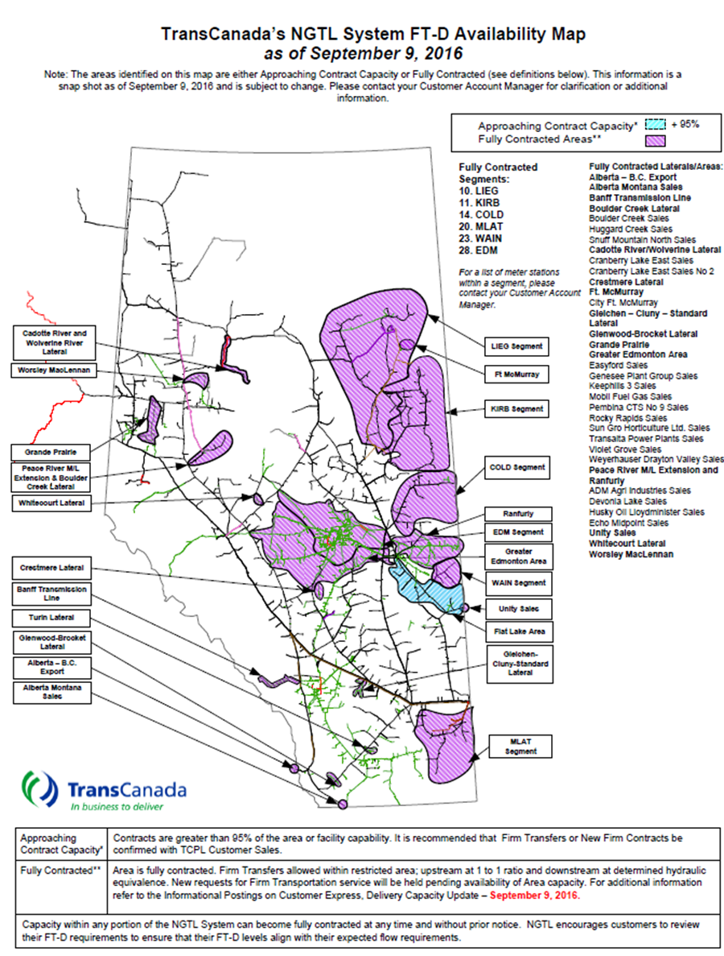
Figure 13-8: Map – NGTL Receipt System Map
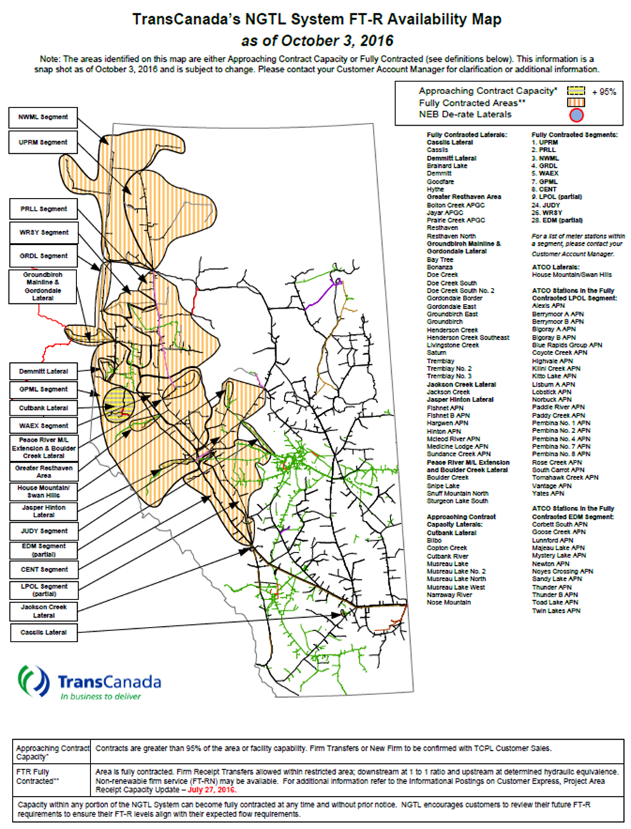
Figure 13-9: Map – NWP North System Map
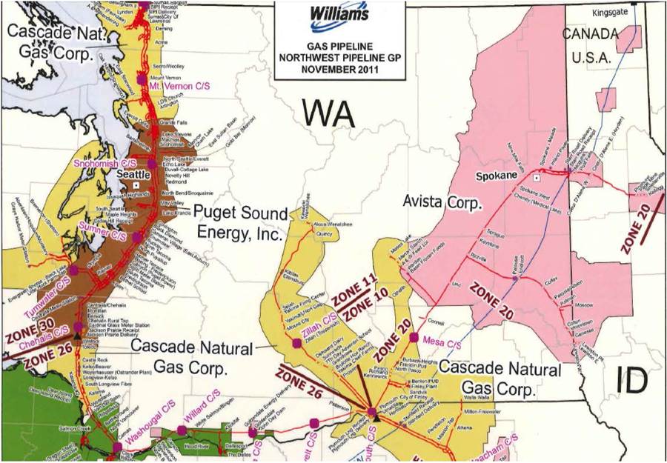

Figure 13-10: Map – NWP South System Map
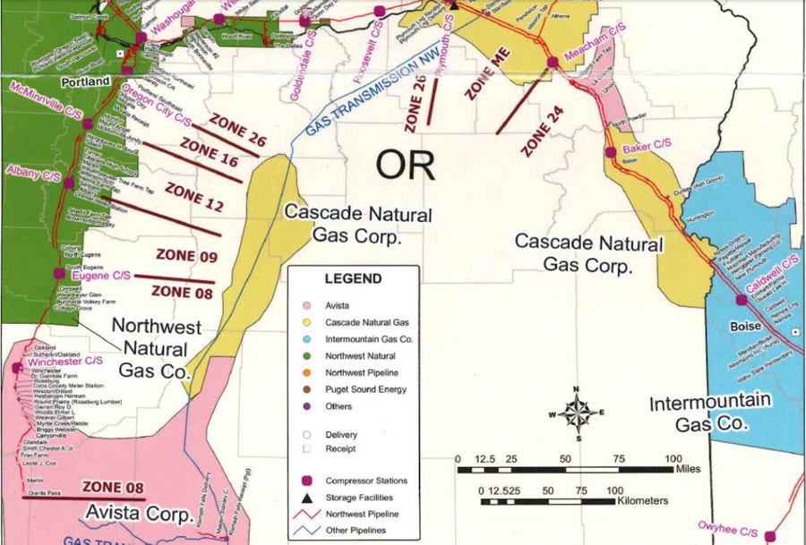

Figure 13-11: Map – Westcoast Sectional Map
