November 30, 2016

via electronic mail (records@utc.wa.gov)

Washington Utilities and Transportation Commission
Docket # TV-161097
P.O. Box 47250
Olympia, WA 98504-7250

re: Docket # TV-161097

To Whom It May Concern:

Enclosed please find the the Notice of Appearance for Ross Day, of Day Law & Associates, P.C. on behalf of Applicant Cheryl Ball.

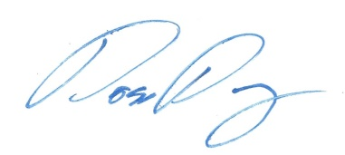
Thank you in advance.

Ross Day
Attorney for Applicant Cheryl Ball

