June 6, 2014

Steven V. King, Executive Director and Secretary
Utilities and Transportation Commission
1300 S. Evergreen Park Dr. SW
P.O. Box 47250
Olympia, WA 98504-7250

RE: Washington Utilities and Transportation Commission v. Petland Cemetery, Inc.

Commission Staff’s Response to Application for Mitigation of Penalties TG-141014

Dear Mr. King:

On May 22, 2014, the Utilities and Transportation Commission issued a $1,000 Penalty Assessment in Docket TG-141014 against Petland Cemetery, Inc. for 10 violations of Washington Administrative Code (WAC) 480-70-071, which requires solid waste companies to furnish annual reports to the commission no later than May 1 each year.¹

On May 27, 2014, Petland Cemetery, Inc. wrote the commission requesting mitigation of penalties (Mitigation Request).² In its Mitigation Request, Petland Cemetery, Inc. does not disputer that the violation occurred. The company states, “There were no accidents in 2013. I do understand the space was left blank and you cannot assume the number zero. In checking our previous reports (included) please note that was not filled out in 2011 or 2012. Schedule 3 was our error. We should have checked that before the report was mailed and while I understand your request for the information, I don’t feel a $100.00 per day fine for missing mileage is fair or reasonable. Schedule 4 doesn’t apply to the best of my knowledge since we don’t own solid waste property. Again, please check the previous two years reports and see it was not filled out either year. In the case of both years, 2011 and 2012, there was nothing forthcoming from UTC regarding the forms being incomplete. In the future we will be sure to complete the form in its entirety and check it prior to mailing it.”

It is the company’s responsibility to ensure that the regulatory fee is paid and the annual report is filed by the May 1 deadline. On February 28, 2014, Annual Report packets were mailed to all regulated solid waste companies. The instructions for annual report completion page of the

UTC Annual Reports
June 6, 2014
Page 2

annual report informed the regulated company that it must complete the annual report form, pay the regulatory fees, and return the materials by May 1, 2014, to avoid enforcement action.

Petland Cemetery, Inc. filed an incomplete annual report on April 30, 2014. Staff notified the company that its report was incomplete, and instructed the company to file the missing information. The company did not respond until the Penalty Assessment was served. Petland Cemetery, Inc. filed a late annual report in 2006 but has filed timely every year since that occurrence. Due to the commission prior practice of accepting annual reports without accident information and the company’s acknowledgement of the requirement for future reporting, commission staff supports the company’s request for mitigation. Staff recommends a reduced penalty assessment of $200.

If you have any questions regarding this recommendation, please contact Amy Andrews, Regulatory Analyst, at (360) 664-1157, or aandrews@utc.wa.gov.

Sincerely,

Sondra Walsh, Director
Administrative Services

ATTACHMENT A

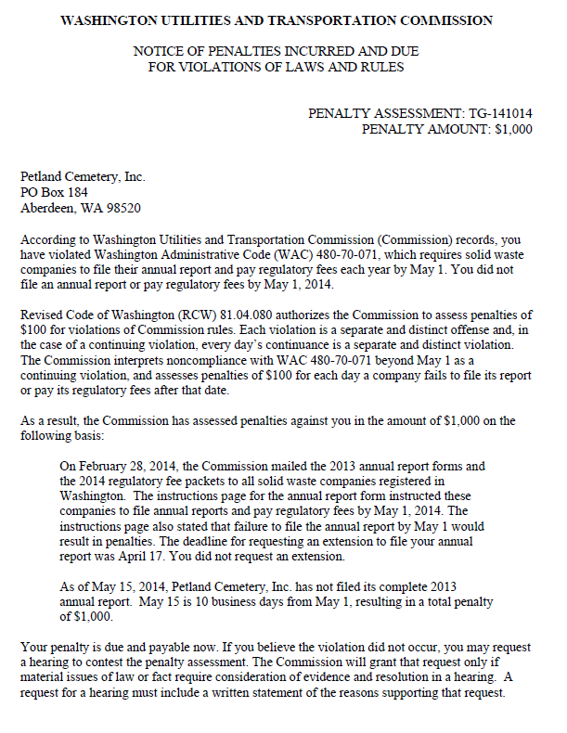

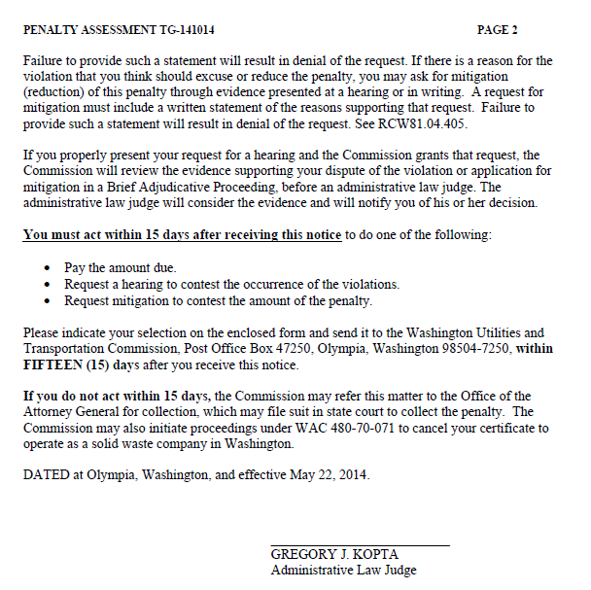

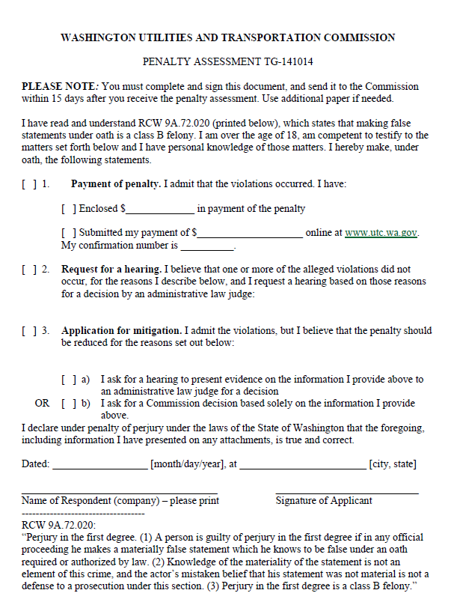
ATTACHMENT B
