June 25, 2014

Steven V. King, Executive Director and Secretary
Utilities and Transportation Commission
1300 S. Evergreen Park Dr. SW
P.O. Box 47250
Olympia, WA 98504-7250

RE: Washington Utilities and Transportation Commission v. Landmark Travel Service, Inc.

Commission Staff’s Response to Application for Mitigation of Penalties TE-141067

Dear Mr. King:

On May 28, 2014, the Utilities and Transportation Commission issued a $1,000 Penalty Assessment in Docket TE-141067 against Landmark Travel Service, Inc. for 10 violations of Washington Administrative Code (WAC) 480-30-071, which requires charter and excursion carriers to furnish annual reports to the commission no later than May 1 each year.¹

On June 11, 2014, Landmark Travel Service, Inc. wrote the commission requesting mitigation of penalties (Mitigation Request).² In its Mitigation Request, Landmark Travel Service, Inc. does not dispute that the violation occurred. The company states, “I for some reason thought the deadline was 31 May 2014, after looking back at the report form it clearly stated that it was to be turned in by 1 May.”

It is the company’s responsibility to ensure that the regulatory fee is paid and the annual report is filed by the May 1 deadline. On February 28, 2014, Annual Report packets were mailed to all regulated charter and excursion companies. The instructions for annual report completion page of the annual report informed the regulated company that it must complete the annual report form, pay the regulatory fees, and return the materials by May 1, 2014, to avoid enforcement action.

On May 27, 2014, Landmark Travel Service, Inc. filed the 2013 annual report and timely paid the required regulatory fees on December 6, 2013. No previous violations of WAC 480-30-071 are on commission record. The UTC also recently adopted new rules requiring the annual report to be filed by May 1 while the regulatory fees remained due on December 31. Despite the
UTC Annual Reports
June 25, 2014
Page 2

commission communication regarding these filing changes to all regulated charter and excursion companies, commission staff supports the company’s request for mitigation. Staff recommends a reduced penalty assessment of $200.

If you have any questions regarding this recommendation, please contact Amy Andrews, Regulatory Analyst, at (360) 664-1157, or aandrews@utc.wa.gov.

Sincerely,

Sondra Walsh, Director
Administrative Services

ATTACHMENT A
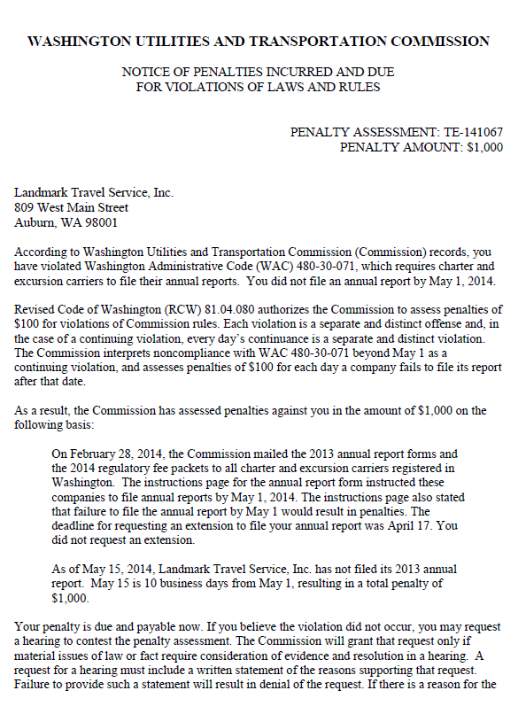

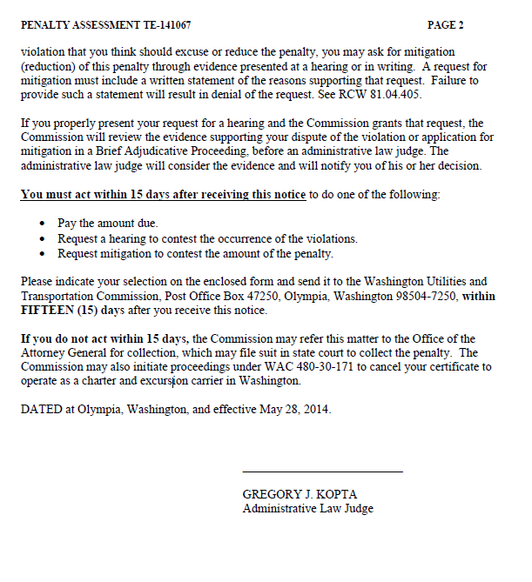

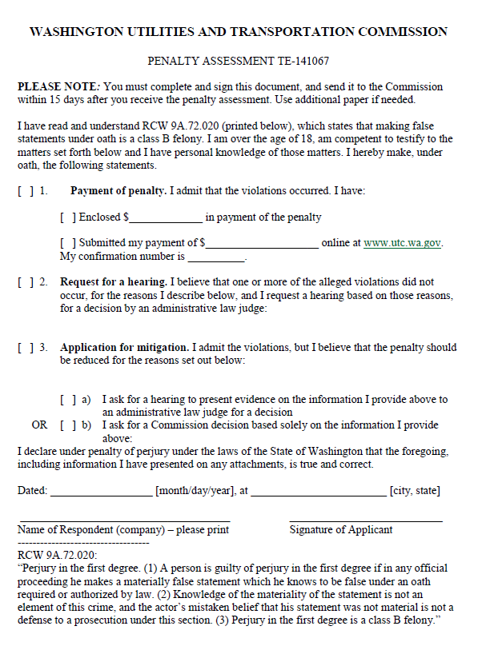

ATTACHMENT B
