Report to the Washington Utilities and Transportation Commission

Electric Service Reliability - Major Event Report

Event Date: June 29, 2015
Date Submitted: October 16, 2015
Primary Affected Locations: Yakima
Primary Cause: Loss of Transmission
Exclude from Reporting Status: Yes
Report Prepared by: April Brewer
Report Approved by: Heide Caswell / David O’Neil / Steve Henderson / Kevin Putnam

Event Description
Due to high summer loading conditions a line section in the Yakima valley was loaded above its continuous rating, but within its four hour emergency rating. Action was taken to resolve the loading condition by reconfiguration the transmission system. During the switching to reconfigure the system, a switch failed to operate correctly (was unable to extinguish the arc), resulting in a flash over causing outages to North Park, Orchard, Pacific, and River Road substations.

Sustained interruptions were experienced by approximately 20% of the company’s Washington customers.

6/29/15 Event Outage Summary
# Interruptions (sustained) | 35
Total Customer Interrupted (sustained) | 27,609
Total Customer Minutes Lost | 2,037,132
Event SAIDI | 14.84 Minutes
CAIDI | 74

Restoration Summary
On June 29th at 16:40 crews were called to respond to an outage that involved 27,333 customers in the Yakima Valley. The first crew was dispatched to Voelker substation at 16:50, and a second to River Road substation at 17:01. At 17:22 the dispatcher closed 2Y108 at Clinton substation via SCADA to restore the load at Orchard Substation. At 17:40 the crew at Voelker informed dispatch that switch 2Y130 had a burnt arcing horn and the structure had evidence of a flash over. The crew performed an inspection of 2Y130 and informed dispatch the switch could be closed manually. Once 2Y130 at Voelker substation was closed, the dispatcher closed 2Y91 at Union Gap substation via SCADA to restore Voelker Substation. At 18:00 the crews at River Road substation reported their findings to the dispatcher and were confident the station could be restored to service. At 18:09, the dispatcher closed 2Y21 at River Road substation which restored power to River Road, Pacific, and North Park substations via SCADA to conclude the customer restoration process.
Restoration activities utilized 14 operations personnel. 99.9% of the sustained customer interruptions were restored within 92 minutes.
There were no company or commission customer complaints made regarding the major event.

Mitigation Measures
Operational procedures were modified to incorporate recent system configuration changes which impact switch limitations (in addition to other equipment ratings). Further work has been initiated to augment switching capability of these and other similar switches within the Yakima loop.
Restoration Intervals
Total Customers Sustained | < 3 Hrs. | 3 - 24 Hrs. | 24+ Hrs.
27,609 | 27,587 | 22 | 0

Restoration Resources
No materials were used or replace due to the event.
Personnel Resources
Wires Journeymen | 6
Substation Journeymen | 8
TOTAL | 14

State Estimated Major Event Costs
Estimate $ | Labor | Materials | Total
Capital | $0 | $0 | $0
Expense | $16,944 | $0 | $16,944
Total | $16,944 | $0 | $16,944
Major Event Declaration
Pacific Power is requesting designation of this event and its consequences to be classified as a “Major Event” for exclusion from network performance reporting with the IEEE 1366-2003. This major event exceeded the company’s current Washington threshold of 1,299,474 customer minutes lost (9.46 state SAIDI minutes) in a 24-hour period.

Event Detail
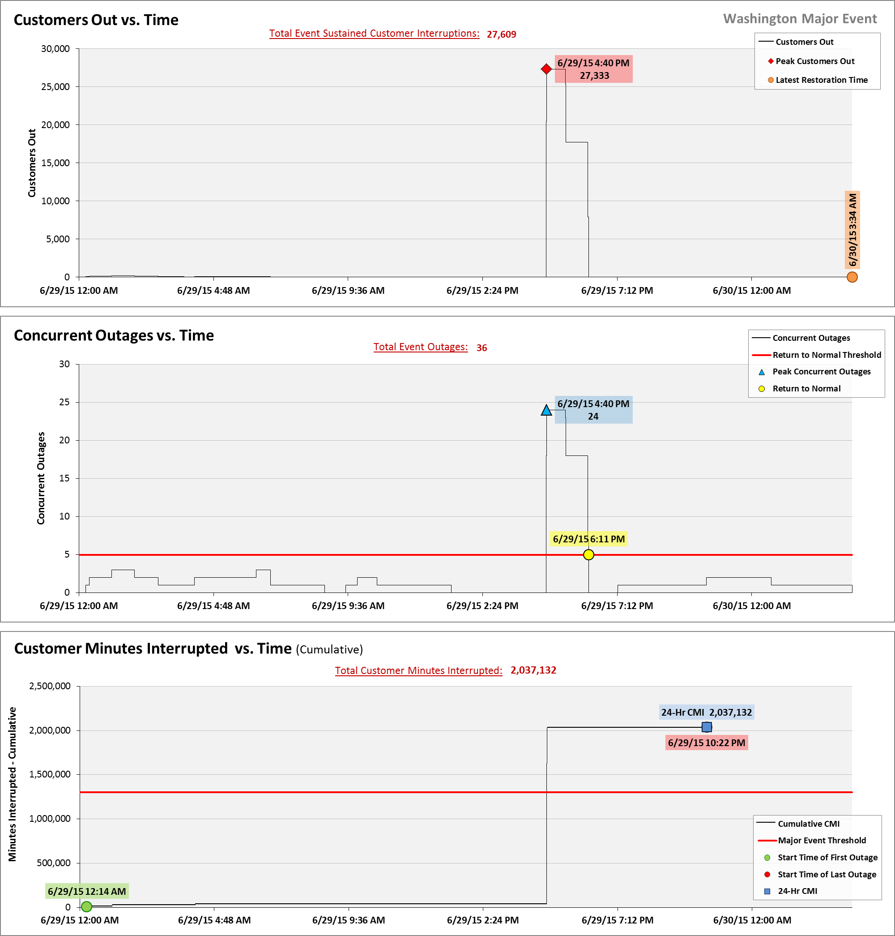

SAIDI, SAIFI, CAIDI by Reliability Reporting Region
Please see the attached system-generated reports.

