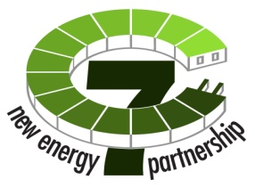
The C-7 New Energy Partnership:
Creating a New Energy Future Together

Via electronic mail - records@utc.wa.gov

March 22, 2010

Mr. David W. Danner
Executive Director and Secretary
Washington Utilities and Transportation Commission
1300 South Evergreen Park Drive S.W.
P.O. Box 47250
Olympia, WA 98504-7250

Subject: Puget Sound Energy (“PSE”) / C-7 New Energy Partnership
Home Energy Reports Program
Docket No. U-091954
120 filing Docket Numbers UE-100382 and UG-100383

Dear Mr. Danner:

We are writing on behalf of a Puget Sound regional partnership referred to as the C-7 New Energy Partnership (“C-7”) to support PSE’s proposed budget as it relates to the Home Energy Reports Program.

C-7 is comprised of the following seven neighboring cities in King County: Bellevue, Issaquah, Kirkland, Mercer Island, Redmond, Renton, and Sammamish. The C-7 geography represents a residential population of approximately 395,430 and a daytime population of approximately 429,689. We work together to develop ideas and seek funding for projects in which the C-7 geography, our shared goals and challenges, and our history of successful collaboration allow us to achieve superior outcomes for our communities. To date, we have focused on opportunities relating to the emerging clean mobility and energy efficiency sectors.

One example has been our collaboration with PSE to bring home energy reports to our residents. This effort, which was approved by the federal Department of Energy as well as the State Department of Commerce for the use of municipal Energy Efficiency and Block Grant funding, is an expansion of a successful PSE pilot program. It was PSE’s financial and programmatic commitment to the continuation and expansion of that program that enabled the participation of our cities. At this time, our ability to proceed is dependent on PSE’s ability to participate on the terms contemplated in our state and federal grant filings.

We believe that a suite of tools and approaches are need to work towards environmental sustainability and energy efficiency and programs such as this one, which not only educate and provide tools, but are shown to result in lasting behavioral changes, are a critical component of those efforts.

Accordingly, we wanted to express to you the import to our cities of PSE’s proposed budget as it relates to the Home Energy Reports Program. We believe this collaboration represents the type of innovative, cross-boundary and cross-sector effort our federal and state governments are encouraging. Additionally, successful pilot program results indicate that this program is as an efficacious use of public funds. The fact that other states not only endorse behavior modification measures through legislation, but also allow them to be counted towards quantifiable energy efficiency measures provides further support as to the potential of such programs. We believe that every incentive provided to utilities to participate in a robust way in energy efficiency efforts provides value to the public.

We appreciate the opportunity to submit this letter and thank you for your consideration.

Sincerely,

The C-7 New Energy Partnership
________________________________  City of Bellevue  Name:  Title: | ________________________________  City of Issaquah  Name:  Title:
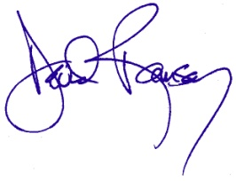__________________________  City of Kirkland  Name: David Ramsay  Title: City Manager | ________________________________  City of Mercer Island  Name:  Title:
________________________________  City of Redmond  Name:  Title: | ________________________________  City of Renton  Name:  Title:
________________________________
City of Sammamish
Name:
Title:

