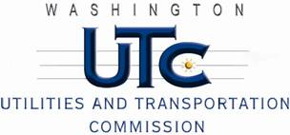

Memorandum
July 7, 2011

To: TR-110680 - File

From: Kathy Hunter, Deputy Assistant Director Transportation Safety

Subject: TR-110680 Eastern Washington Gateway Railroad
Grade Crossing Protective Fund (GCPF) Project at the Intersection of
3rd Avenue and Eastern Washington Gateway Railroad’s Tracks in
the City of Almira, Washington

On April 29, 2011, the Washington Utilities and Transportation Commission (Commission) awarded a GCPF grant totaling $7,140.51 to install LED lights, replace the battery charger, replace the batteries, install a LED power off light, and replace the cross-bucks at the 3rd Avenue crossing in the City of Almira. The USDOT number assigned to this crossing is 066086V.

On June 14, 2011, the applicant, EWGRR submitted a request for an extension of time until June 28, 2011, to complete the project. EWGRR also requested an additional expenditure of $2,175.54 to cover the cost of the LED’s. In the original petition, EWGRR inadvertently omitted the cost of the LEDs when calculating the total grant amount needed for the upgrades. On June 15, 2011, the Commission awarded an amended grant in the amount of $9,316.05 and extended the project completion date to June 28, 2011.

On July 5, 2011, the applicant, EWGRR submitted a request for reimbursement pursuant to Commission order. On July 7, 2011, Commission staff conducted a site visit and verified that the project is completed according to the specifications outlined in the order approving the grant.

Please close this docket.

