REGIONAL TRANSMISSION
RESOURCES
Contents
I-2. OVERVIEW
I-3. THE PACIFIC NORTHWEST
TRANSMISSION SYSTEM
- Regional Constraints
- PSE Westside Transmission Constraints
I-7. PSE TRANSMISSION EFFORTS
- Puget Sound Area / North of Echo Lake / Northern Intertie
- West of Cascades North
I-8. BPA TRANSMISSION EFFORTS
- Network Open Season (NOS)
- Wind Curtailments
- BPA Transmission Planning and Attachment K Projects
I-11. REGIONAL TRANSMISSION
EFFORTS
- Major Proposed Projects
- ColumbiaGrid Efforts
- Order 1000
I-17. OUTLOOK AND STRATEGY

The Pacific Northwest’s regional transmission system
and policies have undergone significant change and reform over the last several years. This change is marked by increasing frequency and duration of transmission constraints, changes in transmission policy and transmission projects, and promising steps in studying and implementing regional transmission solutions. Of these items, some stand out
as particularly important.

OVERVIEW
Existing flowgates and paths managed by the Bonneville Power Administration (BPA) continue to experience congestion resulting in curtailment. BPA has identified and implemented new flowgates and paths on its system to help manage congestion, signaling the increasingly strained nature of the transmission system and the increasing risks of curtailment.
Analysis of internal PSE transmission constraints in the Puget Sound area continues to be refined as generation alternatives are considered.
With the completion of BPA’s Network Open Season (NOS) in the summer of 2014, BPA has identified several transmission projects required to grant new transmission service requests. ColumbiaGrid and its members have completed several studies and developed transmission reinforcement plans to help alleviate regional congestion. PSE will continue to look to ColumbiaGrid to provide the region with an understanding of where future transmission reinforcements should occur and which projects or facilities will be most effective.
These items will be explored in the sections below.

THE PACIFIC NORTHWEST TRANSMISSION SYSTEM

Regional Constraints

BPA provides roughly 75 percent of the high-voltage transmission in the Pacific Northwest region. Historically, PSE and other regional utilities have relied on BPA’s transmission system to deliver energy to serve retail customers. However, as PSE and the region’s resource portfolios have grown in conjunction with increasing loads and renewable energy standards, the Pacific Northwest’s transmission system has not kept pace with the expanding demands. As a result, the region experiences transmission constraints during various times of the year, sometimes resulting in curtailments of firm contractual transmission rights.
What is a constrained path?
Constrained paths and flowgates are sets of transmission lines that are nearly “full.” They have little capacity available to sell, which makes them vulnerable to congestion and curtailment.
What is curtailment?
Curtailments occur when scheduled transmission service must be canceled due to physical constraints.

The situation poses an operational challenge for PSE in particular, since PSE moves significant amounts of energy and capacity resources to the west from eastern Washington (east of the Cascades) and from the south along the I-5 corridor and into the Puget Sound area.

Figure I-1 illustrates how power travels from remote resources, generally located south of Seattle and east of the Cascades, to PSE’s service area. The thick, black bars in Figure I-1 represent a flowgate or path, often consisting of several transmission lines or sets of parallel lines. The flow of power is indicated by the arrow symbol.

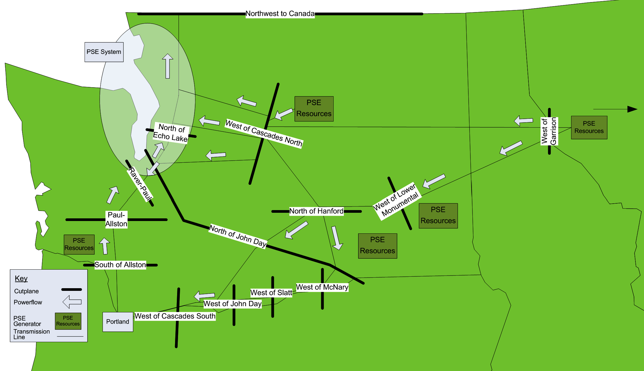
Figure I-1: BPA Transmission System Constraints on PSE Remote Resource Delivery

A summary of the most significant flowgates and paths shown in Figure I-1 are discussed below.
- The majority of energy from PSE’s eastern Washington resources flow across the constrained West of Cascades North flowgate and into the Puget Sound area. This flowgate is most constrained during heavy winter loading periods.
- A portion of the energy flowing from eastern Washington resources also flows over the West of Cascades South flowgate, and in the process of traveling to loads in the Puget Sound area, it flows over the North of John Day and Raver – Paul flowgates. The West of Cascades South flowgate is most constrained during heavy winter loading periods, while the North of John Day and Raver – Paul flowgates are typically most constrained during heavy summer loading periods.
- Energy from PSE’s resources in Montana flow over the West of Garrison path.
- Congestion issues in the Puget Sound area are monitored by the North of Echo Lake flowgate. Generation support from PSE resources located in Skagit and Whatcom Counties is particularly important in reducing curtailment risk on this flowgate.
- Energy from PSE’s Lower Snake River Wind Project flows across the West of Lower Monumental flowgate.

Some paths are designed to operate close to their limits (like West of Garrison), others are not; this latter group presents areas of the system where PSE sees a particular importance in continuing to study, develop and possibly construct new transmission.

PSE Westside Transmission Constraints

Generally, resources located west of the Cascades near PSE load centers and natural gas pipelines have fewer delivery constraints because they are located next to the company’s own local transmission system. Currently, there is sufficient transmission capacity on PSE’s westside system to move surplus energy produced in one part of the service territory to another part that is experiencing a deficit. However, in certain areas, constraints could develop within the system if new resources are added or imported.

Figure I-2 illustrates the PSE Westside Load Zones and transmission paths.

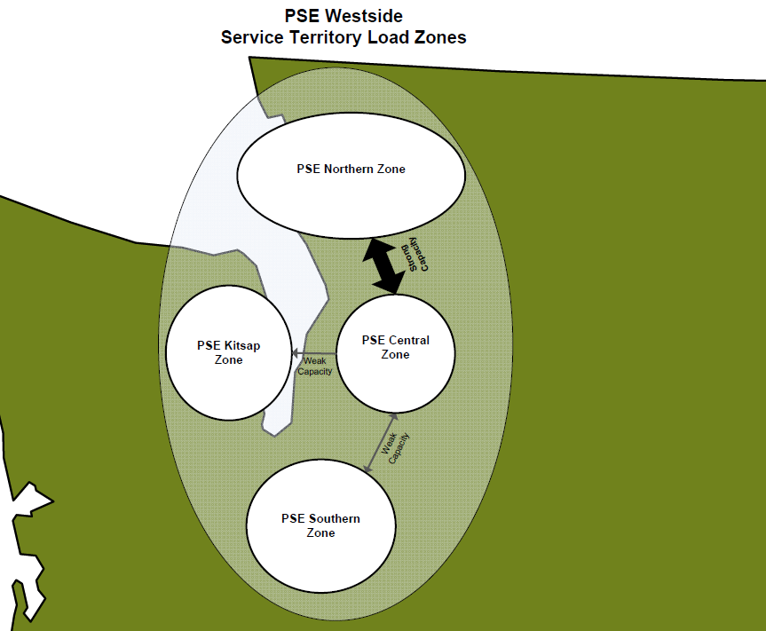
Figure I-2: Transmission System Constraints on PSE Internal Resource Delivery

The illustration above divides PSE’s Westside Service Territory into four geographic load areas, connected by different sets of transmission facilities. The arrows indicate relative transmission capacity between the load areas; the thicker the arrow, the greater the transmission capacity.

- Capacity from the Central Zone to the Northern Zone is adequate in the near term. In the ten-year time frame examined here, it is unlikely that new resources located in (or imported into) the Central Zone would cause PSE to experience limitations in moving energy from the Central to the Northern Zone.
- Transmission capacity from the Central to Southern Zone is more limited. Here, PSE could experience limitations in moving energy from the Central to the Southern Zone if new resources are added or imported in the next ten years.
- In the Kitsap Zone, PSE may begin to see resource deficits after 2024 unless new transmission capacity is built or obtained between the Central or Southern Zones and the Kitsap Zone.

Purchased power agreements (PPAs) also impact energy transfer needs, as do capacity constraints, the geographic location of PSE’s loads and existing resources, and the physical delivery points of remote resources.

PSE will consider these implications as we continue to analyze and study the location of loads, existing resources and transmission limitations.

PSE TRANSMISSION EFFORTS

There may be opportunities for PSE to join with other regional utilities on transmission projects to solve congestion issues in the Pacific Northwest. PSE is considering the following regional transmission projects.

Puget Sound Area / North of Echo Lake / Northern Intertie
As part of the ColumbiaGrid “Transmission Expansion Plan for the Puget Sound Area,” PSE has committed to addressing Puget Sound area congestion through rebuilding its Sammamish – Lakeside – Talbot 115 kV lines from 115 kV to 230 kV (or a similar performing alternative). This is part of PSE’s Energize Eastside project. Only one line will initially be energized at 230 kV. This will significantly increase reliability and reduce curtailment risk for imports into the Puget Sound area. This project is discussed further in the ColumbiaGrid section below.

West of Cascades North
Near-term improvements to the West of Cascades North flowgate will be constructed solely by BPA (see Attachment K section below), but long-term solutions could be improved through joint transmission development. As identified by the ColumbiaGrid Cross Cascades North Study team, the most effective transmission project for the West of Cascades North flowgate is the Chief Joseph – Monroe 500 kV #2 transmission line. PSE will continue to participate in the study team and work with regional utility partners to determine the most beneficial transmission project and construction time for West of Cascades North transmission improvements.

BPA TRANSMISSION EFFORTS

Network Open Season (NOS)

The primary option for acquiring contractual transmission in the Northwest is through BPA. Historically this involved submitting an OASIS (Open Access Same-time Information System) transmission service request to BPA, but the agency now requires participation in its Network Open Season (NOS). The NOS process was designed to obtain financial commitments from transmission customers in advance of any new facility construction. For long-term transmission requests, the process uses cluster studies to analyze impacts and new transmission facility requirements on an aggregated basis. Commencing in 2008, and in accordance with Federal Energy Regulatory Commission (FERC) approval, BPA initiated an NOS process under its Open Access Transmission Tariff (OATT). The multi-step process began with the submission of Transmission Service Requests (TSR) by transmission customers. BPA responded with a Precedent Transmission Service Agreement (PTSA) that requires customers to pledge a security deposit equal to the charge for 12 months of transmission service at the tariff rate. The PTSA obligates the customer to take service for its TSR if BPA satisfies the following conditions:

- BPA determines that it can reasonably provide service for the TSR in the cluster at embedded cost rates, and
- BPA decides to construct the facilities required to provide the service after completing an environmental impact study.

2013 NOS Findings. BPA released the findings of its 2013 NOS study on April 30, 2014. They include the following.

- No transmission expansion was necessary to accommodate the potential exchange of transmission facilities with Idaho Power (or any other TSRs that affect the flowgates impacted by this potential asset exchange).
- 5 TSRs totaling 166 MW could be authorized without further system expansion beyond any requirements identified in Large Generator Interconnection Procedure studies.
- 30 TSRs totaling 2,505 MW could be offered assuming that the 2008 and 2010 NOS projects and other reliability-based projects were completed as planned.
- 15 TSRs totaling 1,002 MW require completion of 2008 and 2010 NOS and other planned reliability-based projects as well as one or more new projects identified in the 2013 NOS.

Potential future projects identified in the 2013 NOS include:

- For BPA: upgrade Monroe – Novelty Hill 230 kV
- For PSE: Portal Way area 230-115 kV transformer

The next NOS was originally scheduled to begin in the fall of 2015, but has been delayed indefinitely, pending BPA policy decisions.

Past NOS Findings. From the 2008 NOS, BPA authorized four transmission reinforcement projects. These included the following.

- McNary – John Day 500 kV line (completed)
- Big Eddy – Knight 500 kV (to be complete by the end of 2015)
- Central Ferry – Lower Monumental 500 kV (to be complete by the end of 2015)
- I-5 Corridor Reinforcement Project (estimated completion, end of 2021).

There were no additional projects identified in 2009. In the 2010 NOS, BPA authorized the Northern Intertie Reinforcement Project. This project will help to integrate thousands of megawatts of new resources into the Northwest.

Wind Curtailments

Wind power plays a significant role in meeting the region's future energy needs and satisfying RPS requirements. In fact, approximately 5,000 MW total of renewable generation (predominantly wind power) will be necessary to fulfill the combined RPS requirements of Washington and Oregon. To meet this increase, BPA must continue to build transmission lines and substations to deliver renewable electricity from new wind projects that are often located in remote areas. Integrating this amount of wind energy into the region’s electrical grid poses many challenges, and BPA’s role will certainly require innovative and cooperative approaches to manage the variability of wind power effectively. Current BPA efforts to manage wind energy include the following.

Dispatcher Standing Order (DSO) 216. DSO 216 enables BPA to either curtail generation schedules or limit generation to the scheduled amount when there is insufficient regulating capacity on the federal hydroelectric system. Regulating capacity is an ancillary service that BPA provides to integrate wind. However, that service is not always available, as shown by the historical frequency of DSO 216 curtailments. Curtailments may result in lost energy and/or renewable energy credits (RECs) without compensation.

Oversupply Management Protocol. Similar to DSO 216, BPA uses Oversupply Management Protocol to curtail wind energy, but in this case when there is an oversupply of hydroelectric and wind generation in the region. Curtailments may result in lost energy and/or RECs with compensation.

PSE’s future resources – especially renewables – will most likely face tough economic and technical challenges, along with business uncertainties. Continuing to rely on BPA to integrate our wind resources has a limit, which means we must continue to look for alternatives to integrate wind either directly into our Balancing Authority (BA), or seek other innovative, lower-cost approaches.

BPA Transmission Planning and Attachment K Projects

Through its various forums (Attachment K, Capital Investment Review), BPA is planning to construct one project that is particularly important for PSE’s customers.

- Raver 500/230 kV Transformer, in service 2017

This project enables new capacity on the North of Echo Lake flowgate, increasing reliability to Puget Sound area loads and decreasing potential congestion experienced in heavy winter and light spring loading periods. This project is also important because it could make new capacity available for PSE requests for transmission service from eastside generation alternatives to PSE loads.

REGIONAL TRANSMISSION EFFORTS

Major Proposed Projects

Several major transmission projects are proposed for the Pacific Northwest. These projects may impact each other as well as existing Western Electricity Coordinating Council (WECC) paths. The WECC maintains a public transmission project database where project sponsors can post information and updates for their projects. The projects listed below can be found in the WECC database or at BPA’s website. All are assumed to have some effect on the paths and flowgates that PSE uses to transmit energy from remote resources to load. Project names are followed by expected cost, completion date and current status.

- PacifiCorp’s Gateway West: ~ $2.7 billion, tentative completion date 2020 – 2024
- Idaho Power’s Boardman to Hemingway: ~ $900 million, tentative completion date 2020
- BPA’s Central Ferry – Lower Monumental Project: ~ $90 million, tentative completion date 2015
- BPA’s I-5 Corridor Reinforcement: ~ $340 million, tentative completion date 2021
- PacifiCorp’s Walla Walla – McNary 230 kV: cost unknown, tentative completion date 2017

These projects are displayed in Figure I-3. For a complete listing of WECC projects, see https://www.wecc.biz/TransmissionExpansionPlanning/Pages/Project-Information-Portal2.aspx.

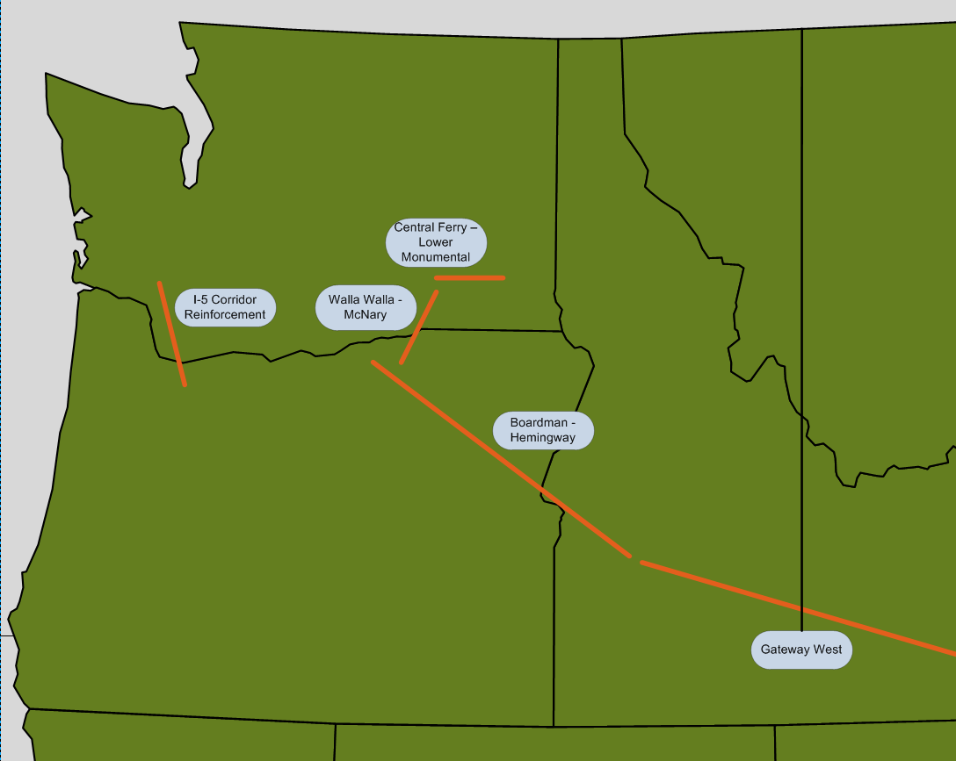
Figure I-3: Proposed Regional Transmission Projects

These projects bring three main benefits to the region:

      - access to significant incremental renewable resources in the northwestern states,
      - improvement in regional transmission reliability, and
      - new market opportunities for dealing with participants outside of the region.

ColumbiaGrid Efforts

ColumbiaGrid is a non-profit membership corporation formed in 2006 to improve the operational efficiency, reliability and planned expansion of the Pacific Northwest’s transmission grid. While ColumbiaGrid does not own transmission, PSE, other members and additional parties to ColumbiaGrid’s agreements do own and operate an extensive network of transmission facilities. ColumbiaGrid’s members are PSE, Avista, BPA, Chelan County PUD, Grant County PUD, Seattle City Light, Snohomish PUD and Tacoma Power.

ColumbiaGrid has substantial responsibilities for transmission planning, reliability, OASIS and other development services. These tasks are defined and funded through a series of “Functional Agreements” with members and other participants. Development of these agreements is carried out in a public process with broad participation. ColumbiaGrid's transparent processes encourage broad participation and interaction with stakeholders, including customers, transmission providers, states and tribes. It also provides a non-discriminatory forum for interested parties to receive and present pertinent information concerning the regional interconnected transmission system.

Planning and Expansion. ColumbiaGrid's planning and expansion efforts are intended to promote single-utility planning and expansion of the regional grid. The Planning and Expansion Functional Agreement (PEFA), which has been signed by all of ColumbiaGrid's members and three non-member participants (Cowlitz County PUD, Douglas County PUD and Enbridge, Inc.), defines the obligations under this program.

The PEFA charges ColumbiaGrid with answering three key questions concerning the transmission network: what should be built, who should build it and who should pay for it. ColumbiaGrid provides a number of services in this planning program, including performing annual transmission adequacy assessments, producing a Biennial Transmission Plan and identifying transmission needs. ColumbiaGrid also facilitates a coordinated planning process for the development of multi-party transmission system projects.
ColumbiaGrid’s 2014 System Assessment serves as an input to the 2015 Biennial Transmission Expansion Plan. The Assessment highlights areas of the system that may be vulnerable to deficiencies in meeting reliability standards. In support of the Biennial Plan, PSE participated in three study teams addressing specific regions: the Puget Sound Area Study Team (PSAST), the Wind Integration Study Team (WIST) and the Cross Cascades North Study Team.

Puget Sound Area Study Team (PSAST). The ColumbiaGrid PSAST published its “Transmission Expansion Plan for the Puget Sound Area” in October 2010; an update was issued in October 2011. Since then, area utilities have continued to meet and develop additional scenarios to study. Six projects have been identified as being the most effective at reducing risk of curtailing firm transfers for south-to-north congestion on the North of Echo Lake flowgate.

- Reconductor the Bothell – SnoKing 230 kV double circuit line.
- Add series inductors to the Massachusetts – Union – Broad and Broad – East Pine 115 kV underground cables.
- Extend the Northern Intertie Remedial Action Scheme (RAS) to compensate for the combined loss of Monroe – SnoKing – Echo Lake and Chief Joseph – Monroe 500 kV lines.
- Add a Raver 500/230 kV transformer and a 230 kV Raver – Covington line.
- Upgrade both Sammamish – Lakeside – Talbot 115 kV lines to 230 kV. Energize one line at 230 kV and the other at 115 kV. (This is part of PSE’s Energize Eastside project.)
- Reconductor the Duwamish – Delridge 230 kV line.

PSAST has also updated the north-to-south portion of the “Transmission Expansion Plan for the Puget Sound Area.” Two projects were identified to be the most effective at correcting major limitations for north-to-south transfers in the Puget Sound area.

- Add a second Portal Way 230/115 kV transformer.
- Upgrade Monroe – Novelty 230 kV line to operate at 80 degrees Celsius.

Wind Integration Study Team (WIST). WIST was formed by the Northern Tier Transmission Group (NTTG) and ColumbiaGrid to facilitate the integration of renewable generation into the Northwest transmission grid. Its current focus is to study and address system constraints related to increased use of dynamic transfers for variable energy resources. The study team produced a set of reports in 2011 that confirmed the need for dynamic transfer capability limits, explored dynamic transfer capability study methodologies and applied the methodology to several NW paths. Work continued through 2012 to quantify the dynamic transfer capability of NW paths and to help identify other dynamic transfer impacts on reliability.

While the Dynamic Transfer Capability Task Force is not currently meeting on a regular basis, ColumbiaGrid facilitated a Dynamic Transfer Capability study on the California – Oregon Intertie (COI) in late 2014 under a separate request by BPA.

Cross Cascades North Study Team. The Cross Cascades North Study Team is currently investigating the extent of system problems on the Cross Cascades North flowgate. It is also evaluating the performance and interaction of various potential transmission projects. As discussed previously, this path delivers remote resources from east of the Cascade Mountains to westside load areas. Should increasing amounts of eastside remote renewable generation displace westside thermal generation, the path may exceed its system operating limits and cause critical outages.
To address these issues, the team studied the incremental transfer capability benefits of potential system expansion alternatives. Alternatives were categorized as short lead-time construction or long lead-time construction. These studies showed that the most beneficial short lead-time alternative was the addition of series capacitors at the Schultz Switching Station on the Raver #3 and Raver #4 lines; the most beneficial long lead-time alternative was a new 500 kV transmission line between the Chief Joseph and Monroe substations. Long lead-time construction is assumed to take at least 10 years.

Order 1000

The Federal Energy Regulatory Commission’s Order 1000 requires transmission providers to:

  - participate in a transmission planning process that evaluates alternatives that may resolve the region’s transmission needs in a more cost-effective and efficient manner than local planning processes;
  - have a methodology for cost allocation for such projects within the region; and
  - consider public policy requirements in its planning process.

The Order further requires transmission providers to improve coordination across regional transmission planning processes by developing and implementing procedures for joint evaluation and sharing of information regarding both regional transmission needs as well as potential interregional transmission facilities. The Order also requires regions to have a common methodology for allocating costs of interregional projects.

PSE recognizes ColumbiaGrid as its regional planning entity. The ColumbiaGrid PEFA addresses many of the Order 1000 requirements for PSE, but an additional Order 1000 Functional Agreement has been created to address incremental changes to the PEFA planning process to ensure that it complies with regional planning requirements.

The Order 1000 Functional Agreement and corresponding changes to the Attachment K to PSE’s OATT were filed with FERC on December 18, 2013 in response to FERC’s June 20, 2013 Order regarding PSE’s original compliance filing of October 11, 2012. On September 18, 2014, FERC issued an Order largely accepting the Order 1000 Functional Agreement filing with some additional modifications. A third compliance filing that addressed those modifications was made on November 17, 2014.

For the interregional portion of the order, PSE worked with ColumbiaGrid and the other regions in the western interconnection (the California Independent System Operator [CAISO], WestConnect and the Northern Tier Transmission Group) to develop the required common language for interregional coordination and cost allocation; this was filed with FERC on June 19, 2013. FERC issued an Order generally accepting the interregional language on December 18, 2014. While no further changes to the Order 1000 Functional Agreement or PSE’s Attachment K are anticipated, a filing will be made with FERC by February 18, 2015 to address changes being made by the CAISO in response to the FERC’s Interregional Order. PSE and ColumbiaGrid will implement the Order 1000 Agreement beginning with the 2015 ColumbiaGrid planning cycle.
What is CAISO?
The California Independent System Operator (CAISO) is an independent, non-profit Independent System Operator (ISO), serving California. The CAISO oversees the operation of California’s bulk electric power system, transmission lines, and electricity market generated and transmitted by its member utilities.

Information regarding Order 1000 is available on the ColumbiaGrid website under Order 1000 at https://www.columbiagrid.org/1000-overview.cfm.

OUTLOOK AND STRATEGY

PSE needs to advocate and participate in local and regional transmission projects that relieve congestion, increase transfer capacity and improve reliability for its electric customers. This can be accomplished through the following actions.

Participate in efforts focusing on relieving existing and future transmission congestion.

PSE should continue to participate in the planning of regional transmission projects that decrease congestion and curtailment risk, increase regional reliability, and help maintain low power prices for its customers. PSE will pursue these opportunities through various forums, including ColumbiaGrid, BPA Network Open Season and Attachment K, and through its utility partners in the Puget Sound area. Because of our geographical location, PSE will focus on efforts to study and develop projects that relieve congestion on the West of Cascades North, North of Echo Lake and Raver – Paul flowgates.

Refine assessment of future internal transmission constraints related to westside generation alternatives.

PSE has begun to lay out the methodology for determining which internal transmission constraints may interfere with bringing new westside resource options to load. To the extent that PSE acquires incremental westside generation in the future, we will need to determine the quantitative and qualitative constraints involved in bringing that resource to load.

Identify opportunities to obtain additional transmission capacity necessary to deliver energy from eastside generation alternatives.

If PSE identifies cost-effective resources located east of the Cascades, we need to consider the means to build or acquire additional transmission service from those remote resources. PSE should continue to assess the quantitative and qualitative strengths and weaknesses of taking additional transmission service (through a BPA NOS process) or obtaining physical transmission capacity. PSE should continue to participate in ColumbiaGrid study groups that seek to refine which West of Cascades North transmission project is most beneficial to the region.

/ ColumbiaGrid is a non-profit membership corporation formed to improve the operational efficiency, reliability and planned expansion of the Northwest transmission grid. Members include Avista, BPA, Chelan County PUD, Grant County PUD, PSE, Seattle City Light, Snohomish County PUD and Tacoma Power.
/ PSE’s current Attachment K document is publicly available at http://www.oasis.oati.com/PSEI/PSEIdocs/PSE_Plan_2014_Final.pdf.
/ The referenced plans and assessments can be found on ColumbiaGrid’s web site at http://www.columbiagrid.org/documents-search.cfm by using the document search function.

