September 28, 2012

David W. Danner, Executive Director and Secretary
Washington Utilities and Transportation Commission
1300 S. Evergreen Park Dr. SW
P. O. Box 47250
Olympia, Washington 98504-7250

RE: Washington Utilities and Transportation Commission v. VMC Telecom, LLC
Commission Staff’s Response to Application for Mitigation of Penalties
Docket UT-121023

Dear Mr. Danner:

On August 1, 2012, the Washington Utilities and Transportation Commission issued a $2,100 Penalty Assessment in Docket UT-121023 against VMC Telecom, LLC, for 21 violations of Washington Administrative Code (WAC) 480-120-382, which requires competitively classified telecommunications companies to furnish annual reports to the commission no later than May 1 each year.

On August 14, 2012, VMC Telecom, LLC, wrote the commission requesting mitigation of penalties (Mitigation Request). In its Mitigation Request, VMC Telecom, LLC does not disputes the violations occurred. The company states, “In view of the mitigating circumstances, VMC Telecom, LLC respectfully requests that the Commission consider this failure to file this Annual Report a single violation or offense, and reduce the Penalty Amount to $100 … Immediately upon receiving the Certified Mail contain the Penalty Assessment UT 121023, we investigated this circumstance giving ruse to this violation of the Commission’s rules. VMC Telecom, LLC received authority from the Commission effective October 20, 2011. In response to changes in the industry, within three months of the effective date of Registration, VMC Telecom, LLC ceased efforts to move forward implementing the business plan … In error, VMC Telecom, LLC did not instruct the company handling ongoing compliance to take necessary steps to withdraw or terminate operating authority in Washington, including the filing of final report … We have corrected this oversight by requesting termination of the authority issued to VMC Telecom, LLC.” A company that went out of business during the prior year but did not cancel its commission-issued permit or registration is not required to file an annual report or pay a regulatory fee. Therefore, the company is not subject to any penalties. VMC Telecom, LLC, failed to notify the commission it no longer intended to retain authority or cancel its permit, which is why the company received a penalty notice.
Based on the above mentioned information, staff recommends waiving any and all penalties related to VMC Telecom, LLC’s 2011 annual report.

If you have questions regarding this recommendation, please contact Mathew Perkinson, Compliance Investigator, at (360) 664-1105 or at mperkinson@utc.wa.gov.

Sincerely,

Sharon Wallace, Assistant Director
Consumer Protection and Communications

Attachment A

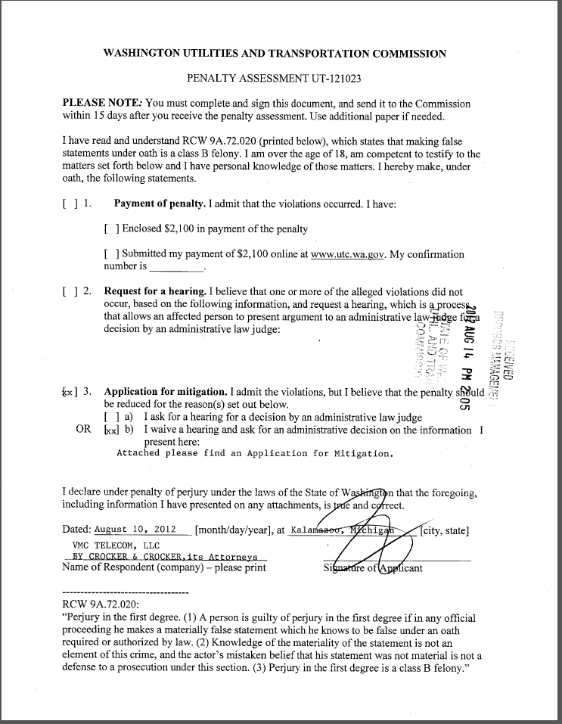
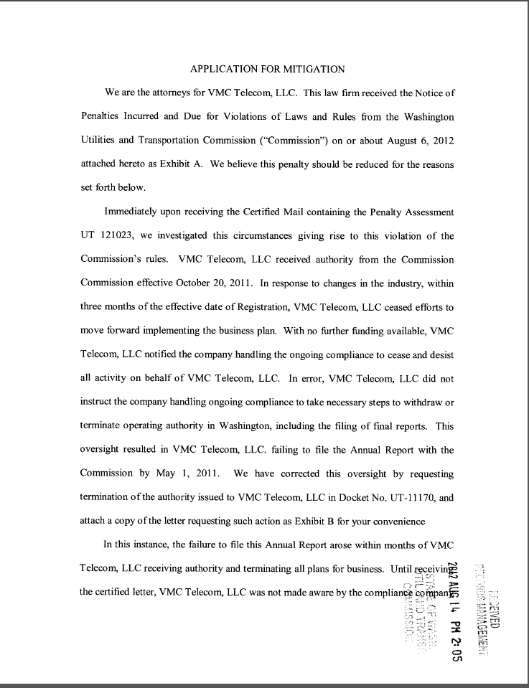
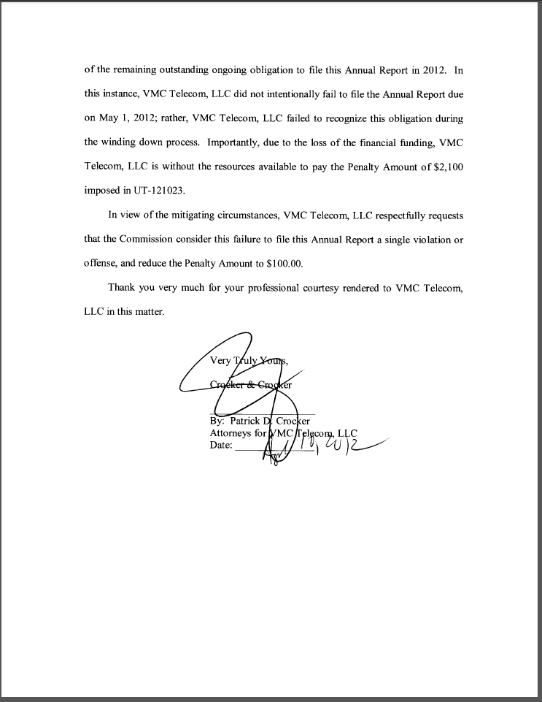
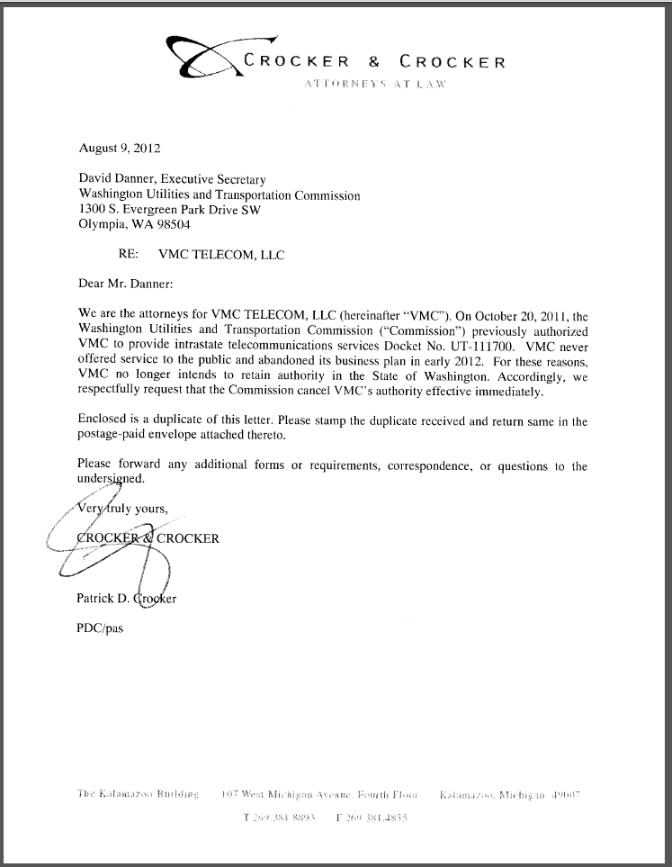

See attachment A for a copy of VMC Telecom, LLC’s Mitigation Request.

